Removing Fringes from Hyperspectral Images Using Truncated Singular Value Decomposition
Dabin Kim^{1,2} and Young Jong Lee^{1,}*
¹Biosystems and Biomaterials Division, National Institute of Standards and Technology, Gaithersburg, MD 20899, USA
²Institute for Soft Matter Synthesis and Metrology, Department of Physics, Georgetown University, Washington, DC 20057, USA
*Email: youngjong.lee@nist.gov
Abstract: Hyperspectral imaging (HSI) often suffers from optical interference fringes that distort resonant spectral features and obscure spatial information. While various hardware and computational mitigation strategies exist, they often become ineffective when interference frequencies overlap with molecular absorption bands or when fringes are irregularly shaped. In this study, we introduce a straightforward, non-iterative approach to eliminate fringes from infrared (IR) HSI by leveraging the wavelength-dependency of fringe patterns in contrast to fixed resonant features in wavelength-variable images. We use singular value decomposition (SVD) to separate them: resonant features are represented by a few principal singular values (SVs), while optical interferences span a wide range of higher-rank SVs. Then, truncated SVD (TSVD) selects low-rank SVs (resonant) and discards high-rank SVs (fringe). We test the TSVD defringing method on synthetic models of increasing complexity, including uniform films, multi-component patterns, and spatially varying molecular orientation samples. Furthermore, the method’s defringing performance is demonstrated on an experimental IR image of a sheared polymer film. Our results confirm that the TSVD method successfully suppresses complex spatial fringes and restores accurate spectral profiles without prior knowledge of the sample, providing a robust, data-driven framework broadly applicable across HSI modalities.

- Introduction
Hyperspectral imaging (HSI) is a powerful analytical technique that provides spatially resolved chemical and structural information across a wide field of view[1–3]. In the mid-infrared (mid-IR) region, HSI is particularly valuable for label-free, non-destructive chemical mapping[4–6]. Recent advancements in bright, coherent light sources, such as quantum cascade lasers (QCLs)[7–9] have significantly accelerated the acquisition speed and spatial resolution of IR HSI without requiring a synchrotron light source. However, the high spatial coherence of these modern light sources introduces significant optical artifacts, most notably optical interference fringes.
Optical interference, often referred to as the etalon effect, occurs when transmitted or reflected light undergoes multiple internal reflections between the parallel or semi-parallel interfaces of a sample, substrate, and cover window[10–12]. In HSI datasets, this interference manifests simultaneously in two domains: as an oscillating, sinusoidal baseline in the spectral domain, and as alternating light and dark “fringe” patterns in the spatial domain. Because the phase delay of the interfering light depends heavily on the local thickness of the air gap or the sample film, these fringe patterns vary dynamically with both location and wavenumber[11,13]. Such artifacts severely distort inherent resonant absorption features, shift apparent spectral peak positions, and obscure vital spatial information, thereby obstructing accurate quantitative analysis and proper image interpretation[14].
Various hardware and computational strategies have been proposed to mitigate optical interference. Hardware solutions—such as the application of index-matching fluids, the use of anti-reflective substrates, or time-delayed integration scanning techniques[15]—can physically reduce interface reflections or average out spatial artifacts. Another approach involves randomizing the phase of coherent laser light by utilizing stationary and moving diffusers [16]. However, these hardware-based methods often accompany sample contamination (in the case of fluids) or technical complexity with high insertion losses (in the case of source randomization), making them challenging for routine static measurements. Consequently, computational defringing methods applied during post-processing are frequently pursued as a more flexible alternative.
Current computational approaches often rely on signal processing transforms, including sine wave subtraction[17], autocorrelation[18], deconvolution[19], wavelet transforms[20], and Fourier transform (FT) filtering[21,22]. While FT filtering can remove high-frequency baseline oscillations, it inherently struggles—and often induces spectral artifacts—when the optical interference frequency overlaps with broad resonant absorption bands. To overcome this, physical modeling approaches have been developed, most notably extended multiplicative signal correction (EMSC)[13,14,23,24] and forward modeling of the etalon cavity. While highly accurate, these physical models demand stringent prior knowledge of the sample’s thickness, geometry, or complex refractive index, which are often unknown and spatially heterogeneous in real-world samples[25]. More recently, deep learning methodologies have been successfully applied to fringe pattern analysis[26,27]. However, these require extensive, highly representative training datasets and can behave as a “black box” regarding spectral preservation.
To address these limitations, we propose a non-iterative, data-driven methodology for removing fringes from HSIs using truncated singular value decomposition (TSVD). Singular value decomposition (SVD) is a widely used matrix factorization technique for denoising, dimensionality reduction, and feature extraction. Conventionally, SVD and TSVD have been extensively utilized for denoising[28–30], dimensionality reduction and feature extraction[31], and spectral unmixing [32]. However, existing SVD-based approaches in HSI predominantly target uncorrelated random noise, sensor striping, or global spectral compression. Mitigating etalon interference fringes presents a distinct challenge because the fringes exhibit strong spatial-spectral variations in phase and period driven by non-uniform sample geometries. Therefore, exploiting the singular value domain to selectively decouple spatially varying interference patterns from intrinsic physical absorption signatures remains unexplored.
We hypothesize that the fundamental resonant absorption features of the sample are highly correlated across pixels and therefore localize into a small number of principal singular values (SVs). Conversely, the optical interference fringes—whose periods and phases vary spatially due to non-uniform air gaps—distribute broadly across higher-order SVs. By applying TSVD to retain only the primary signal-carrying components and zero out higher-order interference components, we eliminate fringes selectively. The novelty of this approach lies in leveraging the spatial-spectral correlation of physical absorption features to separate them from interference patterns that vary in the spatial and spectral domains.
In this paper, we systematically evaluate the TSVD defringing method on both synthetic and experimental HSI data. We first establish the theoretical foundation for fringe generation in HSI data. We then construct and test our TSVD approach on synthetic models of increasing complexity. Finally, we demonstrate the practical efficacy of the TSVD method on an experimental HSI of a seared poly(ε-caprolactone) (PCL) film acquired with a wide-field QCL-IR microscope, highlighting its ability to suppress complex spatial fringes and restore accurate spectral profiles.

- Theory of Fringes in a Hyperspectral Image
Optical interference in imaging can occur when lights from multiple interfaces arrive coherently at a detector. In HSI, optical interference may appear as an oscillating baseline in a spectrum or as a fringe pattern in an image. Here, we examine fringe-related optical interference using synthetic HSI data. We introduce a few simplified but practical models with different sample geometries, compositions, and orientations. All simulated data are for $(200×200)$ pixels and 451 wavenumber steps. Figures 1(a) and 1(b) display the first two models with a uniform film (Model UF), in which a thin sample film is attached to a non-absorbing substrate and a cover window is located at a variable air gap from the substrate. For simplicity, we assume that the film’s refractive index is similar to that of the substrate, and thus reflection at the film-substrate interface is neglected. Based on this assumption, optical interference occurs due to reflections at the film’s top surface and the cover window, and variations in the air-gap distance between them cause fringes. For an absorbance measurement of a sample film, a reference spectrum is measured at a sample-free region where the identical substrate and cover window are extended. We consider two cases of reference measurement. In Fig. 1(a), a spectrum acquired from a single location was used as the reference spectrum (Model UF1), which will contain an optical interference corresponding to the air gap at that single location.

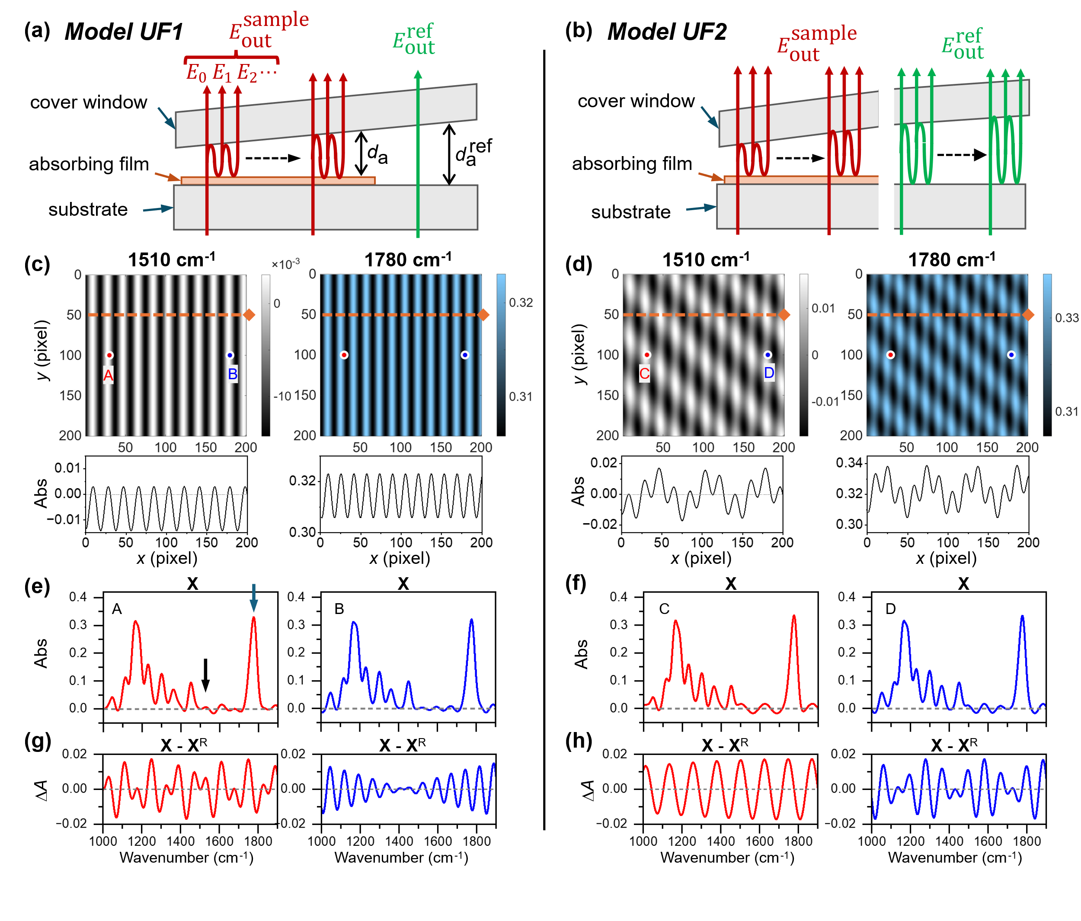
Figure 1. Schematic of the electric fields of light passing through model systems consisting of a thin absorbing film with (a) a single-point reference for Model UF1 and (b) an area-based reference for Model UF2. (c,d) Images simulated at the representative wavenumbers 1510 cm⁻¹ and 1780 cm⁻¹ and corresponding linescans at y = 50 (indicated by the orange dotted line). (e,f) Infrared (IR) spectra at the pixels at (30, 100) and (180, 100). (g,h) Difference between the original spectra with interference (X) and the interference-free resonant film spectra (X^{R}) to isolate the interference-only spectra. Parameters for the simulation: $d_{\text{a}}= 35 μm \frac{x}{200}+ 35 μm$; $d_{\text{a}}^{\text{ref}} = 70 μm$ (Model UF1); $d_{\text{a}}^{\text{ref}} = 20 μm \frac{\left(x - y + 200\right)}{400} + 35 μm$ (Model UF2); $r_{f} = r_{w}= -0.1$; and $d_{\text{f}} = 1 μm$.
In contrast, in Fig. 1(b), an HSI is acquired at a sample-free area, and the spectrum at each image pixel is used as a reference spectrum for the sample spectrum at its equivalent image pixel. The sample-free area used for the reference image will have optical interferences from a variable air gap between the substrate and the cover (Model UF2). Since the sample and reference areas differ, their fringe patterns are assumed to be distinct.
As shown in Fig. 1(a), the light passing through a sample film will consist of a straight light and reflected light between a sample film and a cover window. Because of the assumption of no reflection at the sample-substrate interface, the electric field of a straight light, $E_{0}$, can be expressed as
$$E_{0}=t_{\text{w}}t_{\text{f}}\exp\left(2iπn_{\text{f}}^{*}d_{\text{f}}ν\right)E_{\text{i}\text{n}}$$
(1)
where $t_{\text{w}}$ and $t_{\text{f}}$ denote the transmission coefficients of the cover window and the film, respectively; $d_{\text{f}}$ is the film thickness; $ν$ is the frequency of the light; and $n_{\text{f}}^{*}(=n_{\text{f}}+iκ_{\text{f}})$ is the complex refractive index of the film. $n_{\text{f}}$ is the real refractive index; and $κ_{\text{f}}$ is the extinction coefficient. It must be noted that $κ_{\text{f}}$ is proportional to the absorption coefficient ($a_{\text{f}}$ in cm⁻¹) of the film as $κ_{\text{f}}=a_{\text{f}}/4πν$, and thus, the exp() term in Eq. (1) reflects the absorption spectrum of the film.
The electric field of the first round-trip light, $E_{\text{1}}$, can be expressed with the transmission and reflection coefficients of the cover window ($t_{\text{w}}$ and $r_{\text{w}}$, respectively) and compared to $E_{0}$ of Eq. (2) as
$$E_{1}=t_{\text{w}}r_{\text{f}}\exp{[4iπn_{0}d_{\text{a}}(x,y)ν]}r_{\text{w}}t_{\text{f}}\exp\left(2iπn_{\text{f}}^{*}d_{\text{f}}ν\right)E_{\text{i}\text{n}}=r_{\text{f}}r_{\text{w}}\exp{[4iπn_{0}d_{\text{a}}(x,y)ν]}×E_{\text{0}}$$
(2)
where $n_{0}$ is the refractive index of air ($≈1$); and $d_{\text{a}}(x,y)$ is the variable air gap between the film and the cover window. The term in exp[ ] of Eq. (2) can be considered as the phase delay, $ϕ_{\text{a}}$, by a round-trip of the light across the air gap, which can be expressed as $ϕ_{\text{a}}(x,y,ν)≡4πn_{0}d_{\text{a}}(x,y)ν$. Like the relation between $E_{1}$ and $E_{0}$ in Eq. (2), the electric field of (n+1)-th round-trip light, $E_{\text{n+1}}$, can be expressed with $E_{\text{n}}$ as
$$E_{n+1}=r_{\text{f}}r_{\text{w}}\exp\left(iϕ_{\text{a}}\right)E_{\text{n}}$$
(3)
Then, the electric field of total transmitted light can be expressed as the sum of a geometric progression as
$$E_{\text{out}}^{\text{sample}}=E_{0}+E_{1}+E_{2}+⋯=\frac{E_{0}}{1-r_{\text{f}}r_{\text{w}}\exp\left(iϕ_{\text{a}}\right) }=\frac{t_{\text{w}}t_{\text{f}}\exp\left(2iπn_{\text{f}}^{*}d_{\text{f}}ν\right)E_{\text{i}\text{n}}}{1-r_{\text{f}}r_{\text{w}}\exp\left(iϕ_{\text{a}}\right) }$$
(4)
Similarly, the electric field of a reference beam can be expressed as
$$E_{\text{out}}^{\text{ref}}=\frac{t_{\text{w}}t_{\text{s}}E_{\text{i}\text{n}}}{1-r_{\text{s}}r_{\text{w}}\exp\left(iϕ_{\text{a}}^{\text{ref}}\right) }$$
(5)
where $t_{\text{s}}$ and $r_{\text{s}}$ denote the transmission and reflection coefficients of the substrate; and $ϕ_{\text{a}}^{\text{ref}}\left(x',y',ν\right)=4πn_{0}d_{\text{a}}^{\text{ref}}(x',y')ν$ is the phase delay across the air gap of the reference beam, $d_{\text{a}}^{\text{ref}}(x',y')$.
The light intensities of a sample beam and a reference beam can be expressed as $I_{\text{sample}}=C{\left|E_{\text{out}}^{\text{sample}}\right|}^{2}$ and $I_{\text{ref}}=C{\left|E_{\text{out}}^{\text{r}\text{ef}}\right|}^{2}$, respectively, where $C$ is a proportional coefficient. The output electric fields of a sample beam and a reference beam of Eq. (4) and Eq. (5), respectively, can be converted into transmittance as
$$T≡\frac{I_{\text{out}}}{I_{\text{ref}}}=\frac{{\left|E_{\text{out}}^{\text{sample}}\right|}^{2}}{{\left|E_{\text{out}}^{\text{r}\text{ef}}\right|}^{2}}=\frac{{\left|t_{\text{w}}t_{\text{f}}\right|}^{2}{\left|\exp\left(2iπn_{\text{f}}^{*}d_{\text{f}}ν\right)\right|}^{2}{\left|E_{\text{in}}\right|}^{2}}{{\left|1-\left(r_{\text{f}}r_{\text{w}}\right)\exp\left(iϕ_{\text{a}}\right)\right|}^{2} }\frac{{\left|1-\left(r_{\text{s}}r_{\text{w}}\right)\exp\left(iϕ_{\text{a}}^{\text{ref}}\right)\right|}^{2}}{{\left|t_{\text{w}}t_{\text{s}}\right|}^{2}{\left|E_{\text{in}}\right|}^{2}}$$
(6)
If $n_{\text{f}}^{*}$ is replaced with $(n_{\text{f}}+iκ_{\text{f}})$,
$${\left|\exp\left(2iπn_{\text{f}}^{*}d_{\text{f}}ν\right)\right|}^{2}={\left|\exp\left(2iπn_{\text{f}}d_{\text{f}}ν\right)\right|}^{2}{\left|\exp\left(-2πκ_{\text{f}}d_{\text{f}}ν\right)\right|}^{2}=\exp\left(-4πκ_{\text{f}}d_{\text{f}}ν\right)=\exp\left(-a_{\text{f}}d_{\text{f}}\right)$$
(7)
Also, based on the assumption of $n_{\text{s}}=n_{\text{f}}$, we can assume that $t_{\text{s}}=t_{\text{f}}$ and $r_{\text{s}}=r_{\text{f}}$, and then, Eq. (6) can be simplified to
$$T=\exp\left(-a_{\text{f}}d_{\text{f}}\right)\frac{{\left[1-\left(r_{\text{f}}r_{\text{w}}\right)\exp\left(iϕ_{\text{a}}^{\text{ref}}\right)\right]}^{2}}{{\left[1-\left(r_{\text{f}}r_{\text{w}}\right)\exp\left(iϕ_{\text{a}}\right)\right]}^{2} }$$
(8)
Then, $T$ can be converted into absorbance, $A$, as
$$A≡-\log{T}=a_{\text{f}}d_{\text{f}}+2log\left|1-\left(r_{\text{f}}r_{\text{w}}\right)\exp\left(iϕ_{\text{a}}\right)\right|-2log\left|1-\left(r_{\text{s}}r_{\text{w}}\right)\exp\left(iϕ_{\text{a}}^{\text{ref}}\right)\right|$$
(9)
The first term corresponds to the film absorption spectrum, equivalent to the Beer-Lambert law. The second term represents the optical interference of the sample beam, and the last term corresponds to that of the reference beam.
The sample beam interference appears in both the spectral and spatial dimensions because $ϕ_{\text{a}}(x,y,ν)$ is a function of light wavenumber and pixel coordinates. For example, we calculate $ϕ_{\text{a}}(x,y,ν)$ with $d_{\text{a}}=ax+b$, where a and b are constants. Meanwhile, the reference beam interference differs between Model UF1 and Model UF2. In Model UF1, the air gap of a reference beam is from a single location, making its phase delay a function unvarying over $(x,y)$, and thus, $ϕ_{\text{a}}^{\text{ref}}=ϕ_{\text{a}}^{\text{ref}}(ν)$, and the apparent images contain fringe patterns only from the sample beam, as shown in Fig. 1(c). On the contrary, in Model UF2, $d_{\text{a}}^{\text{ref}}$ varies with $(x',y')$, and $ϕ_{\text{a}}^{\text{ref}}$ varies with $(x,y,ν)$. Thus, interference patterns from the sample and the reference beams coexist, as shown in Fig. 1(d), where $d_{\text{a}}^{\text{ref}}\left(x^{'},y^{'}\right)=c\left(x'-y'\right)+d$, and c and d are constants. The horizontal line scans in Figs. 1(c) and 1(d) show that Model UF1 contains a single fringe mode while Model UF2 contains two fringe modes.
Figures 1(e) and 1(f) show examples of absorption spectra at the two locations marked in Fig. 1(c) and Fig. 1(d), respectively. Because we assume the sample film is homogeneous, the inherent HSI data of the film must be identical across the entire image. The difference between the apparent data matrix (X) and the interference-free resonant film data matrix ($X^{\text{R}}$) will represent the contribution of optical interferences, and the absorbance difference will be expressed as
$$∆A=A-a_{\text{f}}d_{\text{f}}=2log\left|1-\left(r_{\text{f}}r_{\text{w}}\right)\exp\left(iϕ_{\text{a}}\right)\right|-2log\left|1-\left(r_{\text{s}}r_{\text{w}}\right)\exp\left(iϕ_{\text{a}}^{\text{ref}}\right)\right|$$
(10)
Based on Eq. (10), the interference-only spectra ($X-X^{\text{R}}$) are calculated for Model UF1 and Model UF2 and plotted in Figs. 1(g) and 1(h), respectively. In both models, two interference modes exist in an $X$ spectrum: one from the sample beam and the other from the reference beam. Because the air gap in the sample beam changes, the resulting interference pattern varies at different locations. It must be noted that in Model UF1, an image at a wavenumber exhibits only one fringe mode, whereas a spectrum at a location consists of two interference modes.

- Method to Remove Fringes
3.1. Truncated Singular Value Decomposition (TSVD)
Singular value decomposition (SVD) is a linear algebraic method that is widely used in signal and image processing. In the context of HSI, SVD decomposes the original imagery into patterns ranked by variance (highest to lowest), constructing orthonormal basis functions in spatial and spectral domains and a diagonal matrix of “singular values”.[33] Herein, we aim to apply SVD to decompose HSI data into spatial and spectral components in the order of covariance. The apparent absorbance data from Eq. (9) is denoted as the three-dimensional matrix form $X(x,y,ν)$. This cube is reshaped into a two-dimensional matrix, $X(xy,ν)$ by unraveling its spatial dimensions before SVD is performed. Mathematically, SVD factorizes this real-valued absorbance matrix into three constituent matrices:
$$X\left(xy,ν\right)=U\left(xy\right)⋅S⋅{V\left(ν\right)}^{T}=\sum_{k=1}^{n}{U_{k}S_{k}V_{k}^{T}}$$
(11)
where $U(xy)$ is an orthogonal matrix containing image information, and ${V(ν)}^{T}$ is the transpose of an orthogonal matrix containing spectral information. $S$ is a diagonal matrix containing non-negative real numbers (singular values, SVs) sorted from largest to smallest, which represent the square roots of the eigenvalues of $XX^{T}$ or $X^{T}X$. In this paper, we do not consider any additional preprocessing.

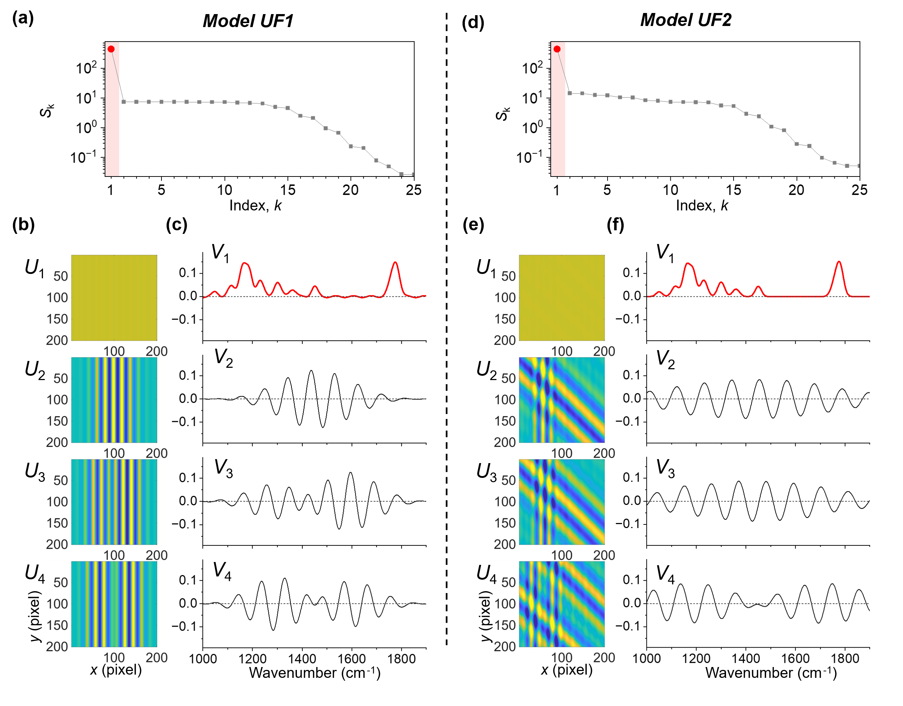
Figure 2. Singular value decomposition (SVD) results of the synthesized data from Model UF1 (a-c) and Model UF2 (d-f).

Figure 2 shows the SVD results from the HSI data of Fig. 1. First, the singular values, $S_{\text{k}}$, calculated from Model UF1 and Model UF2 are plotted in Figs. 2(a) and 2(d), respectively. In the $S_{\text{k}}$ plots of both models, $S_{\text{1}}$ is significantly larger than the rest $S_{\text{k}}$, while the decrease in $S_{\text{k}}$ for $k≥2$ becomes much smaller. In SVD, $S_{\text{1}}$ represents the average of the primary spectral signature, which corresponds to that of the absorption spectrum of the homogeneous film. Accordingly, its corresponding $U_{\text{1}}$ image represents the spatial distribution of the primary spectral feature, which corresponds to the $V_{\text{1}}$ spectrum. In Figs. 2(b) and 2(e), the $U_{\text{1}}$ image appears featureless, consistent with the homogeneity of the absorption spectrum across the sample film. On the other hand, $U_{\text{2}}$, $U_{\text{3}}$, and $U_{\text{4}}$ images exhibit clear fringe patterns. In Figs. 2(c) and 2(f), the $V_{\text{1}}$ spectrum shows a feature similar to the sample film’s input absorption spectrum. Meanwhile, the $V_{\text{2}}$, $V_{\text{3}}$, and $V_{\text{4}}$ spectra show oscillatory features unrelated to the absorption peaks. This clear distinction between ($S_{\text{1}}$, $U_{\text{1}}$, $V_{\text{1}}$) and the rest ($S_{\text{k}}$, $U_{\text{k}}$, $V_{\text{k}}$) for $k≥2$ strongly suggests that SVD can be used to separate the fringe contribution from the resonant absorption spectrum of a sample. Thus, we can divide the original HSI data $X$ into a group of low-rank $(k≤m)$ matrices and a group of remaining $(k>m)$ matrices as
$$X=\sum_{k=1}^{m}{U_{k}S_{k}V_{k}^{T}}+\sum_{k=m+1}^{n}{U_{k}S_{k}V_{k}^{T}}$$
(12)
This matrix division leads to the truncated SVD (TSVD) method, which is a powerful data-driven framework that retains only a small number of principal SVs to preserve the most significant signal components while filtering out unwanted noise or artifacts. Then, Eq. (12) can be rewritten as $X=X^{\text{TSVD}}+X^{\text{∆}}$, where
$$X^{\text{TSVD}}≡\sum_{k=1}^{m}{U_{k}S_{k}V_{k}^{T}}$$
(13)
is the truncated data, and $X^{\text{∆}}$ is the remainder. If the etalon-free resonant data, $X^{\text{R}}$, is highly concentrated at low-rank matrices, and the etalon-dominant interference data, $X^{\text{E}}$, is broadly distributed over the rank space, $X^{\text{TSVD}}$ can be close to $X^{\text{R}}$ by selecting the meaningful (typically the first several largest) $S_{\text{k}}$ and their corresponding $U_{\text{k}}$ and $V_{\text{k}}$ vectors and zeroing out the rest of the SVs, the etalon effect is effectively eliminated. We test this approach using the two previously introduced HSIs (Model UF1 and Model UF2) and two other synthesized HSIs of practical, representative sample systems, and evaluate how well TSVD can eliminate fringes without losing resonant spectral data.

3.2. Application of TSVD to Fringes from Uniform Film Models
As shown in Figs. 2(c) and 2(f), the $V_{\text{1}}$ spectrum looks similar to the input absorption spectrum of the sample film, which is also found in Figs. 1(f) and 1(e), while the $V_{\text{2}}$, $V_{\text{3}}$, and $V_{\text{4}}$ spectra are mostly dominated by oscillatory interference features. Likewise, in Figs. 2(b) and 2(e), the $U_{\text{1}}$ image looks smooth and fringeless, while the $U_{\text{2}}$, $U_{\text{3}}$, and $U_{\text{4}}$ images exhibit fringe patterns. Based on this observation, we perform TSVD on the HSI data shown in Figs. 1 and 2, and reconstruct the image only with the $S_{\text{1}}$, $U_{\text{1}}$, and $V_{\text{1}}$. Figure 3 shows the reconstructed $X^{\text{TSVD}}$ in comparison with the original $X$.

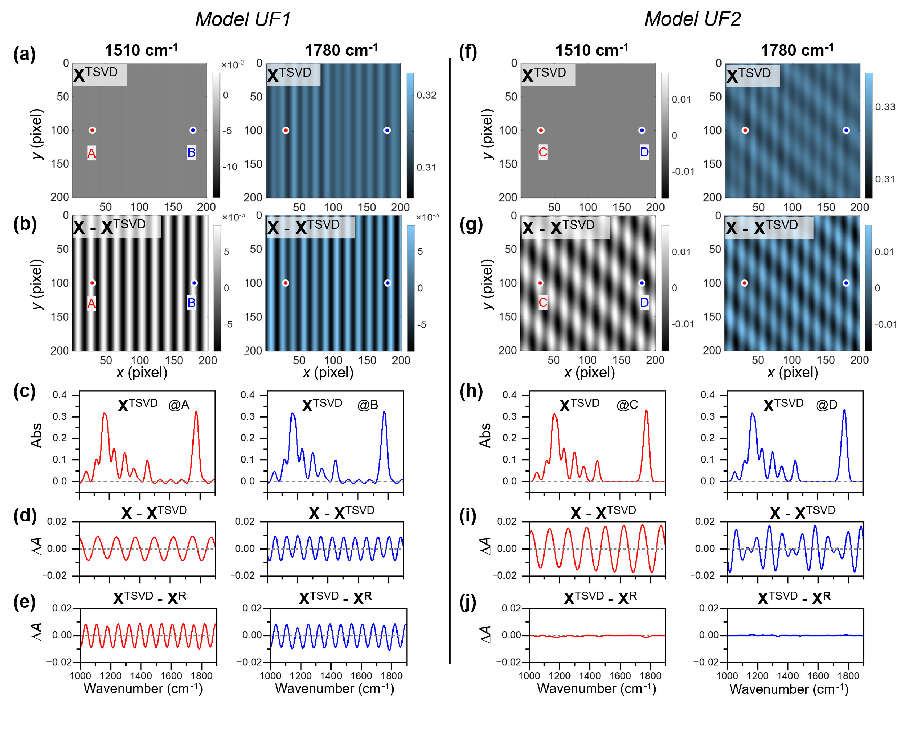
Figure 3. Truncated SVD (TSVD) results for Model UF1 (a-e) and Model UF2 (f-j). (a, f) TSVD-processed images (X^{TSVD} with $k≤1$) at the representative wavenumbers 1510 cm⁻¹ and 1780 cm⁻¹. (b,g) Difference images between before and after TSVD at the corresponding wavenumbers. (c,h) TSVD-processed IR spectra at the pixels (30, 100) and (180, 100). (d,i) Difference spectra before and after TSVD processing. (e,j) Difference $(X^{\text{TSVD}}-X^{\text{R}})$ between TSVD-processed spectra and interference-free resonant spectra .

First, the TSVD results of Model UF1 data are shown on the left side of Fig. 3. The images of Fig. 3(a) are reconstructed at an off-resonant wavenumber (1510 cm⁻¹) and a resonant wavenumber (1780 cm⁻¹) from the TSVD output ($X^{\text{TSVD}}$). The two $X^{\text{TSVD}}$ images exhibit significantly reduced fringe amplitudes compared to the corresponding images of the unprocessed data ($X$), shown in Fig. 1(c). The effectiveness of fringe suppression can also be reconfirmed by comparing the remaining fringes in $X^{\text{TSVD}}$, shown in Fig. 3(a), and the eliminated fringes in $(X-X^{\text{TSVD}})$, shown in Fig. 3(b). The reconstructed images of $X^{\text{TSVD}}$ indicate that fringe suppression is more effective with the off-resonant image at 1510 cm⁻¹ compared to the highly absorbing peak image at 1780 cm⁻¹. In Figs. S1(a)–S1(c), the horizontal linescans from images of $X$, $X^{\text{TSVD}}$, and $(X-X^{\text{TSVD}})$ are plotted for quantitative comparison, and the standard deviation is calculated for each linescan. The standard deviation ratios of $X$ and $(X-X^{\text{TSVD}})$ are > 99 % and 82 % at the off-resonant and on-resonant wavenumbers, respectively, while the standard deviation ratios of $X$ and $X^{\text{TSVD}}$ are < 1 % and 29 % at the off-resonant and on-resonant wavenumbers, respectively. The results indicate that the TSVD process suppresses fringes effectively by > 99 % at a non-absorbing wavenumber and by (80 or 70) % at an absorbing wavenumber. Unlike the unambiguous fringe suppression observed in TSVD-processed images, the interference suppression in a spectrum is more complicated. The TSVD-processed spectra in Fig. 3(c) still contain undulating baselines. To understand the origin of the remaining undulation, $(X-X^{\text{TSVD}})$ spectra and $(X^{\text{TSVD}}-X^{\text{R}})$ spectra are compared in Fig. 1(d) and 1(e), respectively. Interestingly, both $(X-X^{\text{TSVD}})$ and $(X^{\text{TSVD}}-X^{\text{R}})$ spectra show single undulating modes but with different frequencies from each other, indicating that the TSVD process removes only one interference mode out of two. It is noted that the TSVD-removed spectrum of $(X-X^{\text{TSVD}})$ varies with image pixel, while the remaining spectra of $(X^{\text{TSVD}}-X^{\text{R}})$ is identical at all image pixels. This difference indicates that spatially varying interference, or a fringe, is effectively removed by TSVD, but the spatially homogeneous interference, originating from the single reference spectrum, remains after TSVD. The inherent film spectrum is inseparable from the common contribution of an interference-containing reference spectrum.
Second, the TSVD results of the Model UF2 data, in Figs. 3(f) and 3(g), exhibit similarly efficient suppression of fringe interference from the images. For example, from Figs. S1(d)–S1(f), the standard deviation ratios of $X$ and $(X-X^{\text{TSVD}})$ are > 99 % and 78 % at the off-resonant and on-resonant wavenumbers, respectively, while the standard deviation ratios of $X$ and $X^{\text{TSVD}}$ are < 1 % and 33 % at the off-resonant and on-resonant wavenumbers, respectively, which are similar to the results from Model UF1. Unlike Model UF1, the $X^{\text{TSVD}}$ spectra of Model UF2 in Fig. 3(h) show flat baselines. The truncated interferences, shown in the $(X-X^{\text{TSVD}})$ spectra of Fig. 3(i), look similar to those in the true interferences, in the $(X-X^{\text{R}})$ spectra of Fig. 1(h), which is reconfirmed by the zero values in the $(X^{\text{TSVD}}-X^{\text{R}})$ spectra in Fig. 3(j). The standard deviation ratios of the $(X-X^{\text{TSVD}})$ spectra and the $(X^{\text{TSVD}}-X^{\text{R}})$ spectra are 3 % and 2 % at the locations C and D, respectively, indicating that TSVD suppresses fringes effectively over the spectral range. The effective suppression of fringes in Model UF2 is observed from both images and spectra. If optical interference varies in space, either in the sample beam or the reference beam, TSVD can reduce the contribution of the fringe-generating interference to the apparent HSI.

3.3. Two-Component Logo Model

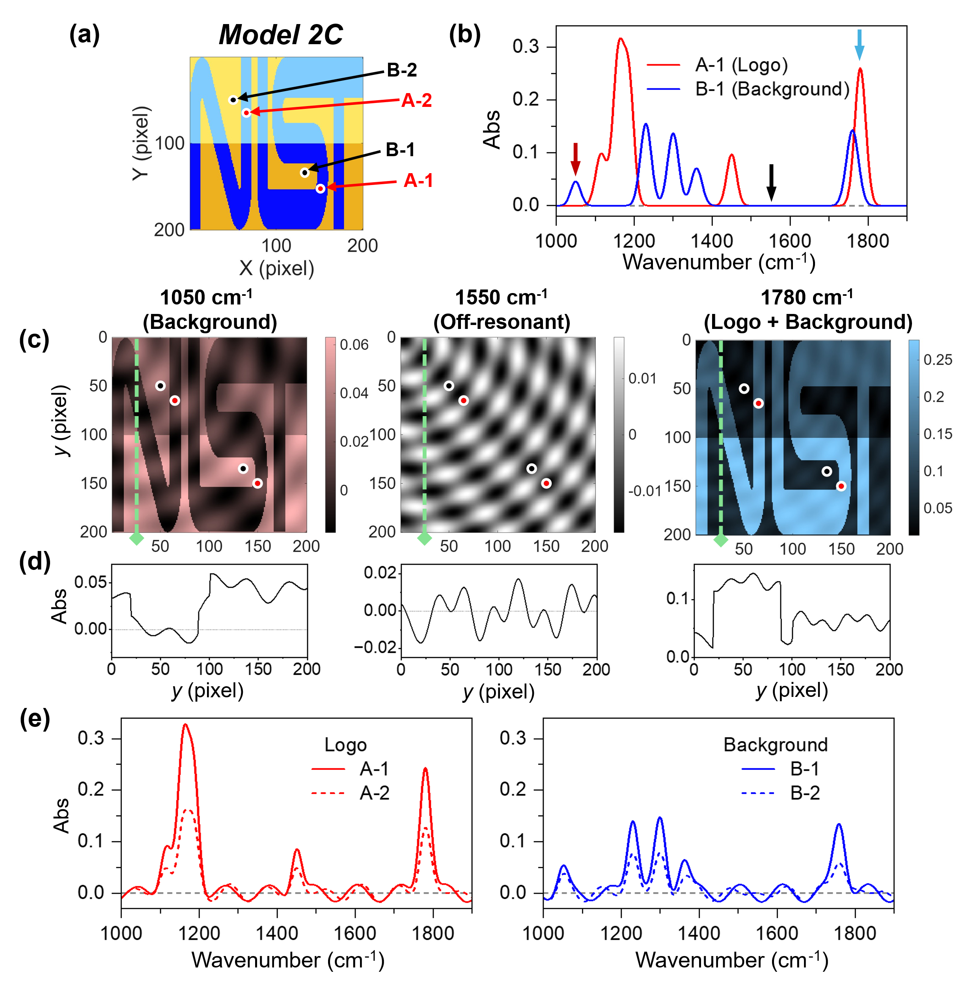
Figure 4. (a) Compositional image of Model C2. The logo contains chemical component A, while the outside of the logo contains chemical component B. The absorbance of the top side of the area is half of that of the bottom side. (b) Spectra of pure component A (red) and component B (blue). (c) Absorbance image simulated at the representative wavenumbers: 1050 cm⁻¹ (resonant, background), 1550 cm⁻¹ (off-resonant), and 1780 cm⁻¹ (resonant, logo and background). (d) Corresponding linescans at x = 25. (e) Absorption spectra at the pixels (65, 65) and (150, 150) for the logo, and (50, 50) and (135, 135) for the background. Solid lines are from the pixels on the bottom side, while dotted lines are from the pixels on the top side. Parameters for the simulation: $d_{\text{a}}=35 μm \frac{x}{200}+35 μm$; $d_{\text{a}}^{\text{ref}}=20 μm \frac{\sqrt{x^{2}+y^{2}}}{282}+35 μm$; $r_{f}=r_{w}=-0.1$; and $d_{\text{f}}=1 μm$.

We consider a slightly more complex model scheme, consisting of two components with spatial variations, called Model C2. Figure 4(a) shows a sample film with a logo whose interference-free absorption spectrum is different from that of the background, as shown in Fig. 4(b). To mimic the density variation within a sample, we assume that the absorbance of the bottom half area is twice that of the top half area. We also introduce different interference patterns by making the air gap in the sample beam increase linearly with the distance from the left top corner and the air gap in the reference beam increase diagonally from the right top corner. The resulting fringe patterns in the images, as shown in Fig. 4(c), consist of one concentric radial mode and another slower diagonal mode. In Fig. 4(d), the absorption profiles of the vertical line in images constructed at different wavenumbers exhibit complex yet unambiguous interference patterns. Figure 4(e) also shows the contributions of optical interference to the spectra at the four different image locations, and the interference effect is significant compared with the interference-free spectra of the logo and the background in Fig. 4(b).

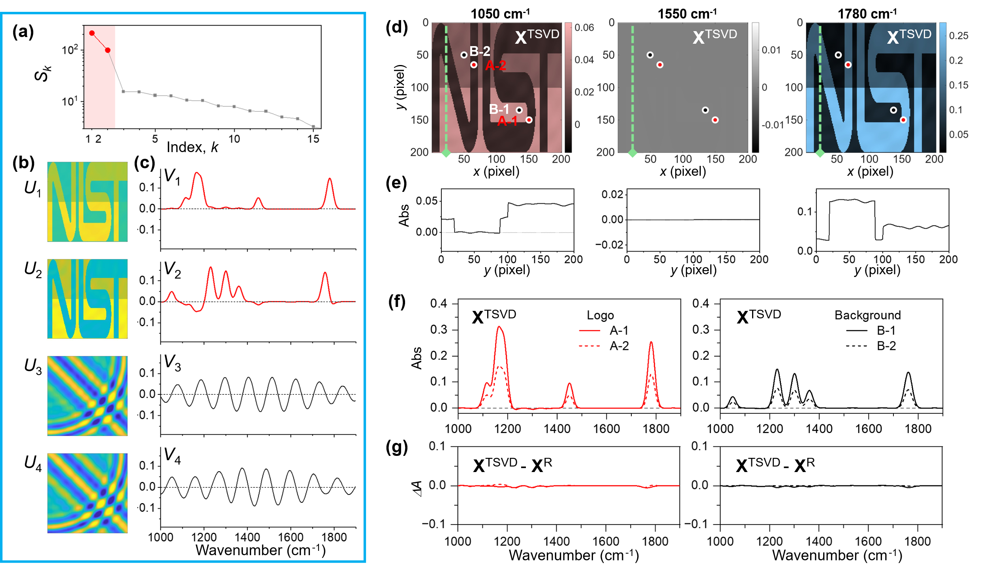
Figure 5. (a-c) SVD results for Model C2 synthesized data: (a) $S_{\text{k}}$, (b) U vectors, and (c) V vectors. (d) TSVD-processed images with ($k≤2$), at the representative wavenumbers: 1050 cm⁻¹, 1550 cm⁻¹, and 1780 cm⁻¹. (e) Corresponding linescans at x = 25. (f) TSVD-processed ($k≤2$) absorption spectra at the pixels on the logo and the background. (g) Absorbance difference (X^{TSVD} – X^{R}) between TSVD-processed and interference-free resonant spectra.

Figures 5(a)–5(c) show the SVD analysis results of the HSI of Model C2. In the $S_{\text{k}}$ plot, shown in Fig. 5(a), $S_{\text{1}}$ and $S_{\text{2}}$ appear to be much higher than the rest of $S_{\text{k}}$, and $S_{\text{k}}$ change very slowly for $k≥3$. In the $U_{\text{k}}$ images, shown in Fig. 5(b), the $U_{\text{1}}$ and $U_{\text{2}}$ images exhibit the logo feature and the thickness difference, while the other $U_{\text{k}}$ ($k≥3$) images show mostly fringe patterns. Similarly, the first two V spectra show peaks and dips corresponding to the logo and the background, while the rest of $V_{\text{k}}$ ($k≥3$) spectra are dominated by undulating patterns. All results of $S_{\text{k}}$, $U_{\text{k}}$, and $V_{\text{k}}$ indicate that the first two principal SVs carry the resonant spectral information of the logo and the background, while the fringe interferences spread across the rest of the SVs. Thus, we select the first two SVs and perform TSVD with the Model C2 data. Figure 5(d) shows images constructed from the TSVD output ($X^{\text{TSVD}}$) at three wavenumbers. Compared to the unprocessed $X$ images in Fig. 4(c), the processed $X^{\text{TSVD}}$ images show greatly suppressed fringe patterns. The linescans in Fig. 5(e) also confirm that the fringes are suppressed in all three images compared to those in the unprocessed images shown in Fig. 4(d). The fringe suppression effect of the TSVD method on the Model C2 data appears more clearly in the processed $X^{\text{TSVD}}$ spectra in Fig. 5(f). Undulating interference contribution disappears from the baseline of a $X^{\text{TSVD}}$ spectrum, and the remaining peaks are close to the interference-free spectra of the logo and the background, shown in Fig. 4(b). The marginal difference between $X^{\text{TSVD}}$ and $X^{\text{R}}$ is observed in their difference spectra in Fig. 5(g), indicating the TSVD process eliminates fringe contributions successfully without distorting the interesting signals in the two-component model.

3.4. Aligned Molecules Model
We consider and numerically simulate another complex model in which molecular alignment causes spectral variation. If the incident light for absorption measurement is linearly polarized, the absorption spectrum of aligned molecules will change with the alignment direction because the absorbance of an absorption peak depends on the angle between the light polarization direction and the corresponding transition dipole moment. Thus, the polarization dependence of an IR peak indicates the two-dimensional projected angle of the corresponding transition dipole moment. Recently, an analytical method has been demonstrated to determine the three-dimensional angle of molecular alignment direction by concurrently analyzing the polarization angle dependences of multiple absorption peaks.[34–36] The model system with aligned molecules, called Model A, shown in Fig. 6(a), consists of a single-component film with hexagonal domains with a radial symmetry of molecular alignment. The colormap indicates the alignment direction angle, θ, ranging between 0 and π. We assume that the thin film with alignment domains is located in the interference geometry similar to Model UF2, where both sample and reference beams contain fringes.

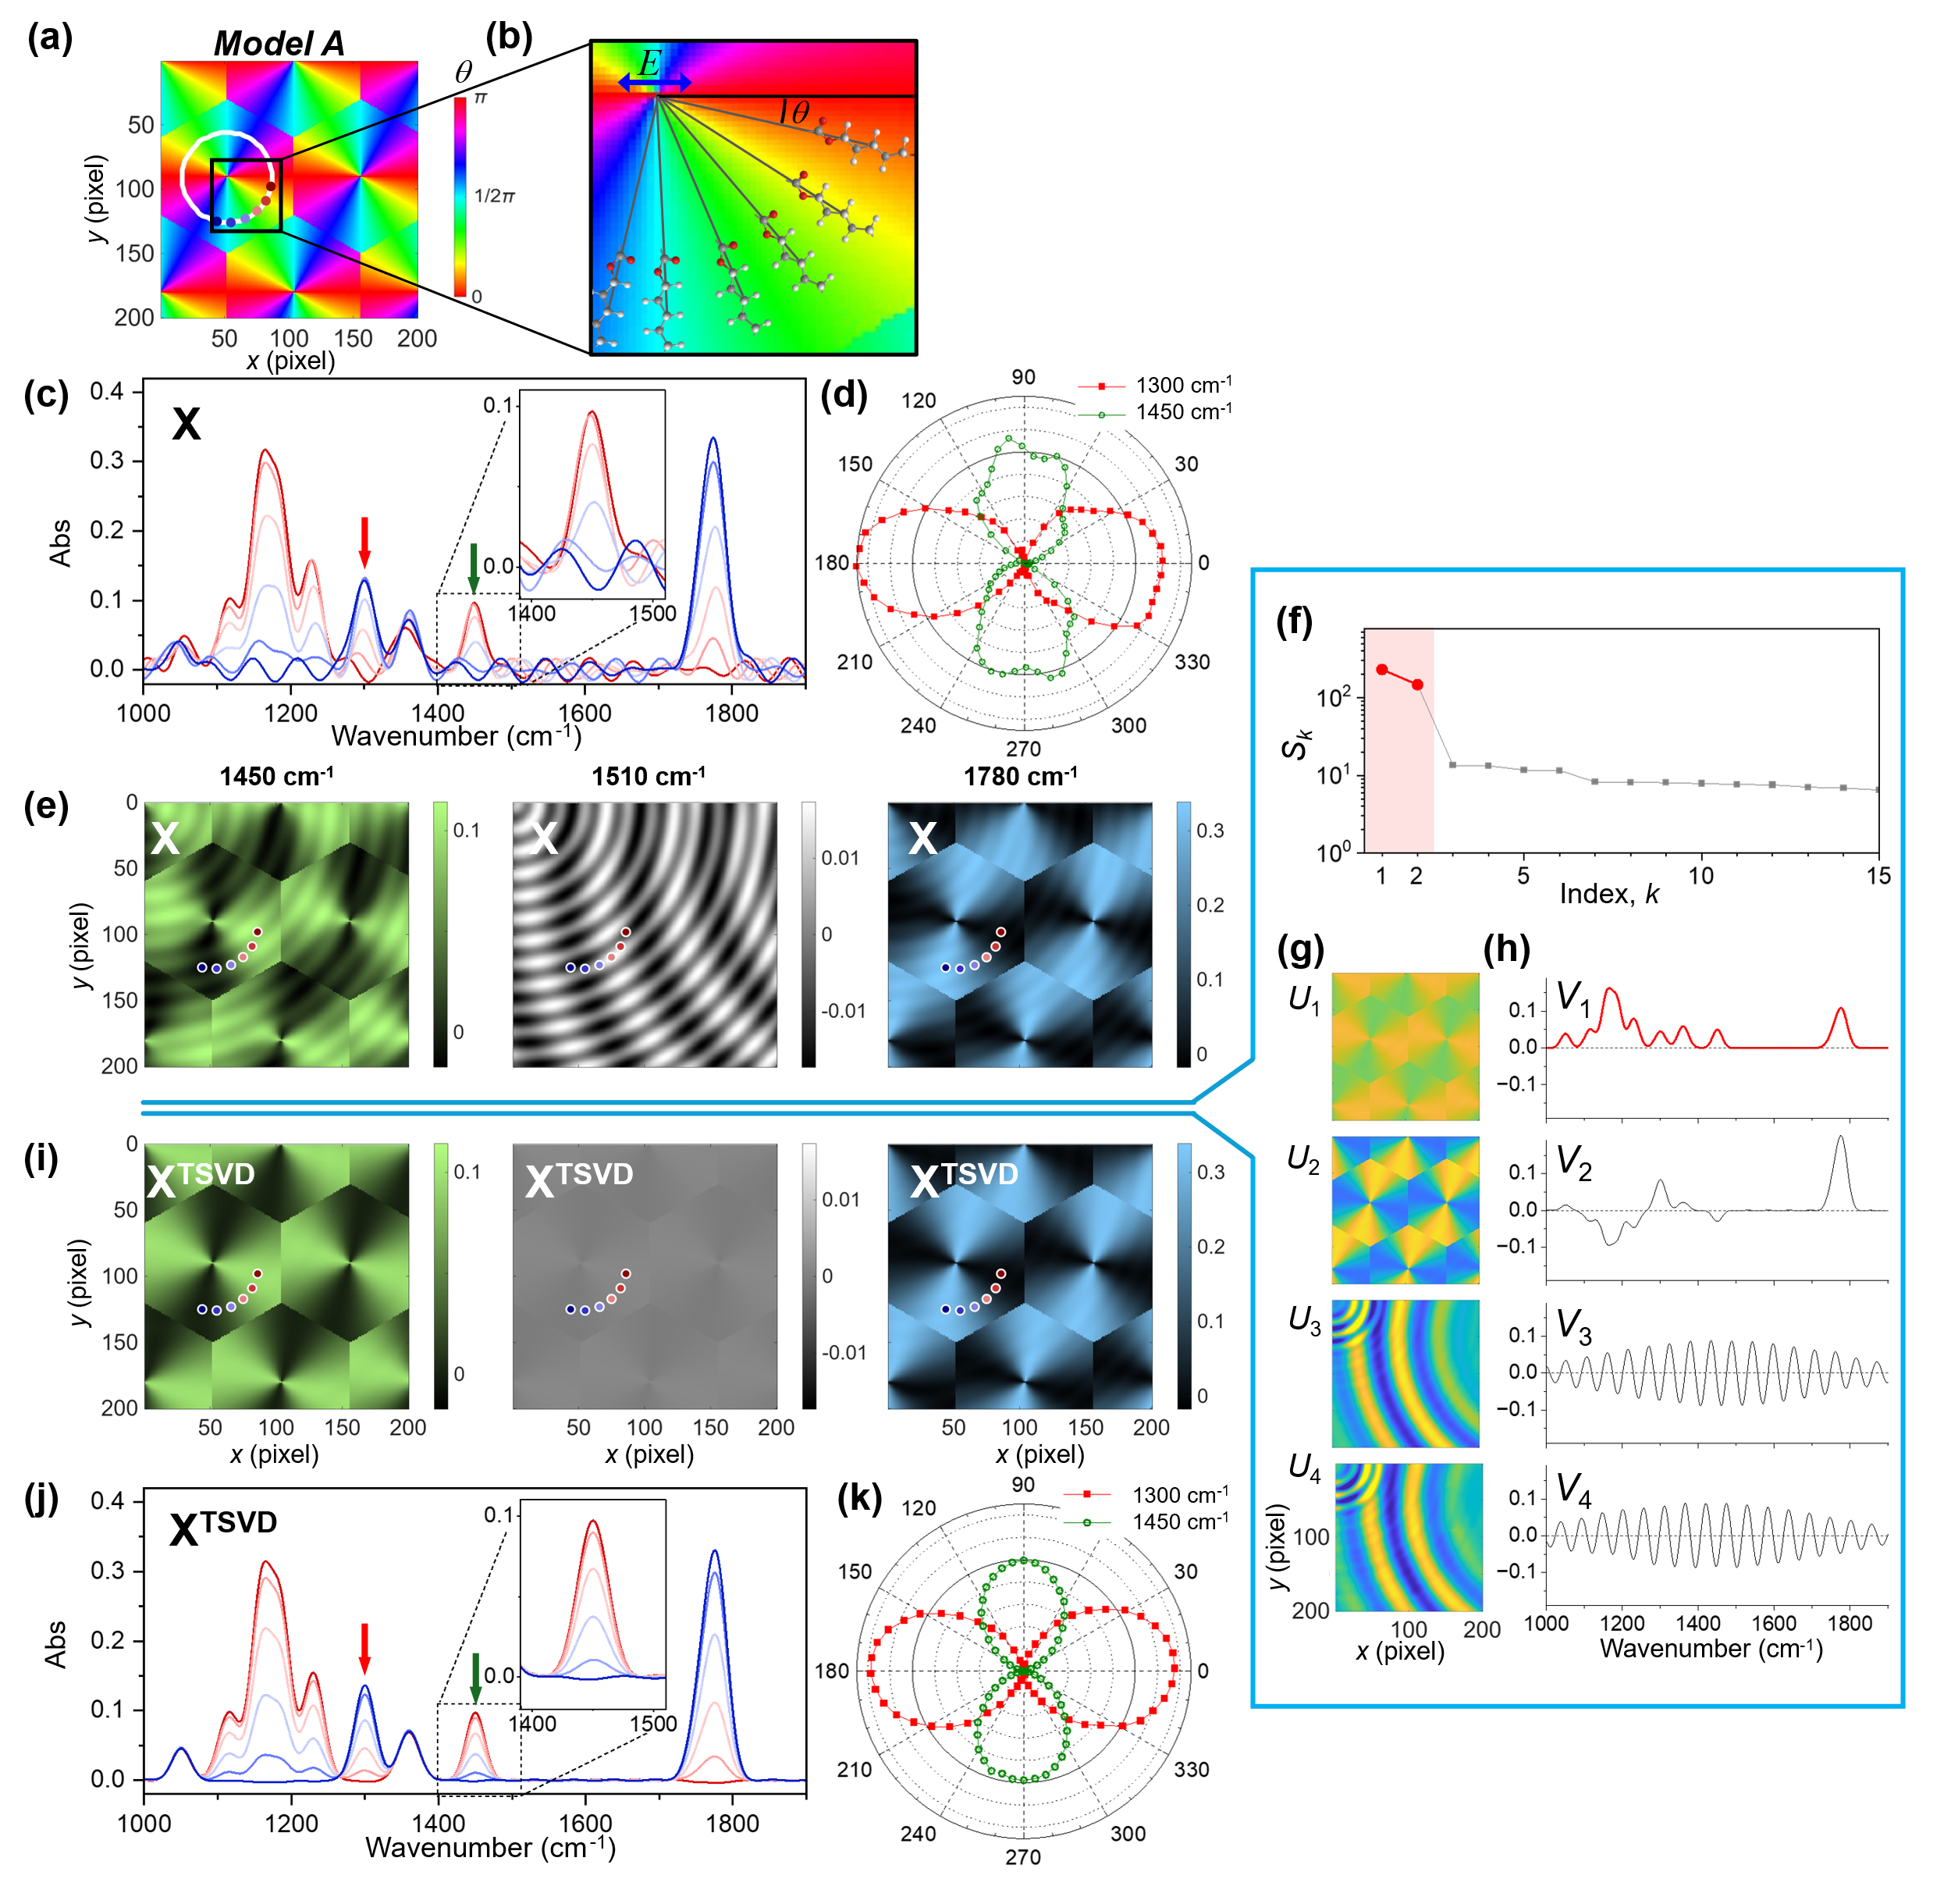
Figure 6. (a) Molecular orientation image of a model sample with hexagonal orientational domains for Model A. (b) Illustration of molecular alignments with radial symmetry with the orientation angle, θ, from the light polarization direction (indicated by the horizontal blue arrow). (c) IR spectra calculated at the six representative pixels along the white circumference in (a). (d) Polar plots of the absorbance at 1300 cm⁻¹ and 1450 cm⁻¹. (e) Images calculated at 1450 cm⁻¹, 1510 cm⁻¹, and 1780 cm⁻¹. (f–h) SVD results. (i) TSVD-processed images with ($k ≤ 2$), compared to (e). (j) TSVD-processed spectra, compared to (c). (k) Polar plots of TSVD-processed absorbance at 1300 cm⁻¹ and 1450 cm⁻¹. Parameters for the simulation: $d_{\text{a}} = 55 μm \frac{\sqrt{x^{2} + y^{2}}}{282} + 45 μm$; $d_{\text{a}}^{\text{ref}} = 20 μm \frac{\sqrt{{\left(x-300\right)}^{2} + {\left(y-50\right)}^{2}}}{334} + 35 μm$; $r_{f}=r_{w}=-0.1$; and $d_{\text{f}} = 1 μm$.

We select six locations within the hexagonal domain shown in Fig. 6(a), which are marked along a white circle. To help visualize the spatial variation of molecular alignment, we present an example molecule at each location along the circle in Fig. 6(b). We assume that the transition dipole moments of some peaks are parallel to the molecular long axis, while those of other peaks are perpendicular. Figure 6(c) shows the absorption spectra calculated at the six locations, representing the alignment dependence of linearly polarized absorption measurement. According to the assumed direction of the transition dipole moment, the absorbance of a peak changes as the alignment direction changes. However, due to interferences in the sample and reference beams, the spectra exhibit spectral interferences. In the inset plots of Fig. 6(c), complex spectral interference changes not only the baseline of an absorption peak but also the peak position. Furthermore, the polar plots of two weakly absorbing peaks at 1300 cm⁻¹ and 1450 cm⁻¹ displayed in Fig. 6(d) show a significant contribution from spectral interference. These peak distortions caused by interference can lead to significant errors in the alignment angle analysis. The images constructed at three frequencies, as shown in Fig. 6(e), show the fringe interference patterns. High-frequency fringes appear as concentric circles centered at the top left corner, while lower-frequency fringes is centered toward the right side of the image. The stronger peak image at 1780 cm⁻¹ shows a relatively weak contribution of the fringes, while the images at the medium height peak at 1450 cm⁻¹ and at the off-resonant peak at 1510 cm⁻¹ show unambiguous fringe patterns.
We perform SVD with this HSI, and the SVD results are shown in Figs. 6(f)–6(h). In Fig. 6(f), the S₁ and S₂ values are more than an order of magnitude larger than the rest $S_{\text{k}}$ values. Similarly, the U₁ and U₂ images show well-defined orientational domains, while fringe patterns dominate the rest of $U_{\text{k}}$ images. The V₁ spectrum corresponds to the mean spectrum, and the V₂ spectrum corresponds to the orientation-dependent component of each absorption peak. Meanwhile, the rest of $V_{\text{k}}$ spectra are dominated by strong undulation patterns. All $S_{\text{k}}$, $U_{\text{k}}$, and $V_{\text{k}}$ indicate that the first two SVs carry the meaningful IR spectral information of the film sample. Based on this result, we perform TSVD using the two SVs, and Figs. 6(i)–6(k) show the outcome. The $X^{\text{TSVD}}$ images are constructed at the three wavenumbers in Fig. 6(i), showing greatly suppressed fringes when compared to the corresponding $X$ images in Fig. 6(e). Compared to the $X$ spectra in Fig. 6(c), the $X^{\text{TSVD}}$ spectra along the circumference in Fig. 6(j) also show greatly reduced undulations in the baseline, and the peak shape and position becomes stable (see the inset plots), indicating that the optical interference has been suppressed successfully. In the polar plots in Fig. 6(k), the angle-dependent absorbance of two representative peaks becomes close to the cosine square shape. Thus, the TSVD results of Model A confirm that the TSVD method can eliminate the fringes from the HSI of a sample with variable molecular alignment.

- Application of TSVD to Experimental Data
We test the TSVD method with fringe-containing experimental images acquired from a thin polymer film used in a previous publication, where the detailed description of the sample and the imaging method can be found.[34] Briefly, a sheared poly(ε-caprolactone) (PCL) film with a thickness of (1.0 ± 0.1) μm was prepared by pressing/spreading it with an edge of a glass slide. The uncertainty of thickness was determined by the standard of deviation of three repeated measurements by ellipsometry. The PCL film was placed on a CaF₂ window and imaged in transmission mode with a wide-field quantum cascade laser (QCL) IR microscope (Spero-QT, Daylight Solutions). The incident light was linearly polarized, and the polarization direction was parallel to the stretching direction. For the reference measurement, the sample stage was translated to image a blank area of a pristine portion of the CaF₂ substrate. A wide-field IR image was collected at each frequency as the frequency was scanned from 1794 cm⁻¹ to 1000 cm⁻¹ with a 2 cm⁻¹ increment, yielding a total of 398 wavenumber steps. From an original image with a 650 μm field of view and 480×480 pixels, a 300×300 pixels section without singular scattering sources was cropped and analyzed.

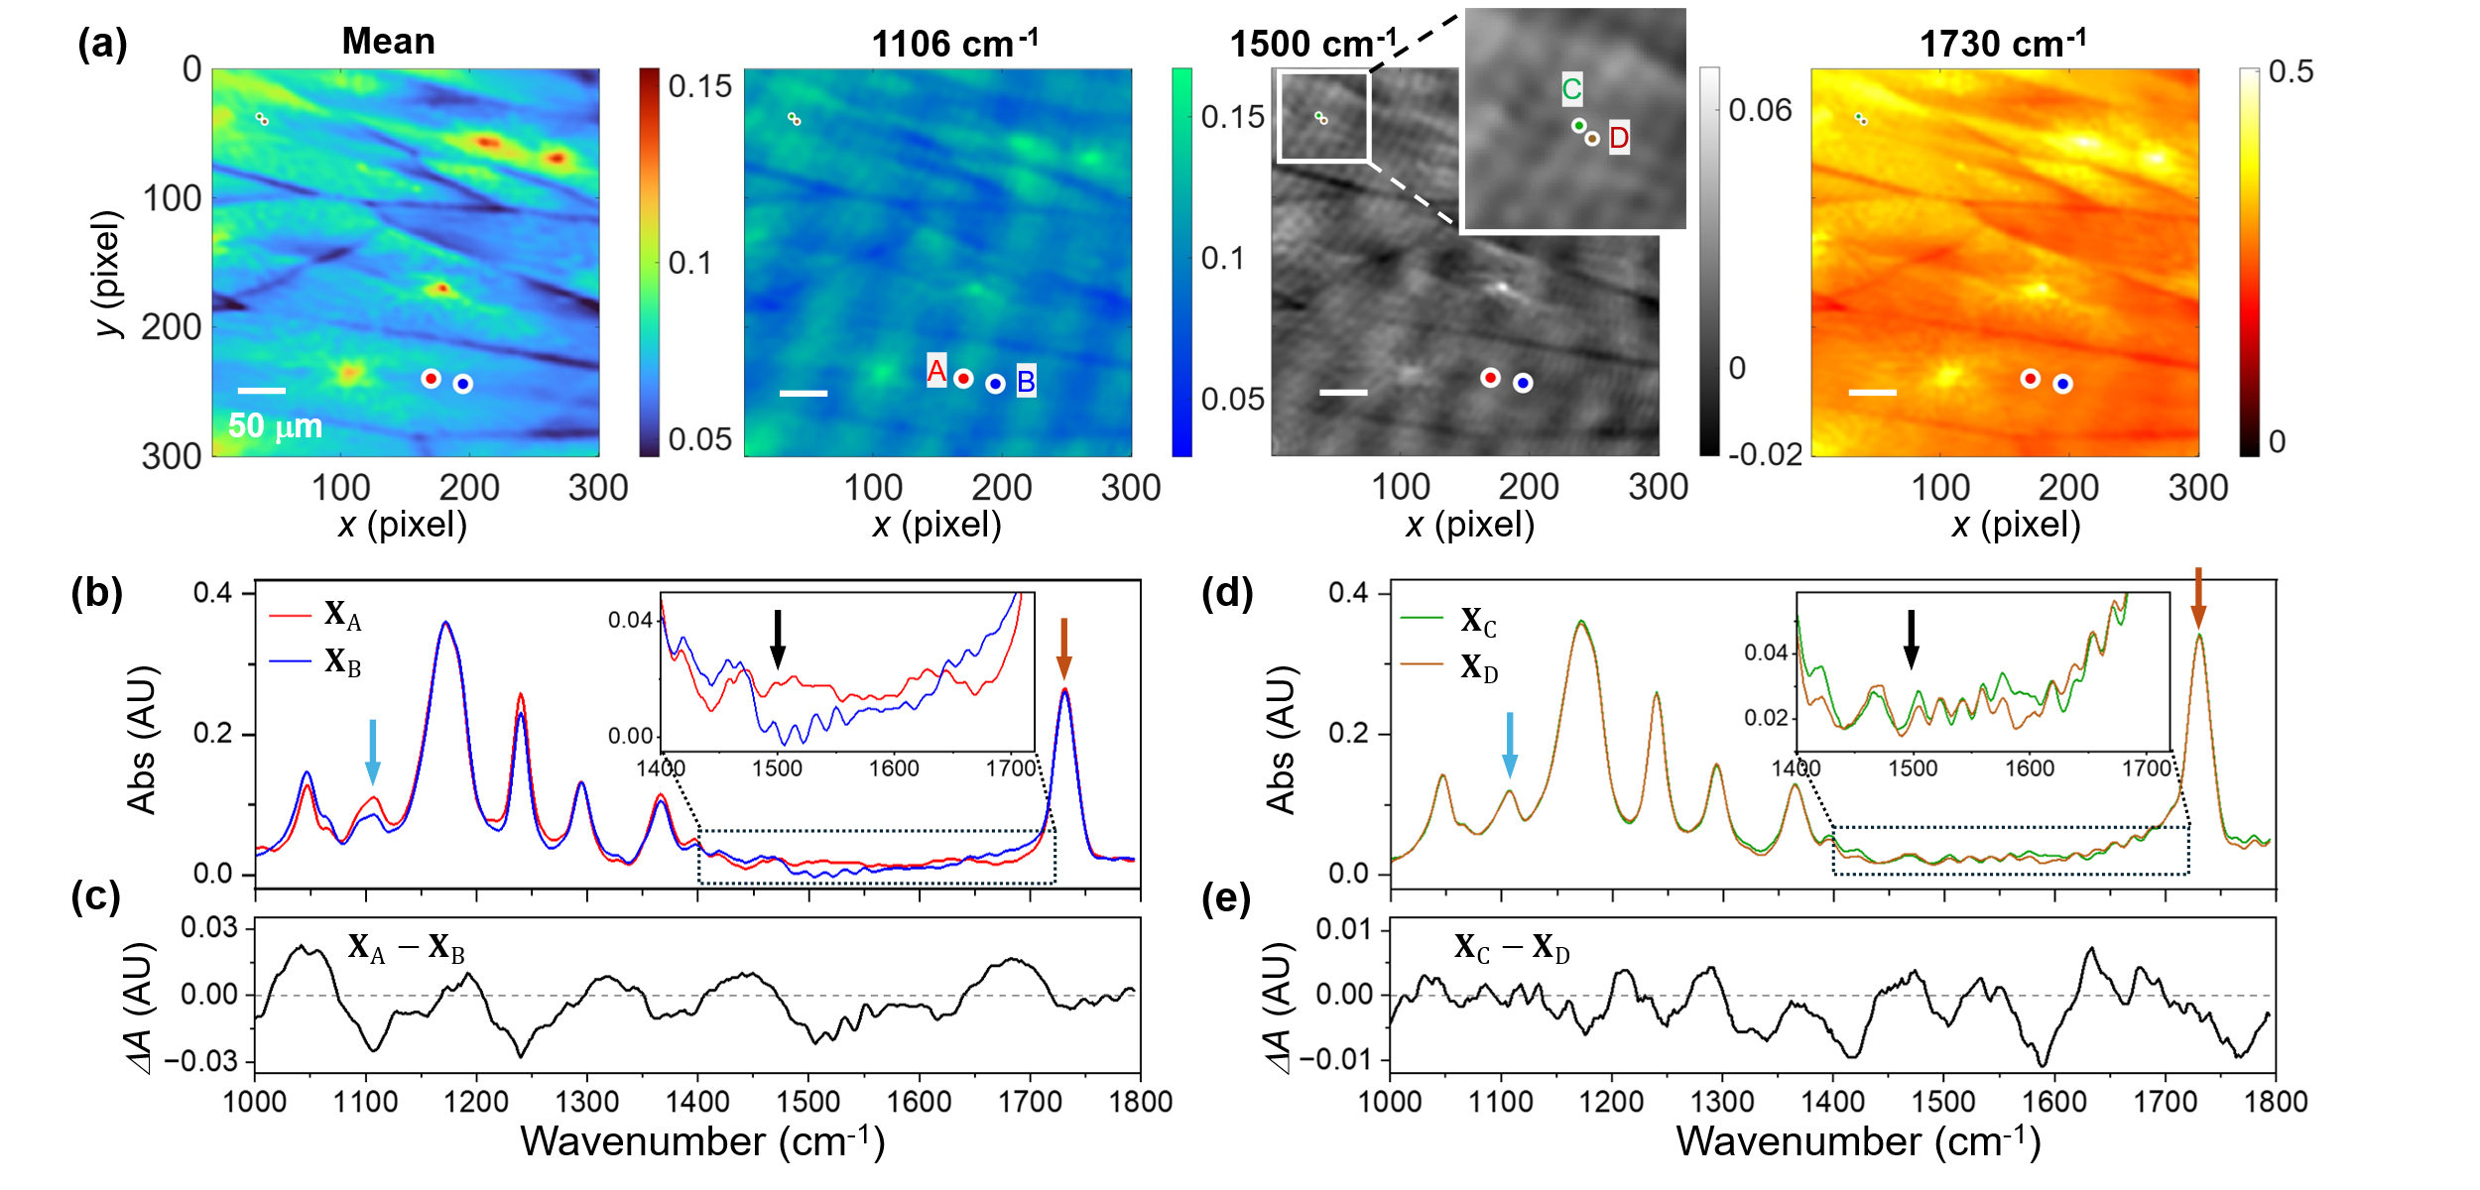
Figure 7. Experimental hyperspectral image (HSI) acquired from a sheared poly(ε-caprolactone) (PCL) film. (a) Mean absorbance image and single-wavenumber absorbance images at the representative wavenumbers 1106 cm⁻¹, 1500 cm⁻¹, and 1730 cm⁻¹. (b) IR absorption spectra at the marked locations A = (170, 240) and B = (195, 244), representing the peak and valley of the slower-varying fringe. (c) Difference of the IR absorption spectra at A and B. (d) IR absorption spectra at the marked locations C = (37, 37) and D = (41, 41), representing the peak and valley of the faster-varying fringe. (e) Difference of the IR absorption spectra at C and D.

Figure 7(a) shows absorbance images of the sheared PCL. The spectrally averaged HSI clearly shows distinct traces of spherulite boundaries, which are stretched along the shearing direction (x-direction). Unlike the mean spectrum image, the images at three frequencies show multiple fringe patterns, which appear with higher contrast in the images of the weakly resonant frequency (1106 cm⁻¹) and the off-resonant frequency (1500 cm⁻¹) than in the image of the strong resonant frequency (1730 cm⁻¹). One fringe mode appears as evenly spaced curves from the top right to the bottom left with an approximate spacing of 50 pixels (slower fringe). Another fringe mode consists of a fine concentric ring pattern centered outside the upper-left corner (faster fringe, more noticeable in the 1500 cm⁻¹ enlarged image). Figure 7(b) shows the absorption spectra from the locations marked as the red and blue dots in Fig. 7(a). The two locations are selected along the fringe direction at the half-period of the slower fringe mode in the 1500 cm⁻¹ image. Figure 7(c) shows that the two spectra are similar overall, with only slight differences, indicating that the slower fringe in the images corresponds to a spectral interference mode with a period around 120 cm⁻¹. To examine spectral differences along the faster fringe, we select two different locations separated by the half period of the finer fringe and mark them as the green and orange dots. In Fig. 7(d), the spectra at the two locations exhibit a smaller difference than those in Fig. 7(b). Their difference spectrum in Fig. 7(e), suggesting that the spectral interference mode with a period between 60 cm⁻¹ and 80 cm⁻¹ may correspond to the faster fringe mode in the images.

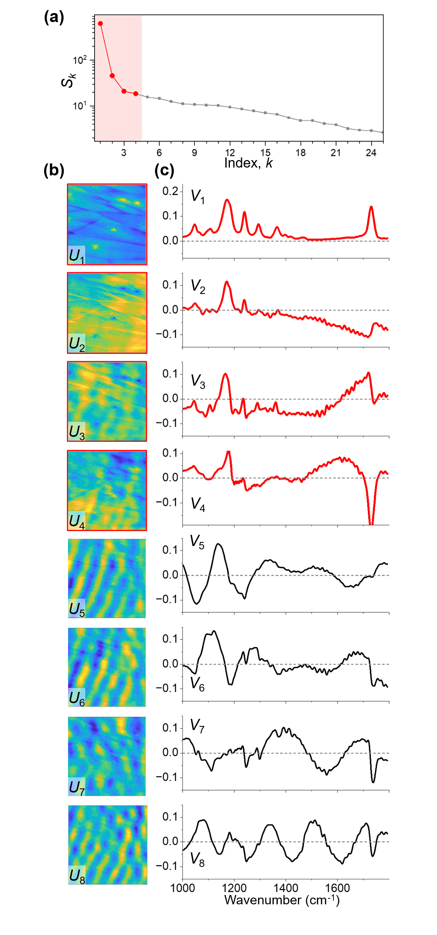
Figure 8. SVD results of the HSI from the sheared PCL film.

Figure 8 shows the SVD results for the experimental data of the sheared PCL. First, we examine the results of $S_{k}$, $U_{\text{k}}$, and $V_{\text{k}}$, separately. In Fig. 8(a), the $S_{k}$ plot shows a large drop from $S_{1}$ to $S_{2}$ and $S_{3}$ but does not show a distinct “elbowing” point found in the SVD results of the earlier simulation data. The absence of the elbowing point makes it challenging to determine which $S_{\text{k}}$ to select for TSVD, solely based on the $S_{\text{k}}$ plot. In Fig. 8(b), the first $U_{\text{1}}$ and $U_{\text{2}}$ images appear unaffected by fringes, and the $U_{\text{3}}$ and $U_{\text{4}}$ images show traces of the slower fringe pattern. Meanwhile, the higher-index $U_{\text{k}}(k≥5)$ images show unambiguous fringes, including previously unseen diagonal lines from the top left to the bottom right. These various fringe contributions to the $U_{\text{k}}$ images indicate that four or fewer SVs can be used for TSVD. The first four $V_{\text{k}}$ spectra in Fig. 8(c) appear to have resonant peaks of the PCL film without significant interference features, while the next four $V_{\text{k}}$ spectra for $5≤k≤8$ exhibit interference features dominantly but still have distinguishable resonant peaks as well. From this experimental data, we learn that resonant and interference contributions can coexist in some $U_{\text{k}}$ images and $V_{\text{k}}$ spectra, and thus, it is challenging to non-subjectively decide which SVs to include in TSVD. Also, surveying each $S_{k}$, $U_{\text{k}}$, and $V_{\text{k}}$ separately makes it difficult to intuitively evaluate the fringe contribution of each SV to the final TSVD output.
Alternatively, we generate a series of TSVD outputs ($X^{\text{TSVD}}$) with various SVs and examine the difference between $X^{\text{TSVD}}$ and the original data ($X$). Figure 9(a) shows the images of $X^{\text{TSVD}}$ constructed at 1730 cm⁻¹, while Fig. 9(b) shows their corresponding truncated portions ($X-X^{\text{TSVD}}$). In the first row, the image of $X^{\text{TSVD}}$ calculated with only $k=1$ is free of fringes. However, in the $X-X^{\text{TSVD}}$ image for $(k=1)$, one can observe not only some fringe patterns but also clear features of stretched spherulites and their boundaries, which indicates that a significant portion of resonant spectral information is lost. The loss of sample signals is observed similarly in the $X-X^{\text{TSVD}}$ images for $(k≤2)$ and $(k≤3)$. However, the $X-X^{\text{TSVD}}$ images for $(k≤4)$, $(k≤5)$, and $(k≤6)$ are quite different from the top three images. The bottom three images exhibit unambiguous fringe patterns with minimal boundary traces, indicating that the TSVD-eliminated components mostly correspond to fringe contributions and that the film signals are not lost significantly. However, as more SVs are included in TSVD, more fringe contributions will be included in $X^{\text{TSVD}}$, which is not intended for the TSVD process. The series of $X^{\text{TSVD}}$ images in Fig. 9(a) show that the images for $k≤4$, $k≤5$, and $k≤6$ show traces of the slow fringe mode diagonal from the top right to the bottom left. However, the fine ring fringe mode and the slow diagonal fringe mode from the top left to the bottom right disappear from the six $X^{\text{TSVD}}$ images. The k-dependence of the remaining fringes is slightly different in other wavenumber images (see Fig. S2). In Fig. 9(c), the spectral difference between $X$ and $X^{\text{TSVD}}$ are mapped accumulatively across all image pixels as a function of wavenumber, displaying whether TSVD eliminates resonant spectral components. The spectral map of $X-X^{\text{TSVD}}$ for $k=1$ shows that a significant part of the film absorption spectrum is removed by TSVD. The spectral map for $k≤$2, and $k≤3$ show that the 1730 cm⁻¹ peak is reduced by TSVD. Down from $k≤4$, the spectral difference becomes even for all wavenumbers, indicating that the TSVD-eliminated portion is mostly from fringes or noises. So far, we have examined not only $S_{k}$, $U_{\text{k}}$, and $V_{\text{k}}$ from the SVD results of the PCL film data, but also the $X^{\text{TSVD}}$ and $X-X^{\text{TSVD}}$ images and the spectral map of $X-X^{\text{TSVD}}$ from the TSVD outputs for various $k$.

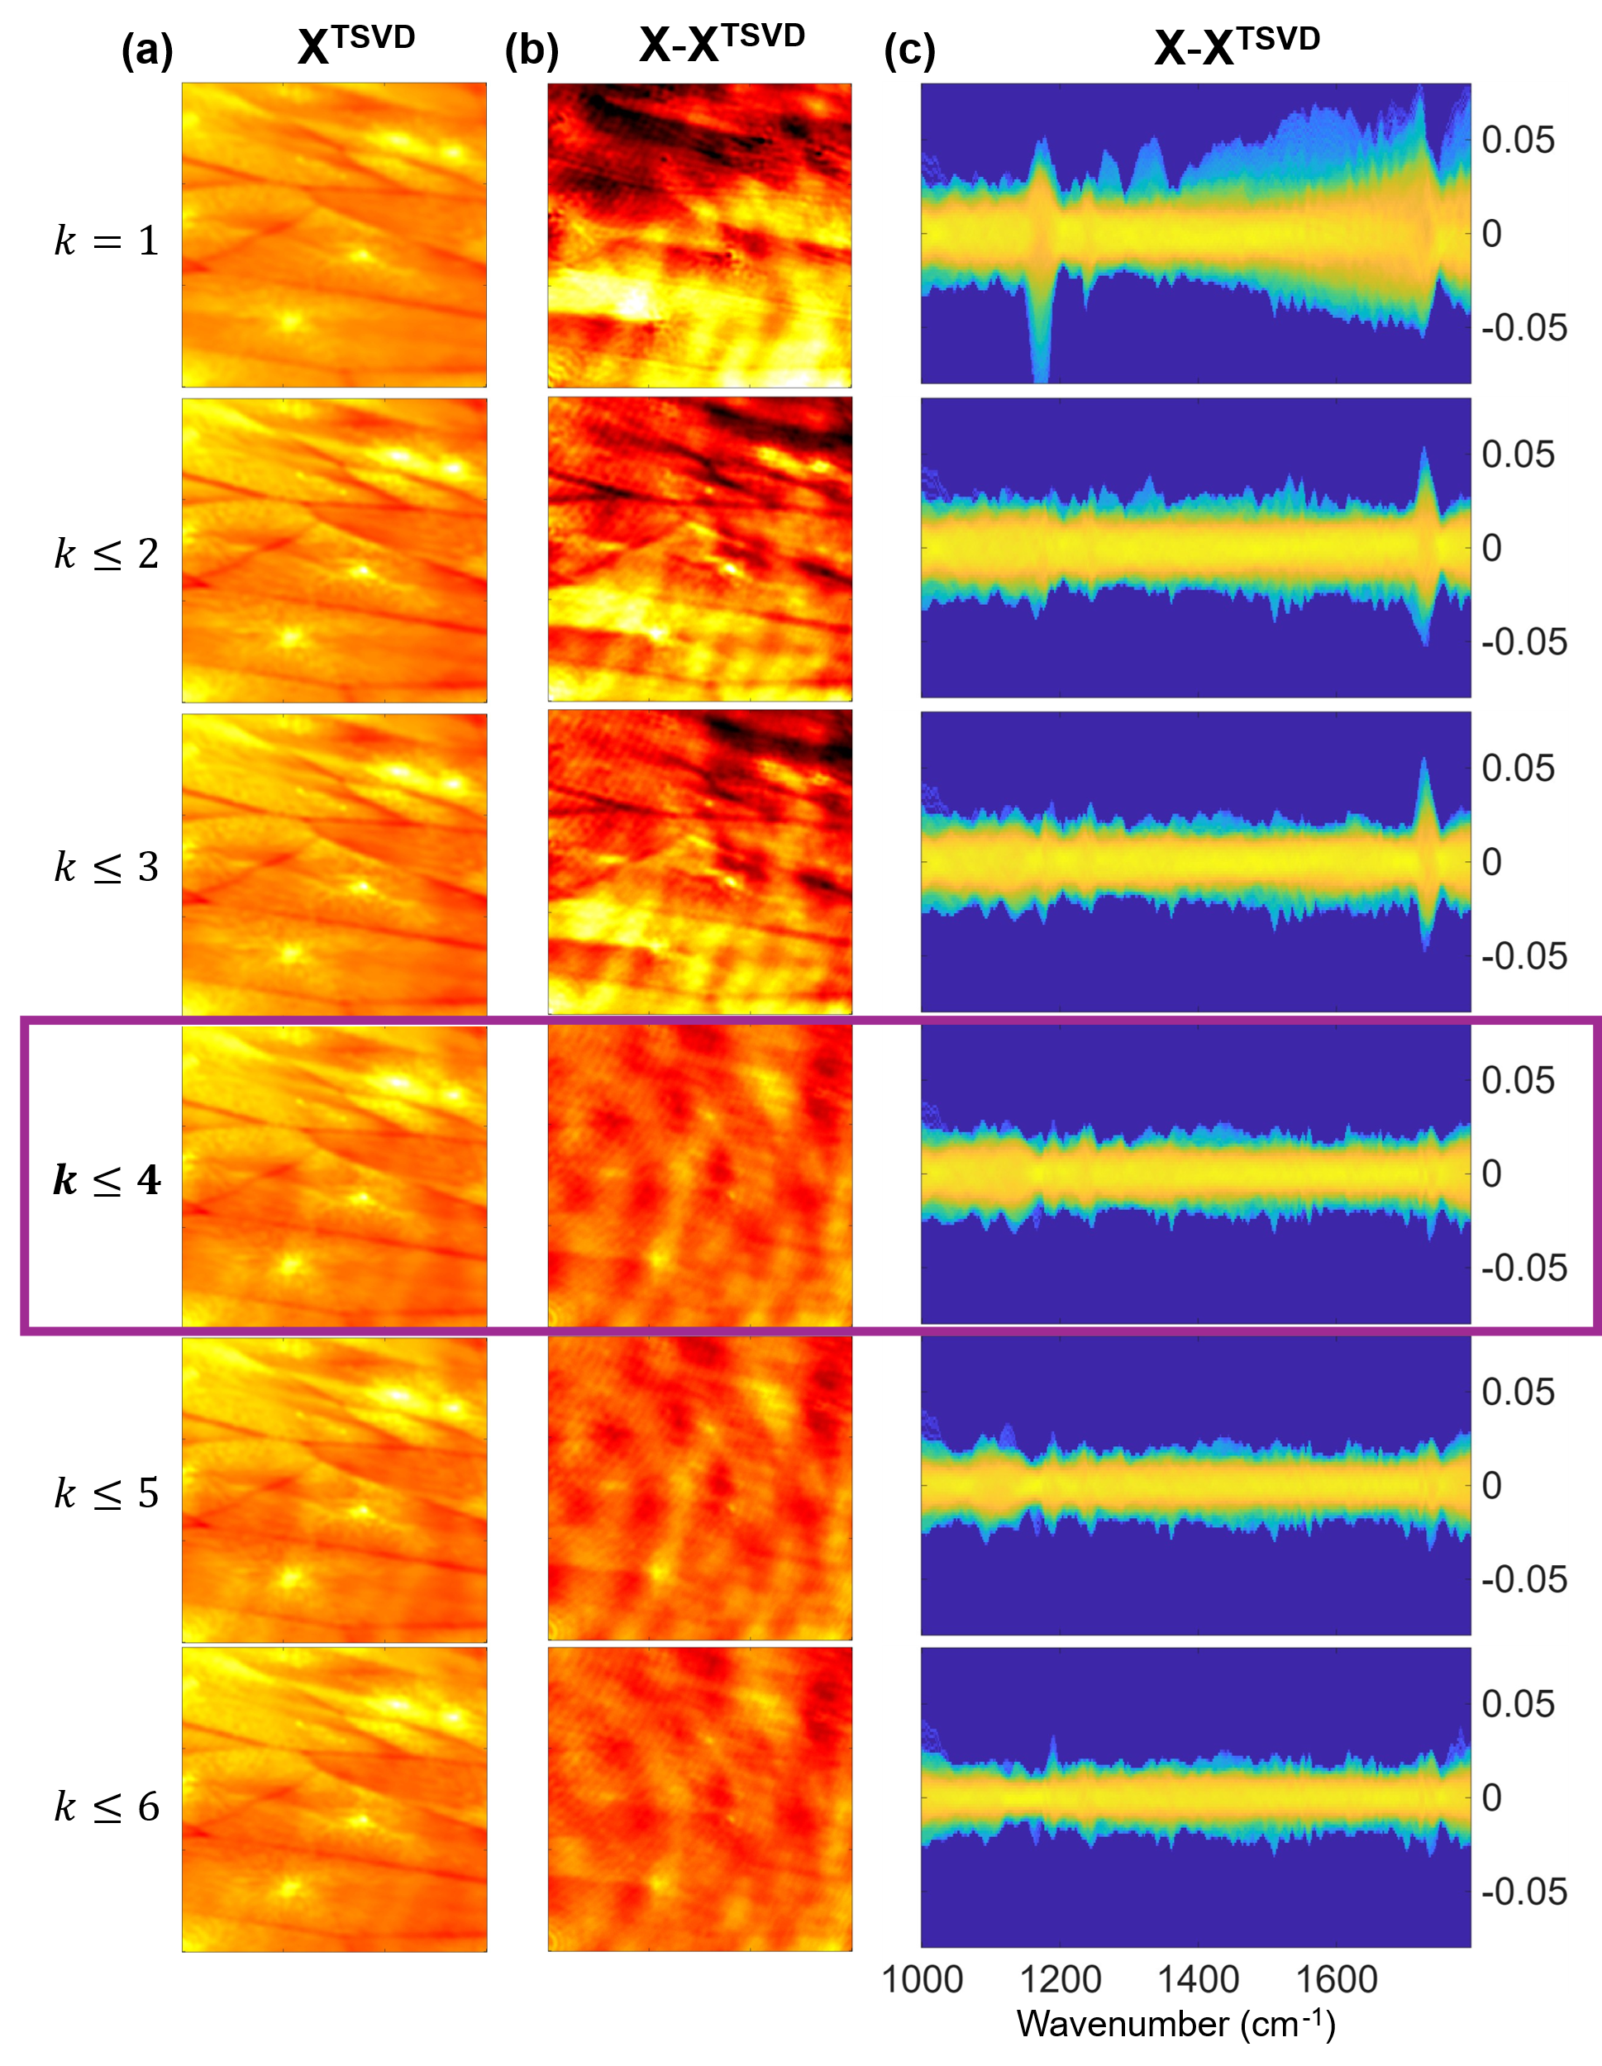
Figure 9. (a) TSVD-processed images (X^{TSVD}) at 1730 cm⁻¹ for various SVs, ($k=1$) to ($k≤6$). (b) Difference images (X – X^{TSVD}) representing the eliminated signals by the corresponding TSVD process. (c) Contour maps of the difference spectra (X – X^{TSVD}) accumulated over the entire image pixels, illustrating the spectral components eliminated by the corresponding TSVD process.

After examining the SVD and TSVD outputs for various 𝑘, we find that processing the TSVD with 𝑘≤4 effectively removes the fringes without significantly losing the sample’s resonant spectral information. The $X^{\text{TSVD}}$ images retrieved with $k≤4$, as shown in Fig. 10(b), show greatly suppressed fringes, including the fine fringes in the inset image, compared to the corresponding original $X$ images in Fig. 10(a). Figure S3 shows the $X$ and $X^{\text{TSVD}}$ images at seven different wavenumbers, demonstrating that the fringe suppression by TSVD is effective even though traces of fringes are still recognizable in some of the $X^{\text{TSVD}}$ images. Meanwhile, the $X^{\text{TSVD}}$ spectra at the four pixels in Figs. 10(c) and 10(e) also show significantly reduced interference contributions in their baselines. In Figs. 10(d) and 10(f), the difference between the pairs at out-of-phase fringe locations (A vs. B; and C vs. D) approaches zero, indicating that the fringe-associated spectral difference is greatly reduced compared to the original data in Figs. 7(c) and 7(e). It is noted that we cannot quantify the efficiency of fringe suppression or the loss of resonant absorption information because we do not have the interference-free image data of the identical film sample. However, the $X^{\text{TSVD}}$ results in Fig. 10 demonstrate that the TSVD method, a simple numerical process, can effectively suppress fringes in HSI data from an unknown sample without prior knowledge of the sample spectrum, film geometry, or imaging system details.

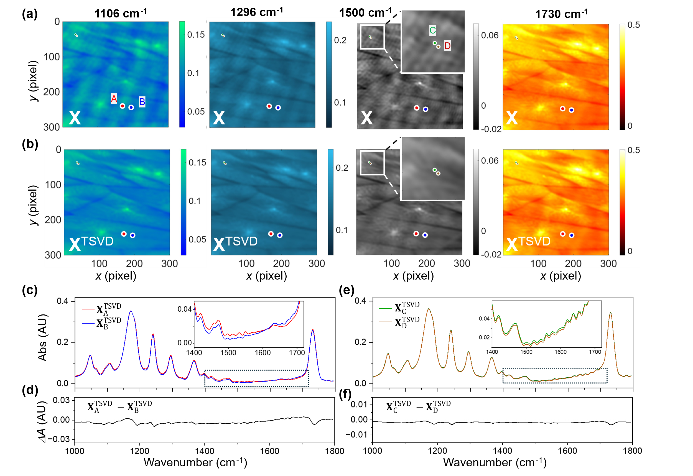
Figure 10. Comparison of the sheared PCL HSIs at the representative wavenumbers (a) before and (b) after the TSVD process. (c, d) TSVD-processed IR spectra at the pixels (c) A and B, and (d) C and D, as marked in (a-b). (e, f) Difference spectra between (e) pixels A and B, and (f) pixels C and D, after the TSVD process.

- Discussion
So far, we have shown that a TSVD method can suppress fringes in HSI data with minimal loss of resonant spectral information when proper SV indices are selected. This approach is based on differences in the SVD factorizations between the resonant spectra of a sample and those of fringe interference. As shown in the SVD results of the earlier simulation data, the $S_{k}$ values corresponding to a resonant spectral image concentrate tightly within a small number of indices. The $S_{k}$ breadth of a resonant spectral image depends on the number of independent spectral components. Meanwhile, the $S_{k}$ values corresponding to fringe interferences stretch to high indices because the periods and phases of fringe modes vary in different wavenumber images due to a variable air gap. TSVD takes advantage of this difference in the $S_{k}$ breadth to keep the SVs filled with resonant spectral information and to truncate the SVs containing fringe contributions. Thus, fringe suppression by TSVD can become more effective when (1) the resonant spectral image corresponds to more concentrated $S_{k}$, and (2) the fringe interferences correspond to more extended $S_{k}$. The number of major independent spectral components in the sample determines the breadth of principal $S_{k}$ from the resonant spectral image. If a sample contains a small amount of chemical impurities or structural abnormalities, their corresponding $S_{k}$ values will be small and appear at high indices, and it will become difficult to separate the resonant SVs from the fringe SVs. It must also be noted that the TSVD method will not be effective in defringing a HSI acquired from a sample system consisting of many independent spectral components. The mixing of resonant SVs with fringe SVs is shown earlier in the SVD results of the experimental data in Fig. 8.

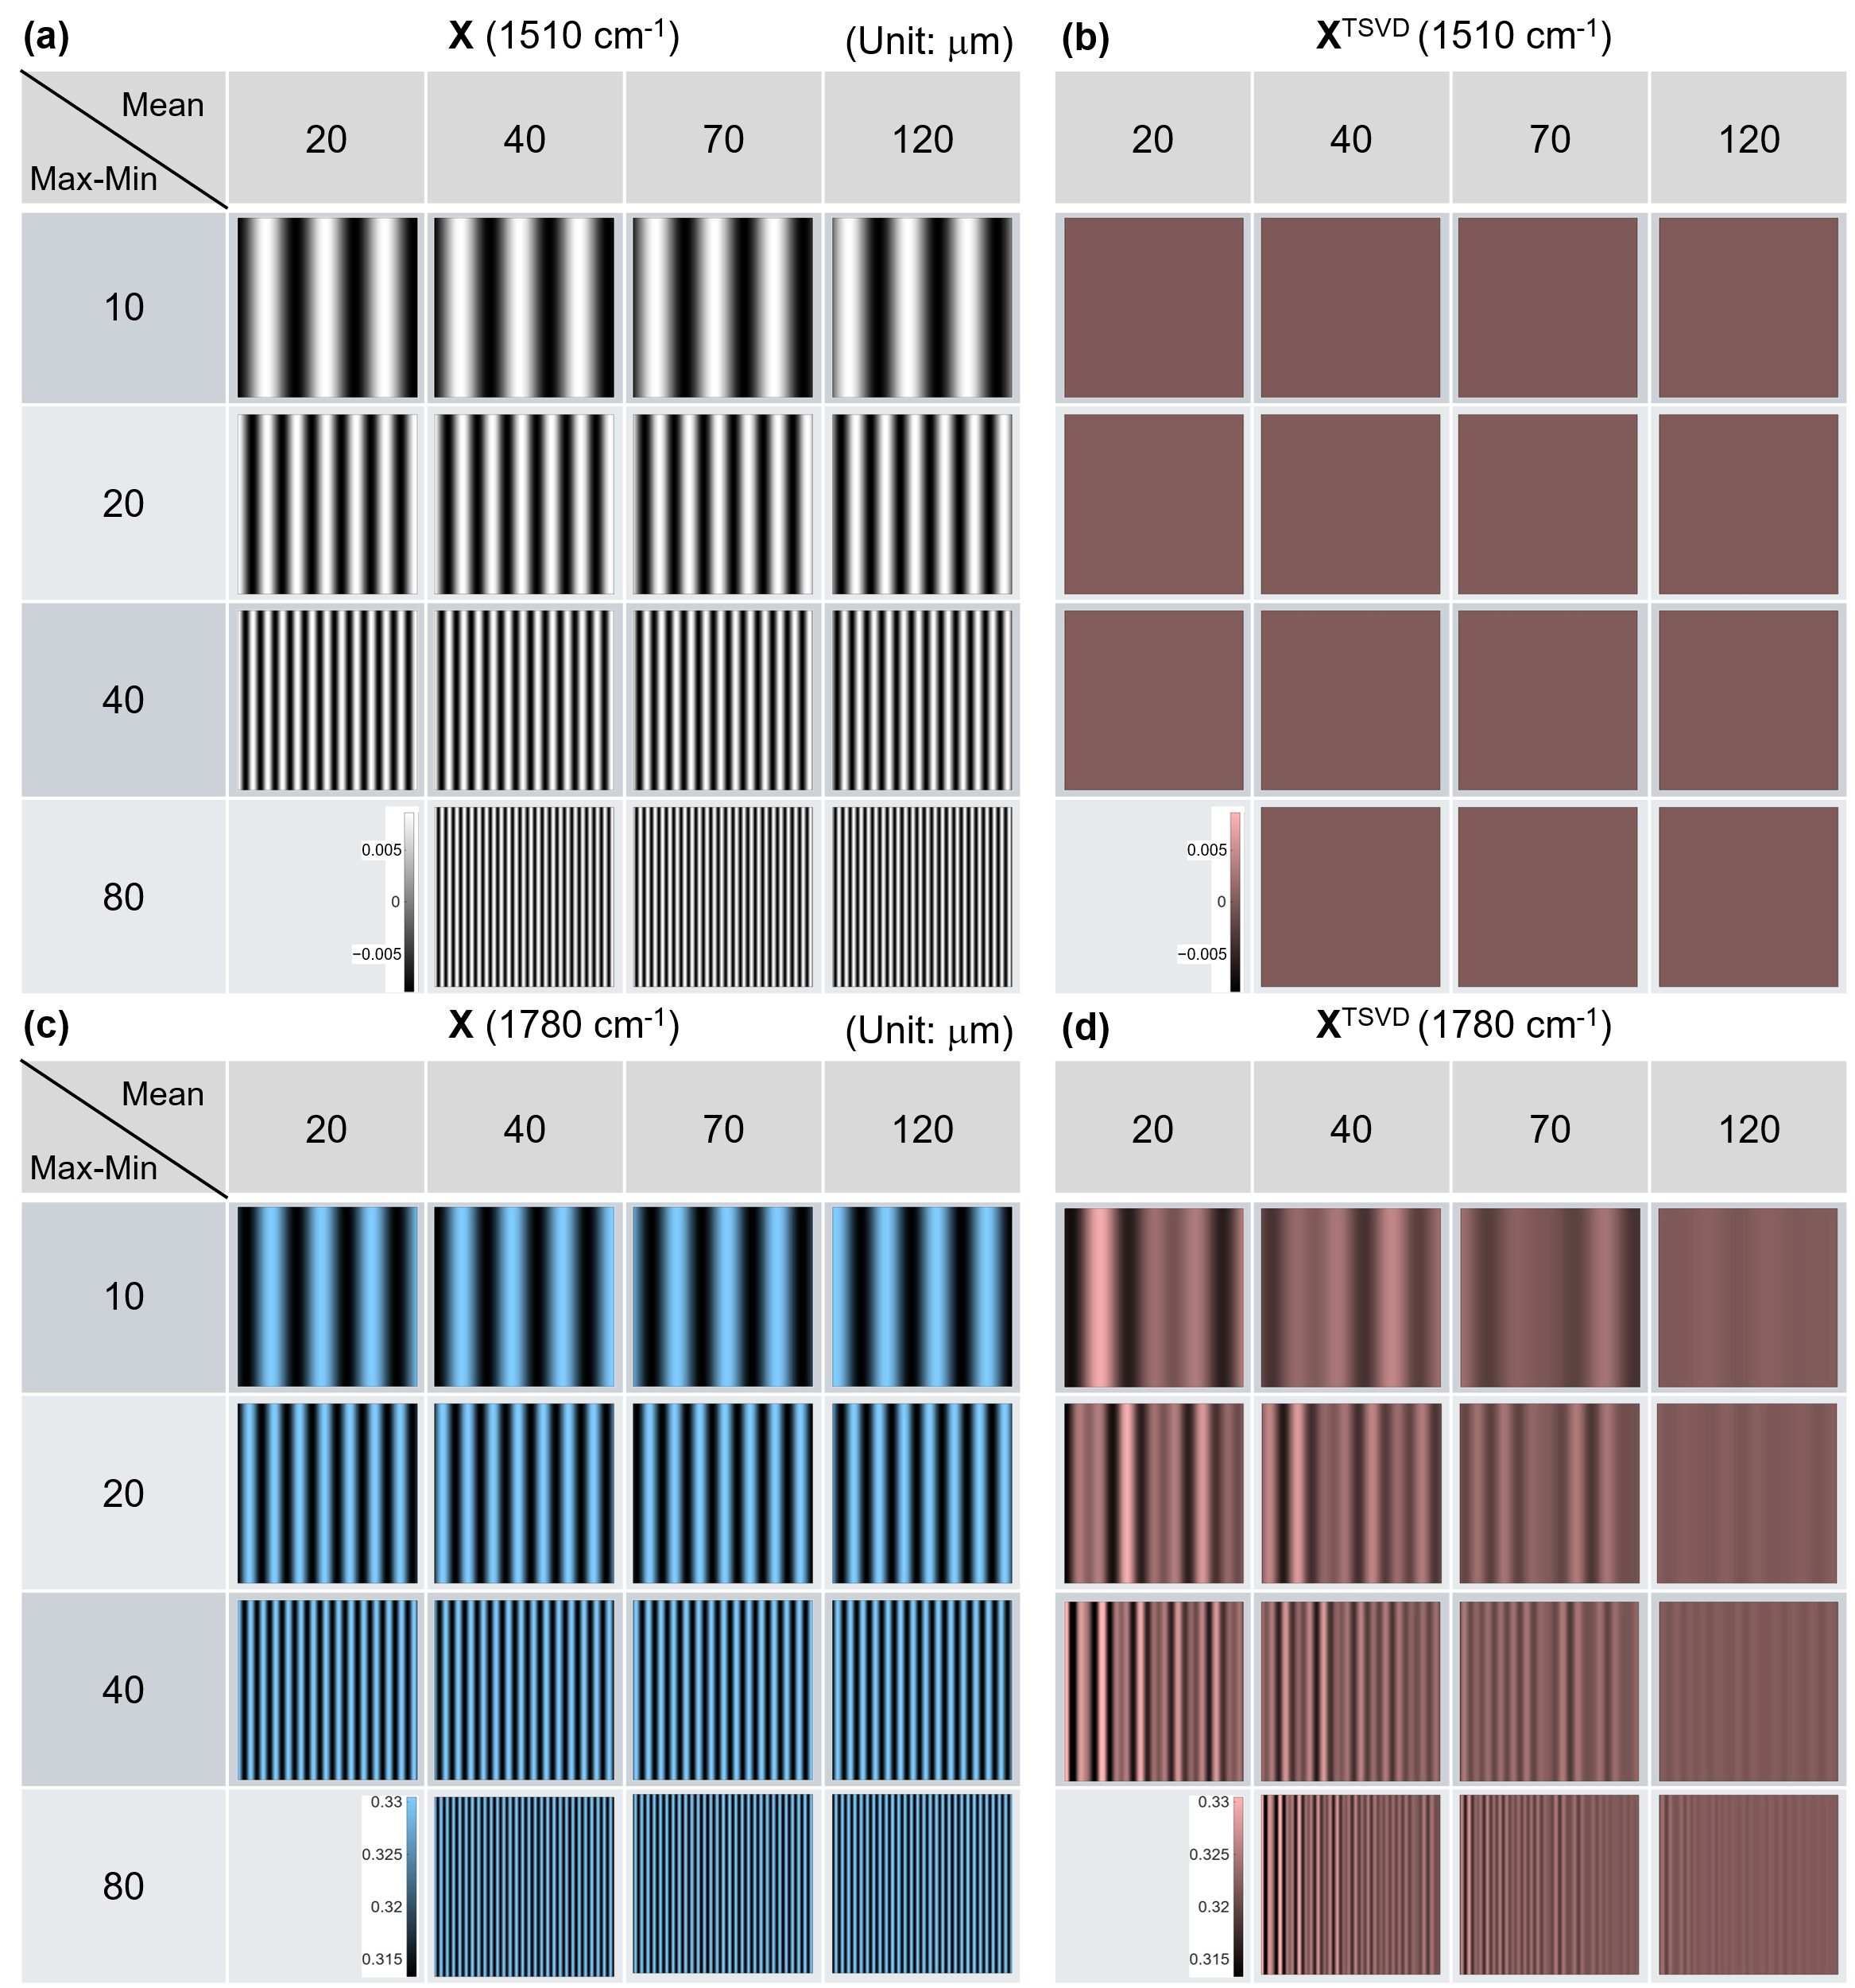
Figure 11. Fringe parameter effect on fringe suppression by the TSVD method. Various HSIs are calculated based on Model UF1 by changing the air-gap slope and the mean air-gap distance. As the Max-Min difference, representing the air-gap slope, increases from 10 μm to 80 μm (columns), the number of fringes increases. Meanwhile, the mean air gap distance increases from 20 μm to 120 μm (rows), not changing the number of fringes but increasing the undulation frequency of a spectral baseline (not shown here). (a) Original absorbance image (X) at an off-resonant frequency (1510 cm⁻¹) and (b) its corresponding TSVD-processed image (X^{TSVD}). (c) Original absorbance image (X) at a resonant frequency (1780 cm⁻¹) and (b) its corresponding TSVD-processed image (X^{TSVD}).

Now, we examine which properties of the fringe affect the TSVD’s performance in suppressing them. We generate HSIs by combining four mean distances and four air-gap differences across the image. We use the film spectrum from Model UF1 in Fig. 1(a) and assume the reference beam is interference-free for simplicity. Figure 11 shows a table of the $X$ and $X^{\text{TSVD}}$ images at 1510 cm⁻¹ for an off-resonant baseline and 1780 cm⁻¹ for a resonant peak. As the air gap difference (= Max – Min) increases from 10 μm to 80 μm, the number of fringes increases eightfold in the $X$ images, shown in Figs. 11(a) and 11(c). Meanwhile, a sixfold increase in the mean distance does not affect fringe spacings; instead, interference undulations increase in the spectra, which is not displayed here. First, the $X^{\text{TSVD}}$ images at 1510 cm⁻¹ in Fig. 11(b) show very effective fringe suppression in all fringe parameter combinations, while those at 1780 cm⁻¹ in Fig. 11(d) show remaining fringes. Interestingly, as the mean air gap increases, fringe suppression becomes more effective. The mean air gap distance does not affect the fringe pattern but alters the undulation frequency in spectra. On the other hand, increasing the air gap difference, which increases the number of fringes, does not appear to affect the fringe suppression efficiency. As a result, TSVD can suppress fringes more effectively with more spectral undulations than with more spatial fringes. This is further confirmed by testing varying minimum air gap distances at a constant air gap range (Fig. S4), which identifies spectral undulation density as the critical factor for TSVD efficacy. This interesting TSVD dependence on fringe parameters must be due to the complex coupling of spatial and spectral variations in a HSI.
Earlier models used to generate HSIs assume that the reflection coefficient of a sample film is constant with wavenumber. However, the reflection coefficient of a real film can vary with wavenumber. For example, when the absorption coefficient of a sample is high, the refractive index can change near the absorption peak due to the Kramers-Kronig relation, resulting in a dispersive-shaped reflection coefficient. Also, multiple reflections within a sample film can result in a reduction in the effective transmission coefficient and reflection coefficient at the film’s resonant absorption frequencies. Other complex factors that can affect the TSVD efficiency of fringe suppression include lateral/axial chromatic aberrations, discrepancies in the diffraction limit of widely varying wavelengths, Mie scattering depending on the film morphology and texture. Despite the various types of spatial-spectral couplings in a HSI, this straightforward TSVD process can effectively suppress fringes without iterative fitting or other nonlinear data processing, as demonstrated by the experimental results in the Results section.

- Conclusion
Hyperspectral imaging (HSI) in the mid-IR region, powered by coherent light sources, has the potential to enable label-free chemical fingerprint mapping. Still, its efficacy can be hampered by optical interference fringes due to the etalon effect. These artifacts distort resonant absorption features and obscure vital spatial information, ultimately preventing accurate quantitative analysis and proper image interpretation. This study introduces an unsupervised, data-driven approach based on truncated SVD to isolate the resonant signals, localized to a few low-rank singular values, from the optical interference fringes spanning higher-order singular values. The performance has been demonstrated with both complex synthetic models and an experimental image. By retaining only the proper signal-carrying singular values, the TSVD method effectively suppresses complex spatial fringes and restores accurate spectral profiles with minimal loss of meaningful resonant information. Ultimately, this research delivers a robust, practical numerical solution that enables accurate chemical mapping of completely unknown samples with minimum supervision.

Disclosure. The authors declared no conflicts of interest. Certain commercial equipment, instruments, or materials are identified in this paper to foster understanding. Such identification does not imply endorsement by NIST, nor does it imply that the materials or equipment identified are necessarily the best available for the purpose. Official contribution of the National Institute of Standards and Technology; not subject to copyright in the United States.
Data availability. Data underlying the results presented in this paper are not publicly available at this time but may be obtained from the authors upon reasonable request.
Acknowledgment. Dabin Kim was financially supported by the NIST Circular Economy Program.

Reference
1. A. Jullien, R. Pascal, U. Bortolozzo, N. Forget, and S. Residori, "High-resolution hyperspectral imaging with cascaded liquid crystal cells," Optica 4(4), 400–405 (2017).
2. D. Knez, B. W. Toulson, A. Chen, M. H. Ettenberg, H. Nguyen, E. O. Potma, and D. A. Fishman, "Spectral imaging at high definition and high speed in the mid-infrared," Sci. Adv. 8(46), eade4247 (2022).
3. M. H. Tran, L. Ma, M. Yuan, and B. Fei, "Medical hyperspectral imaging: an updated review of technology advancements and biomedical applications," J. Biomed. Opt. 31(03), 030901 (2026).
4. J. Zhao, A. Matlock, H. Zhu, Z. Song, J. Zhu, B. Wang, F. Chen, Y. Zhan, Z. Chen, Y. Xu, X. Lin, L. Tian, and J.-X. Cheng, "Bond-selective intensity diffraction tomography," Nat Commun 13(1), 7767 (2022).
5. P. Koziol, D. Liberda, W. M. Kwiatek, and T. P. Wrobel, "Macromolecular Orientation in Biological Tissues Using a Four-Polarization Method in FT-IR Imaging," Anal. Chem. 92(19), 13313–13318 (2020).
6. H. Tiernan, B. Byrne, and S. G. Kazarian, "ATR-FTIR spectroscopy and spectroscopic imaging for the analysis of biopharmaceuticals," Spectrochimica Acta Part A: Molecular and Biomolecular Spectroscopy 241, 118636 (2020).
7. M. C. Phillips and N. Hô, "Infrared hyperspectral imaging using a broadly tunable external cavity quantum cascade laser and microbolometer focal plane array," Opt. Express 16(3), 1836–1845 (2008).
8. T. P. Wrobel, P. Mukherjee, and R. Bhargava, "Rapid visualization of macromolecular orientation by discrete frequency mid-infrared spectroscopic imaging," Analyst 142(1), 75–79 (2017).
9. K. Yeh, I. Sharma, K. Falahkheirkhah, M. P. Confer, A. C. Orr, Y.-T. Liu, Y. Phal, R.-J. Ho, M. Mehta, A. Bhargava, W. Mei, G. Cheng, J. C. Cheville, and R. Bhargava, "Infrared spectroscopic laser scanning confocal microscopy for whole-slide chemical imaging," Nat Commun 14(1), 5215 (2023).
10. T. Konevskikh, A. Ponossov, R. Blümel, R. Lukacs, and A. Kohler, "Fringes in FTIR spectroscopy revisited: understanding and modelling fringes in infrared spectroscopy of thin films," Analyst 140(12), 3969–3980 (2015).
11. U. Schade, D. Cao, L. Puskar, E. Ritter, and J. Beckmann, "Removal of Etalon Features in the Far-Infrared–Terahertz Transmittance Spectra of Thin Polymer Films," Appl Spectrosc 74(12), 1530–1539 (2020).
12. J. L. Martínez, I. Moreno, M. Del Mar Sánchez-López, A. Vargas, and P. García-Martínez, "Analysis of multiple internal reflections in a parallel aligned liquid crystal on silicon SLM," Opt. Express 22(21), 25866–25879 (2014).
13. G. Azarfar, E. Aboualizadeh, N. M. Walter, S. Ratti, C. Olivieri, A. Norici, M. Nasse, A. Kohler, M. Giordano, and C. J. Hirschmugl, "Estimating and correcting interference fringes in infrared spectra in infrared hyperspectral imaging," Analyst 143(19), 4674–4683 (2018).
14. J. H. Solheim, F. Borondics, B. Zimmermann, C. Sandt, F. Muthreich, and A. Kohler, "An automated approach for fringe frequency estimation and removal in infrared spectroscopy and hyperspectral imaging of biological samples," Journal of Biophotonics 14(12), e202100148 (2021).
15. S. Ran, S. Berisha, R. Mankar, W.-C. Shih, and D. Mayerich, "Mitigating fringing in discrete frequency infrared imaging using time-delayed integration," Biomed. Opt. Express 9(2), 832–843 (2018).
16. A. Schönhals, N. Kröger‐Lui, A. Pucci, and W. Petrich, "On the role of interference in laser‐based mid‐infrared widefield microspectroscopy," Journal of Biophotonics 11(7), e201800015 (2018).
17. F. R. S. Clark and D. J. Moffatt, "The Elimination of Interference Fringes from Infrared Spectra," Appl Spectrosc 32(6), 547–549 (1978).
18. C. Robertson, "Theory and practical recommendations for autocorrelation-based image correlation spectroscopy," J. Biomed. Opt 17(8), 080801 (2012).
19. A. M. A. Pistorius and W. J. DeGrip, "Deconvolution as a tool to remove fringes from an FT-IR spectrum," Vibrational Spectroscopy 36(1), 89–95 (2004).
20. W. Ren, Q. Cao, D. Wu, J. Jiang, G. Yang, Y. Xie, and S. Zhang, "Wavelet transform based defringing in interference imaging spectrometer," Opt. Express 25(15), 17039–17050 (2017).
21. I. Amidror, "Fourier spectrum of radially periodic images," J. Opt. Soc. Am. A 14(4), 816–826 (1997).
22. M. F. Faggin and M. A. Hines, "Improved algorithm for the suppression of interference fringe in absorption spectroscopy," Review of Scientific Instruments 75(11), 4547–4553 (2004).
23. J. H. Solheim, B. Zimmermann, V. Tafintseva, S. Dzurendová, V. Shapaval, and A. Kohler, "The Use of Constituent Spectra and Weighting in Extended Multiplicative Signal Correction in Infrared Spectroscopy," Molecules 27(6), 1900 (2022).
24. H. Martens, J. P. Nielsen, and S. B. Engelsen, "Light Scattering and Light Absorbance Separated by Extended Multiplicative Signal Correction. Application to Near-Infrared Transmission Analysis of Powder Mixtures," Anal. Chem. 75(3), 394–404 (2003).
25. V. Tafintseva, T. A. Lintvedt, J. H. Solheim, B. Zimmermann, H. U. Rehman, V. Virtanen, R. Shaikh, E. Nippolainen, I. Afara, S. Saarakkala, L. Rieppo, P. Krebs, P. Fomina, B. Mizaikoff, and A. Kohler, "Preprocessing Strategies for Sparse Infrared Spectroscopy: A Case Study on Cartilage Diagnostics," Molecules 27(3), 873 (2022).
26. S. Feng, Q. Chen, G. Gu, T. Tao, L. Zhang, Y. Hu, W. Yin, and C. Zuo, "Fringe pattern analysis using deep learning," Adv. Photon. 1(02), 025001 (2019).
27. S. Guo, T. Mayerhöfer, S. Pahlow, U. Hübner, J. Popp, and T. Bocklitz, "Deep learning for ‘artefact’ removal in infrared spectroscopy," Analyst 145(15), 5213–5220 (2020).
28. R. E. Roger, "A faster way to compute the noise-adjusted principal components transform matrix," IEEE Trans. Geosci. Remote Sensing 32(6), 1194–1196 (1994).
29. C. H. Camp Jr., J. S. Bender, and Y. J. Lee, "Real-time and high-throughput Raman signal extraction and processing in CARS hyperspectral imaging," Opt. Express 28(14), 20422–20435 (2020).
30. F. Masia, A. Glen, P. Stephens, P. Borri, and W. Langbein, "Quantitative Chemical Imaging and Unsupervised Analysis Using Hyperspectral Coherent Anti-Stokes Raman Scattering Microscopy," Anal. Chem. 85(22), 10820–10828 (2013).
31. J. M. Bioucas-Dias and J. M. P. Nascimento, "Hyperspectral Subspace Identification," IEEE Trans. Geosci. Remote Sensing 46(8), 2435–2445 (2008).
32. N. Keshava and J. F. Mustard, "Spectral unmixing," IEEE Signal Process. Mag. 19(1), 44–57 (2002).
33. H. Andrews and C. Patterson, "Singular value decompositions and digital image processing," IEEE Trans. Acoust. Speech Signal Process. 24(1), 26–53 (1976).
34. S. Xu, C. R. Snyder, J. Rowlette, and Y. J. Lee, "Three-Dimensional Molecular Orientation Imaging of a Semicrystalline Polymer Film under Shear Deformation," Macromolecules 55(7), 2627–2635 (2022).
35. S. Xu, J. Rowlette, and Y. J. Lee, "Imaging 3D molecular orientation by orthogonal-pair polarization IR microscopy," Opt. Express 30(6), 8436–8447 (2022).
36. Y. J. Lee, "Determining 3D molecular orientation from polarization-IR spectra: tutorial," J. Opt. Soc. Am. A 42(2), 102–112 (2025).

