Prior infection of harlequin toads by Batrachochytrium dendrobatidis alters their immune-microbial state and increases mortality upon re-infection

Short title: Interactions among pathogen, host immune system and skin microbes.

Authors: Brian Gratwicke ^{¶ 1}*, Owen G. Osborne ^{¶ 2}, Arik Hartmann¹, Nicolette Ávila³, Eric Baitchman⁴, Gina Della Togna^{3,5}, Yimairi Figueroa³, Jorge Guerrel³, Estefany Illueca³, Luke Linhoff¹, Joseph D. Madison^{1,3}, Amy Ellison², Leon Grayfer⁶, Roberto Ibáñez³, Carly R. Muletz-Wolz^{1,7}

Affiliations:
¹ Smithsonian’s National Zoo and Conservation Biology Institute, Washington DC, USA
² School of Environmental and Natural Sciences, Bangor University, Bangor, Gwynedd, UK
3 Smithsonian Tropical Research Institute, Panama City, Panama
4 Zoo New England, Boston, MA, USA
⁵ Amphibian Survival Alliance
6 George Washington University, Washington DC, USA
⁷ National Institute of Standards & Technology, Gaithersburg, MD

¶ These authors contributed equally to this work.
* Corresponding Author
Email: gratwickeb@si.edu

Abstract
Strategies to improve survival of wildlife impacted by emerging infectious disease are needed for species of conservation concern. We investigated how prior infection by the skin fungal pathogen, Batrachochytrium dendrobatidis (Bd), affected subsequent disease outcomes in a highly susceptible and critically endangered toad, Atelopus glyphus. Our experimental design consisted of: 1) Bd infection followed by itraconazole clearance and Bd re-infection (Bd-Bd n = 20), 2) mock infection followed by itraconazole treatment and Bd infection (mock-Bd n = 20), 3) Bd infection followed by itraconazole clearance and mock infection (Bd-mock n = 10), 4) mock infection followed by itraconazole treatment and mock infection (mock-mock n = 10), 5) untreated animals (untreated n = 10). Prior infection shifted the skin bacterial and fungal communities to a new state enriched in putatively anti-Bd bacteria. However, prior infection worsened disease outcomes, accelerating Bd infection and mortality in prior infected animals compared to naïve animals. Prior infection animals not re-infected (Bd-mock) showed immune gene downregulation compared to re-infected Bd-Bd animals suggesting that even after Bd clearance, Bd caused sustained immunosuppression in genes that respond to Bd; this likely led to lowered immune efficacies when re-infected. Upon re-infection, as Bd load increased, Bd became the primary driver of both immune expression and bacterial composition changes regardless of infection history. Observed bacterial community differences were closely tied to host immune gene expression. The fungal community did not shift in response to re-infection, suggesting that the initial shift was due to itraconazole treatment. Prior infected Bd-Bd animals did not show any novel shifts in immune gene expression, rather they had similar expression patterns that were just more pronounced compared to naïve mock-Bd animal. This suggests that the infection-clearance-infection treatment was ineffective in improving animal survival because there was limited long-lasting effects on immune genes once the pathogen was re-encountered. Unlike previous studies demonstrating protective effects following Bd clearance in other species, this highly susceptible amphibian showed no evidence of acquired resistance. Our results underscore the species-specific nature of disease outcomes and the value of integrative approaches for examining strategies to reduce pathogen susceptibility in endangered wildlife.

Introduction
The amphibian chytrid fungus Batrachochytrium dendrobatidis (Bd) is a skin pathogen associated with the severe decline or disappearance of about 200 amphibian species, primarily in the neotropical genera Atelopus, Craugastor, and Telmatobius (1). Harlequin toads of the genus Atelopus are particularly susceptible to Bd (2–5) and are among the most threatened genus of neotropical amphibians (6), with 93 % of them at risk of extinction (7). Captive assurance colonies of endangered Atelopus have been created to provide us time to develop tools that will mitigate disease threats in the wild (6,8).

Amphibians vary widely in their susceptibility to the amphibian chytrid fungus due to a variety of immune and microbiome characteristics (9–11). In a previous study of Atelopus, a small proportion of frogs cleared a chytrid infection and shared a unique skin microbiome compared to the animals that died (12). It is not clear whether these unique microbiomes are what conferred these animals’ survival or somehow reflect the consequence of their immunologically cleared fungal infection. Notably, manipulating the skin microbiome of harlequin frogs has not been successful at protecting them from disease (5,12,13), but a better understanding of the acquired immune response to Bd could lead us to develop vaccines as potential conservation tools (14). Antifungal vaccines, however, represent a unique research challenge. Even though some antifungal vaccines have been developed for human diseases (15) and one for white-nose syndrome in bats (16), none are commercially available (17).

Prior exposure to Bd followed by heat or drug-mediated clearance have been shown to confer protection to subsequent re-exposure to Bd. This approach has been successful in some evolutionarily disparate species (18–20) but not in others (2,21–23). Similarly, exposure to killed Bd or Bd products (18,24) has had beneficial effects in some studies but not others (14). The precise mechanisms responsible for these disparate effects are not well characterized, but prophylaxis treatment was observed to increase the proportion of putatively anti-Bd bacteria in the skin microbiome in one study (25), indicating a potential mechanism for these observations.

The immune response needed to fight fungal infections are complex. In frogs, one MHC-II β1 marker appears to be under strong selection for resistance to Bd (26,27), and certain alleles could potentially prevent the harmful cascades associated with a damaging overactive immune response (28). Overactive acquired immune responses are often associated with Bd susceptible species and individuals (2,9,29). Bd-tolerant species, however, may have no response to the pathogen (29), or they upregulate immune genes upon initial exposure to the pathogen, then modulate these responses (14). The present study was designed to test prior-exposure prophylaxis in a highly susceptible species and to understand the amphibian skin microbial-immune interface and its impact on Bd infection outcome.

Materials and methods
Animal source and husbandry
All A. glyphus were captive-bred, f2 generation offspring from a single sibling group representing 56 males and 14 females (ZIMS Global Accession Number: QJW21-01460, Local ID: ARC-AGLY-F2-5). The wild source population was originally collected from Cerro Pirre, Darién, Panama in 2010. During the experiment, the animals were fed a mixed diet of fruit flies and crickets ad libitum dusted with a 50:50 mix of Repashy Vitamin A Plus and Calcium with Vitamins. Animals were housed individually at room temperature (mean = 23 °C, range = 17°C to 25 °C) in 8 L plastic enclosures containing an opaque plastic hide and unbleached paper towel substrate soaked in water and misted twice daily. The paper towel substrate was changed three times a week and enclosures were replaced weekly. The source of environmental microbes in these artificially clean enclosures would be derived primarily from the host frog maintaining its microbiome, but may also come from and fecal matter, crickets and fruit flies, reverse osmosis-reconstituted water and the paper towels.

First Bd treatment and antifungal treatment
For Bd treatment 1, we infected 30 animals (Fig. 1) by removing them from their enclosures and placing them in low-profile deli cups containing 30 mL of water and a dose of 300 000 live Bd zoospores applied via pipette directly to their dorsum. We harvested Bd zoospores (strain JEL 423, recently thawed from frozen isolate with minimal passage history) from 1% tryptone agar media plates by flooding them with 3 mL of a sterile 1% tryptone water solution. The shallow container with a lid prevented frogs from climbing and the solution was gently swirled every 30 min. After 3 h the animals were returned to their enclosures with the 30 mL of Bd solution. All animals were placed in clean enclosures with no Bd after 24 h. In parallel, 30 animals from the same cohort were mock-infected (Fig. 1) as above but by washing plates without Bd. One treatment group of 10 animals (untreated control) was not removed from their enclosure. Animals were monitored daily. Fourteen days after exposure, all Bd-challenged animals were swabbed and confirmed Bd positive with Bd qPCR (see methods below) and all the mock-infected frogs were confirmed Bd negative. On the day prior to the first Bd exposure, a microbiome swab was collected from all frogs to characterize both the bacterial and fungal communities on the skin (Fig. 1).

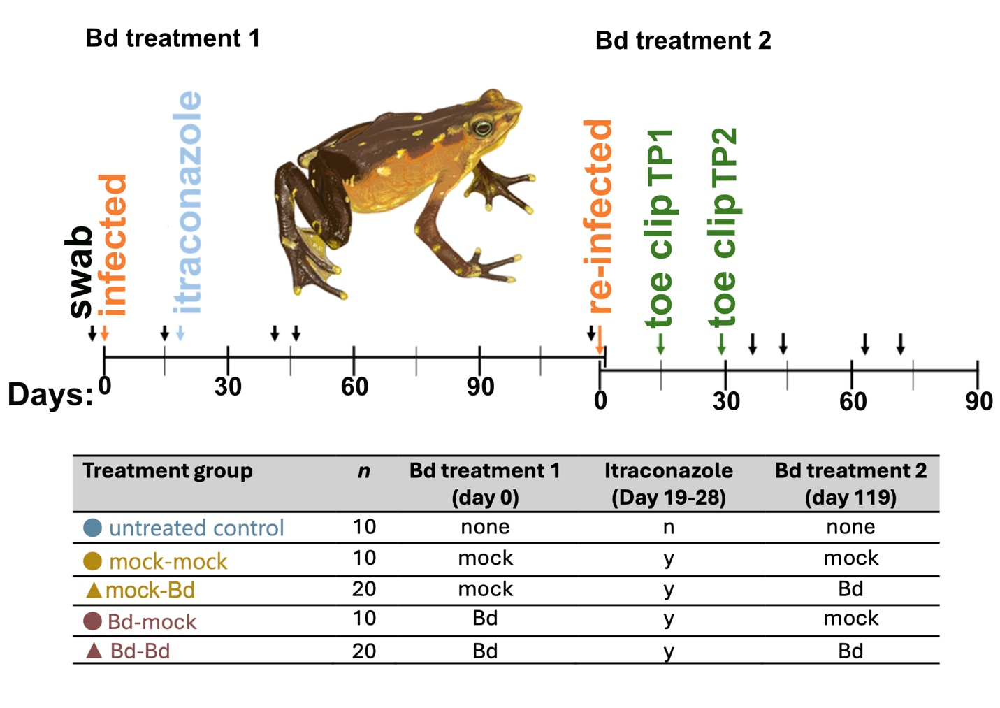
Fig 1. Experimental design and sampling timeline with Pirre Harlequin toad (A. glyphus) and Bd. The entire experiment lasted 200 d and consisted of two experimental sections, Bd treatment 1 and 2. Bd treatment 1 included Bd and mock exposures at day 0 (denoted by orange arrow), clearing infection with itraconazole for 10 d (denoted by blue arrow), swabbing frogs for Bd and microbiomes on multiple days (denoted by black arrows) and concluded at day 118. Bd treatment 2 included Bd and mock exposures at day 0 within this experimental section, toe clips for gene expression at day 14 (TP1) and day 28 (TP2) (denoted by green arrows), swabbing frogs for Bd and microbiomes on multiple days, and concluded at day 82.

Following confirmation of infection, animals in all treatments except the untreated control received an antifungal treatment. Animals were removed from their enclosures and bathed in a 0.005 % aqueous itraconazole solution for 10 minutes for 10 consecutive days on experiment day 18 to day 28 (30). No mortality was observed in any animals. After treatment, all animals were tested for Bd on experiment days 39 and 46, and all animals in all treatments subsequently tested negative for the pathogen. On days 46 and 118 in Bd treatment 1 (18 and 90 d after itraconazole treatment ended, respectively) a microbiome swab was collected from all frogs to characterize both the bacterial and fungal communities on the skin.

Second Bd treatment, microbiome and tissue collection
For Bd treatment 2, on days 119, 20 prior infected and 20 naïve animals were exposed to live Bd (Bd-Bd and mock-Bd) and 10 animals from each group were mock-infected (Bd-mock and mock-mock) (Fig. 1). This counts as day 0 for the second exposure. Fourteen days following reinfection (TP1), all animals were swabbed for microbiome and Bd then toe clipped using scissors cleaned by immersing in bleach, wiping and rinsing with clean water, then dried and wiped with RNase away. All surfaces in the sample collection area were thoroughly cleaned, then dried and wiped down with RNase away. Toe clips were placed in RNAlater (Thermo Fisher Scientific, USA) for 24 h at room temperature, then frozen to –80 °C. After the first death due to chytridiomycosis on day 29 following Bd treatment 2 (TP2), Bd and microbiome swabs were taken, and a second toe clip was taken from all experimental animals. Surviving frogs were also swabbed for Bd on days 36, 43, 64 and 71 after the Bd treatment 2.

Quantification of Bd loads
To detect the presence of Bd and quantify zoospore loads, animals were swabbed with a sterile swab (MW113, Medical Wire and Equipment, Wiltshire, UK) at days 0, 14, 39 and 46 after Bd treatment 1 and at days 0, 14, 21, 29, 36, 43, 64 and 71 after Bd treatment 2 using standard methods. Animals were swabbed using 5 passes of each rear foot, 5 passes of the ventral surface of each thigh, 10 passes of the ventral abdominal surface and 10 passes each flank for a total of 60 passes. Swabs were stored at -20 °C prior to analysis and extracted following Hyatt et al. 2007 (31) then analyzed using a quantitative real-time PCR TaqMan Assay (32). We used a Roche LightCycler 96 System containing 5 μL of sample and 15 μL of a master mix (33). The master mix contained 10 μL of Roche FastStart Essential DNA Probes Master, 0.25 μL of Roche LightCycler Uracil-DNA Glycosylase for avoiding PCR carry over contamination, 0.8 μL of 18 μmol/L ITS1-3 Chytr and 0.8 μL of 18 μmol/L 5.8S Chytr primer solutions, 1 μL of 5 μmol/L ChytrMGB2 probe solution, 2 μL of 10x Exo IPC mix and 0.4 μL of 50x Exo IPC DNA TaqMan Exogenous Internal Positive Control Reagents (Applied Biosystems No. 4308323) for uncovering false negatives due to reaction inhibition (31). Samples were tested in triplicate, and five negative controls and a Bd positive control, were included on each plate (33). Samples with two or three positive reactions were considered Bd positive. Infection load was calculated as the number of zoospore equivalents using tenfold serially diluted standards that ranged from 0.1 zoospore equivalents to 10 000 zoospore equivalents of the JEL 423 Bd strain (originally isolated in Panama) (31). We averaged the quantified values and multiplied them by 100 to compensate for the extraction and dilution of the samples.

Survival analyses
We used the packages Survival ver 3.8 (34) in R (ver 4.3.1, R Core Team, 2021), to calculate and plot Kaplan-Meier survivorship curves for the prior infected Bd+ (Bd-Bd) and naïve Bd+ (mock-Bd) animals. We conducted a log-rank test used to evaluate differences between prior infected and naïve groups. A Cox proportional hazard model evaluated the survival effects of prior infection, sex, weight, Bd load at 14 d after Bd treatment 1, and Bd load at 14 d after Bd treatment 2. Bd loads were standardized by subtracting the mean and dividing by the standard deviation at each time point so that hazard ratios (exponential of the coefficient) could be compared.

Gene expression data collection and analysis
To examine host gene expression, we conducted RNA sequencing (RNAseq) on toe clips sampled at days 14 (TP1) and 29 (TP2) after Bd treatment 2 from all five treatment groups (excluding animals found dead; 135 samples total). To increase the breadth of transcripts in our transcriptome assembly, we also sampled four toes and eight spleens from animals euthanized at the end of the experiment (Supplementary Figure S2). We disrupted samples in 300 μL of RLT buffer (Qiagen) using micropestles (Merck Life Sciences) in a 1.5 mL tubes. We extracted total RNA from the homogenized tissue with EZ2 RNA/miRNA Tissue/Cells Kits (Qiagen) using the EZ2 Connect instrument (Qiagen) according to manufacturer’s instructions. We sent RNA extracts to Azenta Life Sciences for poly-A selection, library construction and sequencing. NovaSeq 2 x 150 libraries (Illumina) were prepared and sequenced on a NovaSeq instrument (Illumina) to produce ~20 million read pairs per sample.

We automated the RNAseq bioinformatic analyses using a custom Snakemake (36) pipeline. We trimmed raw reads and removed adapter sequences using fastp v.0.23.4 (37) using the "detect_adapter_for_pe" setting. To remove rRNA and pathogen-derived reads, we used the program seal from the BBTools package v.37.62 (38) using a speed setting of 15, and seven available Bd genome assemblies (NCBI accessions: GCA_000149865.1, GCA_029704095.1, GCF_000203795.2, GCA_000203795.2_ref, GCA_036289345.1, GCA_003595275.1, GCA_036783925.1) and the SortMeRNA (39) “smr_v4.3_default_db” rRNA database as references. We produced a de novo transcriptome assembly using the combined trimmed data of one sample for each treatment group/time point/tissue combination. For Bd exposed groups, we chose the sample with the highest Bd load and for unexposed groups we chose the sample with the most reads. We generated the transcriptome assembly using Trinity v.2.15.2 (40) with default settings. We used TransDecoder v.5.7.1 (available at https://github.com/TransDecoder) to predict open reading frames (ORFs) and extract predicted peptide sequences, which we functionally annotated using eggNOG-mapper v.2.1.12 (Cantalapiedra et al., 2021) to obtain gene names and gene ontology (GO) terms. We assessed assembly quality and completeness using TransRate v.1.0.3 (41) and BUSCO v.5.8.0 (42) in peptide mode using the “metazoa_odb10” gene set. We quantified transcript expression using Salmon v.1.10.3 (43).

We conducted subsequent RNAseq analyses in R v.4.5.0 (R Core Team, 2025). We imported transcript expression estimates into R using tximport v.1.30.0 (44). We filtered out transcripts with no predicted ORFs before summarizing them to gene level using tximport with the transcript-gene map produced by Trinity. We used DESeq2 v.1.48.1 (45) to identify differentially expressed genes (DEGs) from the toe data using the formula “~ Sex + Trt_TP” (where “Sex” was the animal’s sex and Trt_TP was the combined treatment group and timepoint). We included sex in the model to account for any sex-specific expression patterns. We filtered genes to retain only those with 10 or more reads in 10 or more samples. We used variance stabilizing transformation with the “vst” function from DESeq2 followed by principal component analyses using the “plotPCA” function from DESeq2 to visualize overall expression similarity among samples. To determine whether being previously exposed to Bd affects animals’ transcriptional response when infected with Bd again, we identified DEGs (Supplemental Table S1) between the main four treatment groups (i.e. mock-mock, mock-Bd, Bd-mock, Bd-Bd) for each time point separately, resulting in the following four contrasts: A) mock-mock vs. mock-Bd; B) Bd-mock vs. Bd-Bd; C) mock-Bd vs. Bd-Bd and D) mock-mock vs. Bd-mock. To determine the effect of itraconazole treatment on gene expression we also compared E) mock-mock vs. untreated animals. To identify DEGs consistently related to Bd infection in naïve and prior-exposed animals, we focused on those that showed the same expression pattern in early and late infection (i.e. at both timepoints). By cross-referencing these sets, we identified three classes of DEGs for further interrogation: prior infection specific genes, which were differentially expressed between Bd-mock and Bd-Bd at both timepoints, but not between mock-mock and mock-Bd; current infection specific genes, which were differentially expressed both between Bd-mock and Bd-Bd, and between mock-mock and mock-Bd at both timepoints; and naïve specific genes, which were differentially expressed between mock-mock and mock-Bd at both timepoints, but not between Bd-mock and Bd-Bd). To further examine the expression dynamics of infection specific genes, we calculated the mean scaled expression of each gene across four treatment groups: mock-mock, mock-Bd, Bd-mock, and Bd-Bd. We separated samples by time point and genes by whether they were over or under-expressed according to Bd, and performed paired Wilcoxon signed rank tests across these gene sets comparing: A) mock-mock vs. mock-Bd; B) Bd-mock vs. Bd-Bd; C) mock-Bd vs. Bd-Bd and D) mock-mock vs. Bd-mock. We used these gene set-level comparisons to assess whether there were consistent directional expression shifts across genes, including those which may not have reached the threshold to yield significant DEGs in gene level comparisons. We assessed GO term enrichment in these sets using the topGO package v.2.59.0 (46) and adjusted p-values for multiple testing using the False Discovery Rate method. We also manually curated these sets to only include immune genes and then assigned these immune genes into four broad categories: A) lymphocyte response; B) antimicrobial response; C) immune signaling; and D) immune ligands and receptors. Gene roles were confirmed against published literature. We acknowledge that many immune gene are pleiotropic and some may fit into more than one of the categories demarcated here. Our assignments are based on a combination of the most prominent immune roles associated with respective genes and the most likely context(s) in which they may be involved in context of skin immune responses.

Microbiome analysis
Genomic DNA was extracted from skin swabs collected on days -1, 46 and 118 in Bd treatment 1, and days 14 and 29 in Bd treatment 2 using the DNeasy PowerSoil Pro kit (Qiagen). For bacterial community characterization, the V4–V5 region of the 16S rRNA gene was amplified from samples and controls (negative and positive extraction and PCR controls) using the universal primers 515F-Y and 939R (47). For fungal community characterization, the ITS2 region was amplified from samples and controls (Zymo controls; D6300 (Zymo Community Standard for positive extraction control) and D6305 (DNA standard for PCR positive amplification control) using the universal primers ITS86F and ITS4 (48). The equimolar pooled products from each library (one bacterial library and one fungal library) were individually sequenced on a MiSeq (Illumina) run (2 × 300 V3 kit) at the Center for Conservation Genomics at the Smithsonian National Zoo & Conservation Biology Institute.

Bioinformatics and statistics were performed primarily in R with minor processes in other programs where specified. For bacteria, we used dada2 package (49) to remove primer sequences, low quality reads, filter and trim sequences, and remove chimeric sequences. For fungi, we used CutAdapt (ver 4.9, Martin, 2011) in Python (ver 3.13.0) to remove adaptors and primer sequences and filter reads, then used dada2 for downstream processing. We assigned taxonomy for fungal ASV’s using the UNITE database (ver 8.3, Abarenkov et al., 2024). All ASVs that did not match bacteria or fungi at the kingdom level were removed from downstream analyses, and we also removed any matches for “Batrachochytrium dendrobatidis” at the species-level from fungal reads. After initial sequence processing, we retained 2 171 517 bacterial reads and 3 654 408 fungal reads. We conducted analyses in R using the vegan and phyloseq packages (52,53). Given variation in sequencing depth among samples, we normalized raw sequence counts of bacteria and fungi via rarefaction. Bacterial samples were rarefied to a depth of 2 514 reads per sample, and fungal samples were rarefied to 1 362 reads per sample. We selected rarefaction read count values using rarefaction curve leveling, resulting in a final count of 184 samples for bacteria, and 187 samples for fungi for analyses. We used a custom BLAST in Geneious to match our 16S bacterial reads to the anti-Bd bacterial database 2020 strict version (https://github.com/AmphiBac/AmphiBac-Database) and defined anti-Bd bacterial ASVs as those with 100 % sequence similarity.

Comparing diversity measures and anti-Bd relative abundances
We estimated alpha diversity (ASV richness) for bacteria and fungi using rarefied datasets. For bacteria, we also calculated the relative abundance of anti-Bd bacteria. We checked if ASV richness and anti-Bd relative abundance data were normally distributed using Shapiro tests and confirmed homogeneity of dispersion with Levene’s tests. We log10-transformed variables when necessary to achieve normal distributions. For analyses of Bd treatment 1 samples, we first combined mock-mock with mock-Bd and Bd-mock with Bd-Bd to increase sample size as the second Bd treatment had not occurred yet, equating to mock and Bd treatments, respectively. We examined differences in richness and anti-Bd bacterial relative abundance between treatments within each day using ANOVAs followed by Tukey’s HSD or Kruskal-Wallis tests followed by post-hoc Dunn’s Tests with Bonferroni correction using the FSA package (54), depending on normality. For analyses of Bd treatment 2 samples, we examined differences in richness, composition and anti-Bd bacterial relative abundance among treatment groups using linear mixed-models (LMMs) in the package lme4 (55). Models included treatment group (5 treatments; Fig 1), experiment day (day 14 and day 29) and their interaction as fixed effects, and individual frog ID as a random effect to avoid pseudoreplication. We evaluated model fits by comparing fitted model and predicted residuals, and visually inspecting residual qqplots using the DHARMa package. We conducted post-hoc pairwise tests of significant explanatory variables with estimated marginal means (EMMs) using the emmeans package with Bonferroni corrections (56).

We estimated beta diversity (Jaccard and Bray-Curtis) for bacteria and fungi using rarefied datasets. Jaccard results were similar to Bray-Curtis; Bray-Curtis statistical outputs are reported herein. We then used Principal Coordinate Analyses of Bray-Curtis distances to visualize clustering of bacterial and fungal compositions. To examine differences in beta diversity, we used the “adonis” function in the vegan package (53) to generate PERMANOVAs input with distance matrices. PERMANOVAs included the same explanatory variables previously mentioned: treatment group, experiment day, and we used blocks to account for individual frog ID as a random effect. We performed pairwise comparisons of significant PERMANOVAs using the pairwiseAdonis package (57) with Bonferroni adjusted p-values. For a subset of frogs that were sampled over the entire 200 day experiment in the mock-mock and untreated treatment groups, we examined the effect of experiment day (five time points) using PERMANOVAs with individual frog ID as a random effect.

Relationships between Bd-inhibitory bacteria and microbial richness to severity of Bd infection.
To examine the effects of microbial diversity, function, and treatment on Bd infection, we used linear models (LM) with Bd load as the response variable and included the relative abundance of anti-Bd bacteria and diversity measures as fixed effects. We evaluated model fits by comparing fitted model and predicted residuals, and visually inspecting residual qqplots using the DHARMa package. These models only included treatment groups exposed to Bd and with Bd loads greater than zero. We performed post-hoc pairwise comparisons with a Bonferroni adjustment to compare treatment and infection timepoints using the package emmeans (56). For all analyses, we considered a p-value of < 0.05 as statistically significant.

Integrating gene expression and microbiome data
To investigate the relationship between host gene expression and microbiome, we used a sparse Canonical Correlation analysis (CCA) approach. Low-abundance ASVs present in fewer than 20 % of samples per timepoint were removed. Microbiome matrices were centered log-ratio (CLR) transformed and standardized using the “clr” function in the compositions v2.0-9 R package (58). Variance-stabilized host gene expression data were subset to genes in the prior infection specific or current infection specific sets identified above. To identify gene-microbe correlations independent of infection load (but still prior and current infection specific genes), residuals after regressing out log-transformed Bd-load were used for CCA and gene-microbe correlation analyses.

We used bootstrapped sparse CCA to identify coordinated variation between host gene expression and microbiome composition using the PMA package v.1.2-4 in R (59). Regularization parameters were selected through permutation-based tuning with the “CCA.permute” function in PMA. To quantify stability of the CCA feature selection, we performed a nonparametric bootstrap in which samples were resampled with replacement and sparse CCA was estimated for each bootstrap dataset. For each iteration, rows of the residualized gene expression and microbiome matrices were resampled jointly, preserving sample structure. Sparse CCA was then run for each bootstrap dataset using the CCA function in PMA and the same regularization parameters (penalty_x and penalty_z) selected by permutation tuning of the full dataset, with one canonical component. Across 1 000 bootstrap iterations, we recorded whether each gene or microbial taxon received a non-zero canonical loading, as well as the loading value itself. We then selected stable gene and microbe features which were selected (i.e. had non-zero weights) in at least 40 % of CCA bootstraps at either timepoint. Mean canonical weights across bootstraps were used to compute canonical variates for visualization.

Pearson correlation tests between all pairs of CCA-selected genes and microbial features were conducted for each timepoint using the “rcorr” function from the Hmisc v5.2-3 R package (60), with false discovery rate adjustment of p-values. Correlations significant in both timepoints (adjusted p < 0.05) were retained for network construction and further analysis. A bipartite network was visualized using Gephi v0.1.0 (61) using only significant gene microbe correlations with an absolute correlation > 0.1.

To determine whether gene-microbe correlations differed between treatment groups, we first recalculated correlations using only the samples from each group (treatment:timepoint = 10 groups) using the residualized data. We assessed concordance of correlation signs between treatment groups with Fisher’s exact tests. We assessed the correlation of gene-microbe correlation values between treatment groups using permutation-based correlation tests implemented in the “perm_test” function from the PermCor R package v0.1.0 (62)using Pearson correlation and 1 000 permutations. P-values for correlation and Fishers exact tests were corrected for multiple testing using FDR. Differences in individual gene–microbe correlations between groups were evaluated using Fisher’s Z tests implemented with the “cocor.indep.groups” function in the cocor R package v.1.1-4 (63) with FDR correction of p-values.

Results
Effects of prior Bd exposure on re-exposure disease outcomes
Two weeks following the second Bd treatment, all Bd-exposed animals tested positive for Bd, albeit with great variability, ranging from 198 to 21 940 zoospore equivalents with a mean of 5 278 +/- SD 5 419. After the second Bd treatment, all Bd-exposed animals succumbed to infections (Fig. 2a) whereas all mock-exposed animals remained Bd negative and survived. The Cox Proportional Hazard model indicated that Bd loads at day 14 following the second infection was the most significant variable explaining death (Table 1). This is unsurprising as the most heavily infected animals succumbed more rapidly than those with lower disease loads. However, there was a significant and negative coefficient associated with prior infection, implying that prior infected animals (Bd-Bd treatment group) were negatively affected by their prior infection. There was also a positive correlation between Bd load at first infection and subsequent infection ((r² = 0.28), Supplemental Fig. S1). Previously infected re-challenged animals initially died faster than naïve animals (Fig. 2a, Table 1) and their Bd loads increased more rapidly with infection time (Fig 2b), indicating that prior infection exacerbated re-infections. The apparent dip in Bd infections in the prior infection group towards the end of the experiment (Fig. 2b) is likely due to some highly infected animals dying and being removed from the dwindling pool of surviving animals.

Both infection specific and pre-exposure specific genes were heavily enriched for immune-related GO terms (Supplemental Table S2) including those related to innate immune responses (e.g. pre-exposure specific: “cytokine production involved in immune response”; infection specific: “positive regulation of inflammatory response”) and interleukin signaling (e.g. pre-exposure specific: “interleukin-1 beta production”; infection specific: “interleukin-6-mediated signaling pathway”) in both sets. Additionally, pre-exposure specific genes were enriched for several GO term related to adaptive immunity (e.g. “positive regulation of adaptive immune response based on somatic recombination of immune receptors built from immunoglobulin superfamily domains”; “T cell receptor signaling pathway”). Naïve specific genes were not enriched for any GO terms following adjustment for multiple testing.
Table 1. Cox Proportional Hazards Model showing the influence of predictors on the mortality curve. Hazard ratio is indicated by the exponential (exp) of the coefficient (coef). Standard error (SE) of coefficients are also reported along with the z-score from the model estimates for each covariate. Bd loads were standardized prior to running the model to allow for hazard ratio comparisons, which indicated Bd load at first infection had the strongest effect on the mortality curve followed by Bd load at second infection.
 | coef | exp(coef) | SE(coef) | z | p-value
Prior infection | -5.41 | 224.05 | 2.31 | -2.34 | 0.019 *
Bd load first infection | 2.85 | 17.20 | 1.12 | 2.53 | 0.011 *
Bd load second infection | 2.23 | 9.31 | 0.53 | 4.18 | 2.94e-05 ***
Sex | -0.14 | 0.87 | 1.08 | -0.13 | 0.90
Weight | 0.23 | 1.26 | 0.35 | 0.65 | 0.51

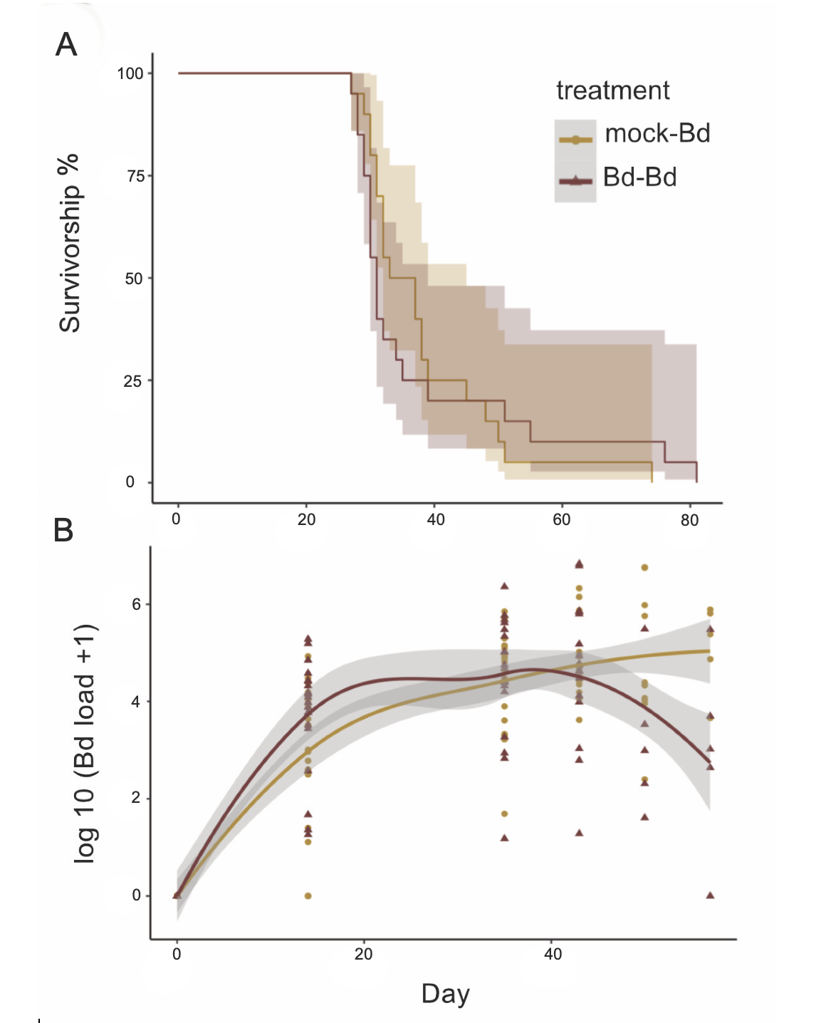
Fig 2. Survivorship and Bd loads over time for 40 Atelopus glyphus infected with Bd at Bd treatment 2 (n = 20 mock-Bd shown as dark crimson triangles and n = 20 Bd-Bd shown as dark goldenrod circles) A) Kaplan meier survivorship curve with 95 % confidence intervals for mock-Bd and Bd-Bd animals. Prior-exposed (Bd-Bd) animals initially died more quickly (Cox Proportional Hazards Model: p = 0.019). B) Bd loads in zoospore equivalents (ZSE) log10 transformed in Bd-Bd animals compared to mock-Bd animals. Line represents smoothed conditional means with 95 % confidence intervals.

Host immune gene expression responses to infection and reinfection
For toe samples, overall variation in gene expression between animals primarily reflected Bd load, rather than prior infection with Bd (Fig. 3). Comparisons between groups sharing the same current infection status, but with different prior exposure produced few DEGs (5 to 74; Fig. S3), especially in late infection (Bd-Bd vs. mock-Bd: TP1 = 74 DEGs; TP2 = 10 DEGs; Bd-mock vs. mock-mock: TP1 = 51 DEGs; TP2 = 5 DEGs), hinting that the effect of prior infection were subtle and likely waned between the first and second timepoints. In contrast, comparisons between groups with different current infection status, but with the same prior exposure yielded a markedly high numbers of DEGs, especially during late-stage infection (Bd-Bd vs. Bd-mock: TP1 = 2 337 DEGs; TP2 = 12 099 DEGs; mock-Bd vs. mock-mock: TP1 = 1 123 DEGs; TP2 = 11 142 DEGs (Supplemental Table S1). We then focused our analyses on subset comparisons of DEGs consistently related to Bd infection in prior infection and current infection animals that showed the same expression pattern in early and late infection. At both timepoints for prior infection specific genes, 311 genes were differentially expressed in response to Bd infection in prior infection animals (Bd-Bd vs. Bd-mock) but not in naïve animals (mock-Bd vs. mock-mock; Supplemental Fig. S4). At both time points for current infection specific genes a larger number of genes, 527 genes, were differentially expressed between currently infected and uninfected groups (DEGs between Bd-mock and Bd-Bd and also between mock-mock and mock-Bd; Supplemental Fig. S4). A smaller set of 57 genes were differentially expressed in response to Bd infection in naïve animals at both timepoints but not in prior infected animals (naïve specific genes). Toe and spleen samples were highly differentiated in overall expression (Supplemental Fig. S2).

To examine the directional shifts in gene expression, we examined scaled mean expression and found consistent, directional shifts in gene expression across genes from the prior infection specific and current infection specific gene sets (Supplemental Figs. S5, S6). For prior infection specific genes, upregulation in response to current Bd infection was the dominant pattern (upregulated: 242/311, 78 %), but downregulation was also a notable feature of prior infection (downregulated: 69/311, 22 %; Supplemental Fig. S5). For current infection specific genes, current Bd infection also caused upregulation (393/527; 75 %) rather than downregulation (134/527; 25 %) compared to mock-infected controls (Supplemental Fig. S6). While the dominant pattern was current Bd infection consistently showing upregulation, prior infection specific genes also showed subtle, but significant differences of lower expression in Bd-mock relative to mock-mock and lower expression in mock-Bd relative to Bd-Bd (Supplemental Fig. S5a,b) with generally similar differences in scaled mean expression observed for current infection specific genes (Supplemental Fig. S6a, b). For genes which were downregulated, the opposite pattern was generally observed (Supplemental Figs. S5c,d; S6c,d). Expression differences in naïve animals following Bd infection (mock-Bd) generally followed the same directional pattern as in prior infected animals (Bd-Bd) but were less pronounced (Supplemental Figs. S5-S6) and were generally insufficient to identify DEGs in the DESeq2 analysis. Together, this suggests that prior Bd infection accentuates the infection-related expression patterns found in naïve animals rather than leading to novel shifts in gene expression.

We manually curated genes in the prior and current infection specific gene sets to only include immune genes categorized into four broad categories, A) lymphocyte response, B) antimicrobial response, C) immune signaling, and D) immune ligands and receptors (Figs. 4-5). For the prior infection specific genes, prior infection caused decreased immune gene expression compared to animals infected with Bd for the first time (Fig. 4, Supplemental Fig. S7). Prior-infected animals (Bd-mock) had substantially reduced expression of genes associated with adaptive immunity, including genes involved in antigen presentation (B2M, HLADRB1, MR1, PSMB8 & 9, TAP1, TAPBP) as well as T (CD3E, CD3D, CD4, ICOS, TRBV251) and B (BCL3, BATF2, BATF3, CD40, CD40LG, IGLV545, IgV) responses (Fig. 4). This indicates that prior infection had lowered frog immune efficacies at the time of re-infection, corroborating that prior infection negatively affected re-infection outcomes (Fig. 2). For the current infection specific gene set, Bd infection again predominately caused increased expression compared to mock-infected animals (Fig. 5; Supplemental Fig. S7). There was a large number of immune signaling genes in this set (e.g. CD109, CEBPB, EHF, IL6ST, IRAK2, STAT3, TIFA) with smaller numbers of genes linked to antimicrobial responses (e.g. IFIH1, NOS2, TM6SF2), lymphocyte response (e.g. CIITA, HLA-DMA, MHCDMB), and immune receptors and ligands (e.g. IL13RA1, IL17C, IL17RA, IL4R; Fig. 5).

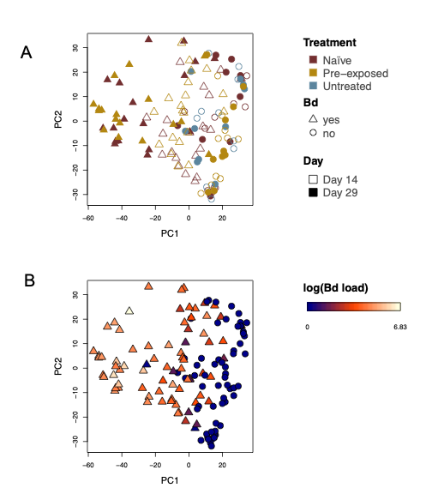
Fig 3. Principal component analysis of gene expression. A) The effect of treatment and infection stage on gene expression in A. glyphus toe clips. Bd treatment 1 groups are shown by color as mock naïve = dark crimson, Bd pre-exposed = dark goldenrod, and untreated = medium blue. Bd treatment 2 groups are shown by shape as Bd = triangle and mock = circle. Day is shown by fill as open = day 14 and closed = day 29. A strong effect of Bd infection was observed on overall gene expression patterns and was unrelated to prior infection. B) The variation in gene expression is related to Bd load reflected in Principal Component axis 1. Colored scale bar represents Bd load log₁₀ transformed. Bd treatment 2 groups are shown by shape as Bd = triangle and mock = circle.
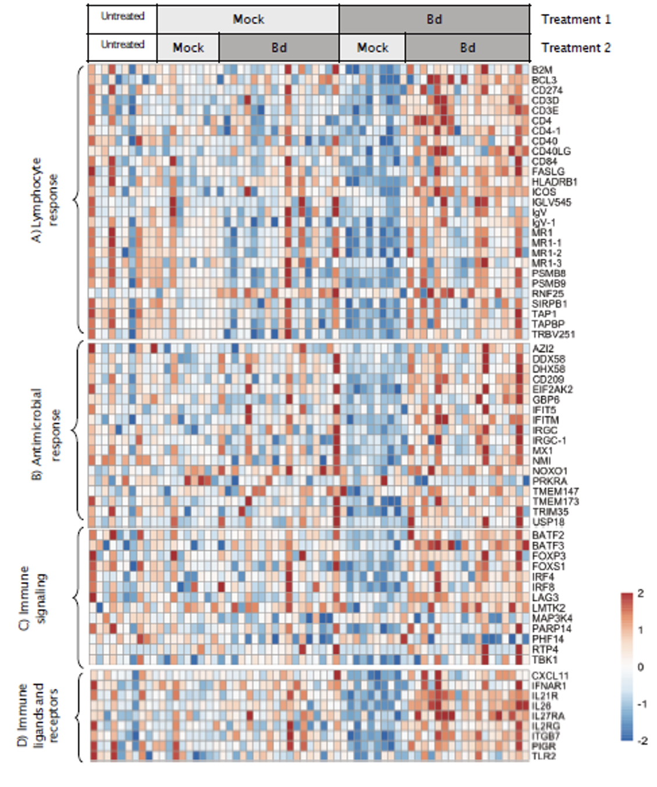
Fig 4. Heatmap of expression patterns for differentially expressed immune genes, organized based on four broad immune gene categories, in the prior infection specific gene set at late infection, day 29 in Bd treatment 2. Prior infection specific gene set are genes that were differentially expressed between prior infection animals (Bd-mock and Bd-Bd), but not between naïve animals (mock-mock and mock-Bd). Colored scale bar represents gene expression values that were scaled per row (i.e. per gene) using Z-scores, which indicate how many standard deviations a gene's expression is from its mean expression across all samples (i.e., -2 to +2).
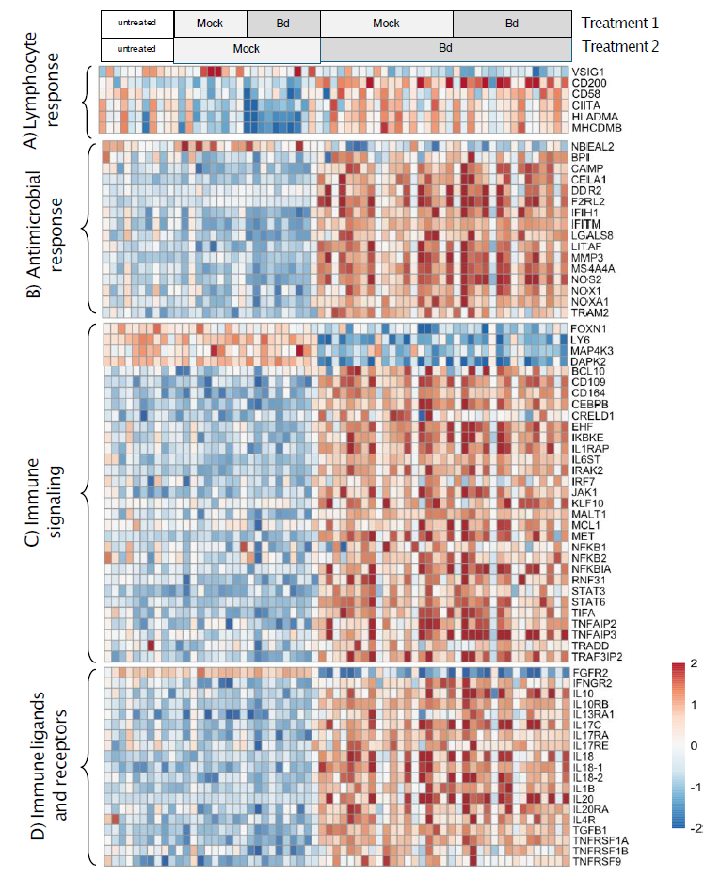
Figure 5. Heatmap of expression patterns for differentially expressed immune genes, organized based on four broad immune gene categories, in the infection specific gene set (i.e. genes that were differentially expressed between all infected vs uninfected comparisons) at late infection, day 29 in Bd treatment 2. Infection specific gene set are genes that were differentially expressed between all currently infected animals (mock-Bd and Bd-Bd) versus uninfected animals (mock-mock and Bd-mock). Colored scale bar represents gene expression values that were scaled per row (i.e. per gene) using Z-scores.

The consequences of itraconazole treatment, Bd infection and reinfection on host microbiomes
Given that we were treating the animals with an antifungal compound, we were first interested in the effects of itraconazole on the microbiome. We compared 10 mock-mock animals treated with itraconazole to the 10 untreated control animals at 1 d before exposure to Bd, 18 d and 90 d post itraconazole in the first Bd treatment section of the experiment. We were unable to analyze the fungal community from the samples taken at 18 d post itraconazole due to low sequence coverage, suggesting that overall fungal abundance was reduced. Bacterial richness was not affected by the itraconazole treatment 18 and 90 d after itraconazole nor was fungal richness at 90 d after timepoint (ANOVAs, Kruskal-Wallis: p > 0.05). However, itraconazole significantly shifted the bacterial composition 18 d post itraconazole treatment (PERMANOVA: Bray-Curtis F = 1.812, p = 0.002; Supplemental Fig. S8). This was only temporary as 90 d following the itraconazole treatment the two groups no longer differed in bacterial or fungal composition (PERMANOVA p > 0.05; Supplemental Fig. S8). Furthermore, itraconazole treatment did not appear to have any long-term effects on overall host gene expression (Supplemental Fig. S10). There were relatively few DEGs related to itraconazole treatment (mock-mock vs. untreated animals: TP1 = 47 DEGs, TP2 = 37 DEGs; Supplemental Fig. S3) and these did not include known immune-related genes

At 90 d after Bd clearance (1 d before Bd treatment 2) prior Bd infection led to persistent changes in the skin bacterial and fungal communities. Prior-exposed animals (Bd-mock and Bd-Bd) possessed distinct changes in their skin bacterial composition (PERMANOVA: Bray-Curtis F = 4.83, p = 0.001; Tukey’s HSD p = 0.003; Fig. 6a, Supplementary S2), skin fungal composition (PERMANOVA: Bray-Curtis F = 2.48, p = 0.001; PERMDISP: F = 11.98, p < 0.001; Tukey’s HSD p < 0.003; Supplemental Fig. S9a). Bd infection followed by clearance led to an average increase in relative abundance of anti-Bd bacteria from 4.4 % in untreated animals to 9.8 % in Bd infected animals prior to re-exposure (Dunn’s test: z = 2.51, p = 0.036; Fig. 6d, Supplemental S3). Prior infection did not affect bacterial or fungal richness (Supplemental Fig. S9b). Fungal richness of Bd naïve animals that were infected for the first time (mock-Bd) was reduced over time by Bd infection (LMM post-hoc p = 0.0058; Supplemental Fig. S9b).

Following Bd treatment 2, the microbiome shifted. At early Bd infection at day 14 after Bd treatment 2, the pre-exposure effect was still present for the bacterial community (PERMANOVA: Bray-Curtis F = 1.644, p = 0.001; Supplemental Table S3) in which mock-Bd and mock-mock animals differed from prior infected Bd-Bd animals (post-hoc p < 0.05). Bd load showed limited effect on bacterial compositional change at day 14 (Fig 6e). However, by day 29 Bd infection drove bacterial composition change (Fig 6c; Supplemental Table S4); while most treatments differed from one another (PERMANOVA: Bray-Curtis F = 2.528, p = 0.001) the Bd infected animals (mock-Bd and Bd-Bd) shared a similar microbiome (pairwise p = 0.36, Fig 6c). In parallel with Bd causing changes to the skin bacterial communities, the relative abundance of anti-Bd bacteria on Bd-Bd animals also decreased by 62 % between days 14 and 29 (EMMs pairwise p = 0.0012; Supplemental Table S5) as infection loads increased (LMM: t = 3.953, p = 0.021; Fig 6c-e; Supplemental Table S5). No differences among treatments were observed for bacterial or fungal ASVs richness (LMMs p > 0.05) or for fungal composition (PERMANOVAs p > 0.05).

We also examined the effect of time on skin bacterial composition across the entire 200 d experiment within mock-mock and untreated treatment groups. We found that bacterial composition did not differ between any time points within these two control groups (PERMANOVAs post-hoc p < 0.05), highlighting that the observed shifts caused by Bd (shown in Figure 6) are a result of the treatment effects rather than the passage of time.

Host gene expression and the microbiome
We used sparse CCA to identify 409 host genes and 154 microbial ASVs (147 bacteria and 7 fungi) that contribute to the major axis of covariation between the transcriptome and microbiome (Supplemental Fig S11; Supplemental Table S6). We next quantified pairwise correlations between CCA-selected genes and ASVs that did not co-vary with Bd load to characterize the structure of host–microbe associations that were robust associations. Across the network, gene–microbe correlations displayed a highly asymmetric network structure, in which a small number of bacterial taxa accounted for a disproportionately large share of all significant associations (Fig. 7; Supplemental Table S7). An ASV annotated as Streptomyces (ASV123) was the dominant hub taxon, exhibiting the greatest number of gene–microbe correlations (197 gene-microbe correlations with P < 0.05 and r > 0.1 at both timepoints), followed by an ASV annotated as Pedobacter (99 gene-microbe correlations). Several members of the genus Sphingobacterium, which has previously been linked to poor Bd infection outcomes (64) also emerged as highly connected taxa, with three ASVs (ASV104, ASV169, ASV242) contributing 75, 47, and 31 edges respectively. The majority of other bacterial ASVs exhibited very few associations (typically < 5 edges), suggesting that host–microbiome coupling is dominated by a limited subset of microbial lineages. In contrast, the connectivity of host gene features was more uniform, with each gene participating in 1 to 6 significant gene-microbe correlations, and 74 % of genes having only 1 or 2 connections.
We next compared gene–microbe correlation coefficients across treatment groups with genes from the prior and current infection specific sets. Despite pronounced differences in gene expression and microbial abundance according to treatment group and infection load, the underlying gene–microbe correlation structure, identified independent of infection load, was remarkably consistent across groups. Gene–microbe correlation values and sign were significantly associated between all pairs of treatment groups with between-group Pearson correlation ranging from 0.12 to 0.76 (mean = 0.46) and sign concordance ranging from 0.66 to 0.98 (mean = 0.83; Supplemental Fig. S12; Supplemental Table S8). No individual gene-microbe correlations were significantly different between groups according to our Fishers Z-tests.

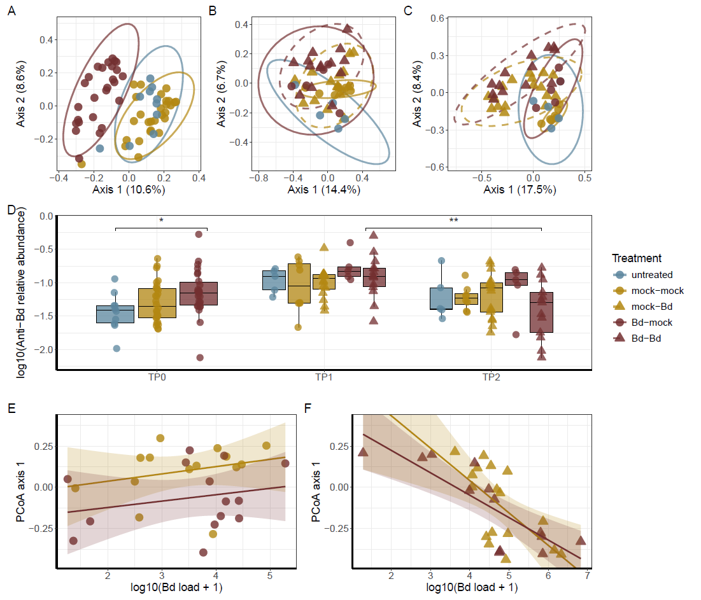
Figure 6. Effects of experimental treatments on skin bacterial communities. Multidimensional scaling plots (A-C) showing the effects of treatments on the bacterial community; 95 % confidence ellipses shown with line type representing treatment in Bd treatment 2: solid = mock, dashed = Bd. Treatment effects shown on bacterial community composition A) 1 d before Bd treatment 2 (TP0), B) early infection 14 d after Bd treatment 2 (TP1), and C) late infection 29 d after Bd treatment 2 (TP2). Boxplots (D) showing median and 1st and 3rd quartiles of the relative abundance of known anti-Bd bacteria at the three timepoints; significantly different groups demarcated with brackets and stars (TP0: Dunn’s test p = 0.036*; TP1/TP2: EMM p = 0.0012**). Linear regression (E-F) between the first principal coordinate of bacterial community composition and Bd load showing the regression line with 95 % confidence intervals; the effect of Bd load on the skin microbiome became more pronounced from early infection (E) to late infection (F). In all subplot, untreated animals = medium blue circles, mock-mock animals = dark goldenrod circles, mock-Bd animals = dark goldenrod triangles, Bd-mock animals = dark crimson circles, and Bd-Bd animals = dark crimson triangles; each point represents an individual.

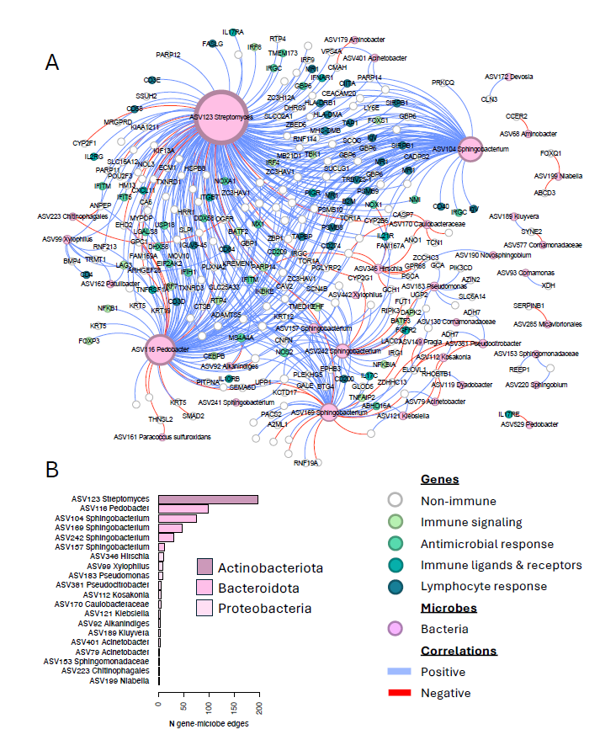
Figure 7. Gene–microbe correlations between CCA-selected features. A) The bipartite network shows correlations between host genes and bacterial ASVs which were significant at both timepoints (adjusted p-value < 0.05; |r| > 0.1). Nodes representing host genes are colored according to broad immune functional category. Bacterial nodes are named for the most specific taxonomic level they were annotated to. Node size is proportional to the number of significant gene–microbe correlations connected to that feature. Edges are colored according to correlation sign. B) The bar plot shows the number of significant gene–microbe correlations for the top 20 bacterial ASVs, colored by bacterial phylum.

Discussion
Host-pathogen relationship
Successful adaptive immune responses are marked by effective clearance of a previously encountered pathogen (18–20). We found that A. glyphus that were infected with and cleared of Bd exhibited stark decreases in their immune gene expression several months following fungal clearance. Among the downregulated genes were genes associated with adaptive immune responses, such as genes encoding antigen presentation components and genes critically involved in B and T cell responses. After re-infection with Bd, previously infected animals had notably increased expression of genes associated with immune suppression, such as CD200, which promotes tolerance (65,66); MS4A4A, a marker of immunosupressive macrophages (67,68); IL10, the hallmark immunosuppressive cytokine (69,70); and TNFAIP3, a negative regulator of NFkB (71). These differences could be reflective of several distinct and not necessarily mutually exclusive changes in these animals’ skin and immune cell composition. These immune cell changes could be explained by 1) fewer antigen presenting cells and skin-resident lymphocytes and increased proportions of immuno-supressive cells such as T regulatory cells or 2) following fungal clearance, these animals may have returned to baseline skin immune cell composition, comparable to naïve frogs albeit with dampened expression of certain key immune genes. More likely, our results indicate some combinantion of the two, with reduction in some resident skin leukocytes, infiltration of new populations and changes in the expression of other skin-resident leukocyte subsets that persisted throughout the exposure and clearance. It is notable, that the prior infected animals did not exhibit upregulated expression of genes classically associated with immune supression until they were re-infected with Bd. This suggests that the decreased immune gene expression may be the new baseline in these animals while Bd re-infection triggered active immune suppression in some genes and overactive immune expression in other genes. At the time of re-infection, Bd-Bd animals were likely in a relatively immunosuppressed state, which could have then been compounded by Bd re-infection in key immune genes causing greater Bd loads and poorer survival. Additionally, responses in Bd infected animals were also observed in other immune genes linked to immune activation, highlighting that dysregulation of the immune system may also be key in Bd susceptibility.

Overactive immune activation responses have been associated with poorer Bd infection outcomes (2,9,29,72), while tolerant species appear to modulate gene expression in later infection, even if the initial immune response was ineffective at controlling the pathogen (14). Bd is also notorious for its immune suppression of both innate and adaptive immune compartments (10,73,74). This suppression can lead to killing of lymphocytes and counter-polarization of myeloid cells towards immunosuppressive effectors (74,75). Prior comparative gene-expression studies including Atelopus found that less susceptible species had lower suppression of lymphocyte activity, lowered inflammatory responses and upregulated genes maintaining skin integrity (72). Our observations indicate that A. glyphus, like A. zeteki, are highly susceptible to Bd and that re-infection worsens disease outcomes (2), despite earlier suggestions that A. glyphus may be moderately susceptible (72). Compared to naïve animals, prior Bd-infected A. glyphus mounted both inflammatory and immunosuppressive responses upon re-infection, which could indicate dysregulated immune responses. Alternatively, these overall expression patterns may be a snapshot of a dynamic immune response, perhaps a more robust inflammatory immune response being quelled by greater immune suppression. Deciphering what aspects of these animals’ physiology and/or immune-Bd interactions dictate their immune response outcomes holds the key to understanding the facets of amphibian susceptibility to this pathogen. In this vein, it will be interesting to learn with future studies whether certain non-pathogenic fungi similarly alter frog skin immune systems towards the states seen in prior Bd-infected A. glyphus reported here. Here, we found that captive A. glyphus hosted approximately 20 fungal strains on average on their skin of presumably non-pathogenic fungi that would be useful for future study to isolate.

The skin-microbial interface
Bd exposure and infection often shifts the bacterial composition of amphibian skin microbiomes (25,76–79). It is well established that husbandry conditions may be associated with skin microbiomes (80) and the experimental setups with not natural substrates would limit new environmental colonization of the skin that would be experienced in nature. Nonetheless our experimental design allowed effective comparisons between treatment groups at different time points. In our experiment, we found that Bd infection and clearance led to A. glyphus having greater relative abundance of anti-Bd bacteria than Bd-naïve animals, but we found no effect on bacterial richness. This would suggest that Bd infection does not appear to be causing a loss of bacterial taxa, but instead shifting the relative abundances of particular bacterial taxa, including putative anti-Bd bacteria. Anti-Bd bacteria were identified by 100% sequence homology to a database of culturable bacteria known to kill Bd in culture, and are presumed to serve similar functional roles on the skin. However, notably, we observed no protective effect by the increase in the relative abundance of these putative anti-Bd bacteria; all animals exposed to Bd at Bd treatment 2 died from infection regardless of their skin anti-Bd bacterial composition. Following clearance, these bacteria may have persisted as better competitors and/or because they can withstand the changes to the skin immunity and physiology (such as keratinocyte destruction) experienced during Bd infections or they may have increased in abundance only after infection clearance. We do not have a baseline microbiome composition for wild Atelopus glyphus, but Becker et al found that captive Atelopus zeteki shared 70% of their microbiome with wild frogs (81) and anti-Bd bacteria in Atelopus varius increased from 40% to 60% of the community after 80 days in wild conditions (80,82). This was confounded by the effects of wild vs captive conditions and Bd exposure, so this captive study sheds further light on the direct interaction between Bd and the microbiome.

Since mucosal barrier microbiomes and resident immune components are highly interconnected across vertebrates, it is likely that the altered microbiomes of the prior infected animals contributed to the observed changes in immune gene expression and how those immune cells/components responded to Bd re-infection (83). Conversely, the observed changes to the skin immune genes of prior infected frogs may likewise be driving and promoting the maintenance of certain bacterial taxa over others (84). Our gene-microbe network analysis supports this hypothesis, with a small number of bacterial ASVs accounting for a large proportion of significant host–microbe associations, whereas most taxa were linked to only one or a few genes (Fig. 7). It is equally notable that two weeks following re-infection, the microbiomes of re-infected animals (Bd-Bd) no longer possessed greater relative abundance of anti-Bd bacteria, and actually had significantly diminshed numbers of these bacteria after 29 d of re-infection. Presumably, this stems at least in part from changes to the skin immune cell composition and activation states. In turn, this begs the question of the extent to which these ‘inhibitory’ taxa truly prevent Bd colonization in vivo as opposed to being selected for by fungal infection. Other studies have found no relationship between disease load and antiBd bacteria richness (14). Since we used relative abundance, it is unclear if the number of anti-Bd bacteria remained constant while the number of bacterial cells increased on infected animal skin or if anti-Bd bacterial cells decreased. Using interal spike-ins or qPCR of 16S rRNA counts to determine absolute abundance in microbiome studies will allow for future studies to determine the biological processes occuring in observed changes of anti-Bd bacteria (85,86). It will be interesting to disintangle with future studies the precise effects of these microbial taxa on amphibian skin immune components and antifungal reponses.

Other Bd studies found that host gene expression was closely tied to infection status and to shifts in microbiomes (87–89), while a hellbender vaccination trial found that immune activation stimulated by exposure to killed Bd did not affect the microbiome (14). It is difficult to disentangle the direct effects of the pathogen on the skin bacteria composition versus the the indirect effects of host gene expression causing changes in the skin that may be altering skin secretions or mucus composition that, in turn may create a different environment for skin bacteria growth (87,88). Furthermore, the amphibian skin microbiome itself can alter host gene expression without pathogen exposure (83). We now know that observed bacterial signatures previously interpreted as markers of Bd resistance e.g. (12) likely reflect underlying variation in host immune state and may partly have a genetic basis (90). In our dataset, we observed unusually high gene-microbe connectivity within the genus Sphingobacterium, a group that has been previously associated with poor Bd outcomes (64,91). Because these taxa were strongly linked to expression of multiple host immune genes, their apparent association with Bd susceptibility may not be a direct effect of microbial inhibition or promotion of the pathogen. Instead, these correlations may arise indirectly, stemming from host expression shifts which in turn affect bacterial abundance. The mechanism for differential disease outcomes within a species are consequential, as disentangling them will allow us to appropriately focus on mitigation approaches. In this study, pathogen infection caused a long-term reduction in immune gene expression, and these transcriptional changes were clearly reflected in the microbiome. Following re-infection, a much broader set of immune genes was activated, and this shift was again tightly mirrored by changes in microbial composition. Together, these patterns indicate that a deeper investigation of the underlying immune mechanisms are warranted for highly susceptible species.

More broadly, comparative studies examining the microbial-immune interface will be key to solving why amphibian species show such high variability in responses to Bd. Based on this study and others, we hypothesize that for resistant species, the skin microbiome and innate immune system play a strong role in reducing the likelihood of infection (11,84), which is likely more of a reflection of processes occuring over evolutionary time (90) including prior exposures to diverse fungi (92,93) and not a direct reflection of interactions with Bd. For moderately susceptible species, evidence indicates the prior Bd exposure, whether to live or dead Bd cells, leads to an increase in survival (18–20,24) but whether the mechanism is immunological or microbial has yet to be determined. For highly susceptible species, we hypothesize that prior Bd exposure will be ineffective, as observed here, because it triggers an inflammatory response at first infection that subsequently leads to poorer responses upon re-infection. It is likely only a small number of bacterial species in the amphibian skin microbiome has pronounced functional relevance to the immune system (Madison et al. 2025) and to Bd (64,78). Therefore integrative studies examining the microbial-immune-Bd interfaces are key to identifying targets for probiotic development that reduce the likelihood of ineffective probiotics (5). To find a way to increase the survival of highly susceptible species, we believe that a combination of alternative approaches are needed (94).

Conclusion
Our results illustrate that the skin microbiome, Bd and the host immune system are intimately connected. Even though the microbiome shifted to a state that included higher relative abundance of anti-Bd bacteria this did not confer a survival benefit, and may simply have been more indicative of shifts in the host immune system. The infection-clearance-infection regime we tried did not confer a survival benefit and we speculate it is only effective in moderately susceptible species (19,95), not those that typically experience 100 % mortality in lab experiments. Our observations are consistent with prior studies showing that the compounds Bd is producing are highly effective in combating specific immune responses (73,74). We also demonstrated that we can conduct longitudinal host gene expression studies using non-sacrificial longitudinal designs with amphibian toe-clips. This has been problematic for previous Bd work because attributing gene expression to disease outcomes must be inferred at a population level with sacrificial designs (26,28,72,96). While 100 % of infected animals died in this experiment and prior infection was detrimental to this species, we found that the severity of Bd infection was correlated at first and second infections, implying there is individual variation in susceptibility that may be relevant to genome wide association studies (97). When individual survivors of susceptible species are observed in disease exposure trials (2,13,18,19), or in wild situations (98) comparative host gene expression data would be invaluable to determine the mechanism using toe-clips (12). This method may be useful to identify candidate resistance genes for targeted genetic interventions that increase disease fitness traits for conservation purposes (97).

Acknowledgements
We thank Marta Vargas at the Naos Molecular Laboratory at the Smithsonian Tropical Research Institute in Panama for assistance with sample preparation and extraction.

Author contributions
The authors confirm contribution to the paper as follows: Study conception and design: B.G., E.B., L.L., C. M-W., A.E., G.D.; Grant application and program management: C.M-W., B.G., R.I., L.G., A.E; data collection: Y.F., E.I., J.G., L.L., N.A., O.O., R.I., C.M-W., J.M.; analysis and interpretation of results: O.O., A.H., B.G., N.A., C.M-W., A.E., J.M., L.G.; draft manuscript preparation: C.M-W., B.G., A.E., O.O., L.G., A.H. All authors reviewed the results and approved the final version of the manuscript.

Funding
This experimental work was supported financially by a Revive and Restore grant awarded to C.M-W., B.G. and R.I., a joint US National Science Foundation(NSF) and UK Biotechnology and Biological Sciences Research Council (BBSRC) grant awarded to C.M-W., A.E., L.G. and B.G.(NSF IOS-2131060 and BBSRC BB/W013517/1) and a NSF award IOS-2147466 to L.G. The Panama Amphibian Rescue and Conservation Project is a joint project of the Smithsonian Tropical Research Institute, the Smithsonian National Zoo and Conservation Biology Institute, the Cheyenne Mountain Zoo and Zoo New England and we gratefully acknowledge financial support from the Shared Earth Foundation, the Anele Kolohe Foundation, Susan and Frank Mars, an anonymous foundation and the Bezos Earth Fund supporting the participation of B.G., R.I., J.G., Y.F., L.L. & N.A.

Data availability
The sequence datasets supporting the conclusions of this article are available at https://www.ncbi.nlm.nih.gov/bioproject/?term=PRJNA1302657. Code used to conduct all RNASeq analyses is available at https://github.com/ogosborne/A.glyphus_Bd_pre-exposure_RNAseq/ and https://github.com/amphibiarik/A.glyphus_Bd_exposure_16s-ITS_analyses for 16S and ITS analyses.

Declarations
Ethics approval and consent to participate
Animal experiments were reviewed and approved by the Smithsonian Tropical Research Institute Institutional Animal Care and Use Committee SI-21009.

Consent for publication
Not applicable.

Competing interests.
The Authors declare no competing interests.

Disclaimer.
Official contribution of the National Institute of Standards and Technology (NIST); not subject to copyright in the United States. All opinions expressed in this paper are the authors’ and do not necessarily reflect the policies and views of NIST or affiliated venues. Certain pieces of commercial equipment, instruments, or materials are identified in this paper to specify the experimental procedure adequately. Such identification is not intended to imply recommendation or endorsement by NIST, nor is it intended to imply that the materials or equipment identified are necessarily the best available for the purpose.

References
1. Scheele BC, Pasmans F, Skerratt LF, Berger L, Martel A, Beukema W, et al. Amphibian fungal panzootic causes catastrophic and ongoing loss of biodiversity. Science. 2019 Mar 29;363(6434):1459–63. doi:10.1126/science.aav0379 PubMed PMID: 30923224.
2. Ellison AR, Savage AE, DiRenzo GV, Langhammer P, Lips KR, Zamudio KR. Fighting a losing battle: Vigorous immune response countered by pathogen suppression of host defenses in the chytridiomycosis-susceptible frog Atelopus zeteki . G3: Genes Genomes Genetics. 2014;4(July):1275–89. doi:10.1534/g3.114.010744 PubMed PMID: 24841130.
3. McCaffery R, Richards-Zawacki CL, Lips KR. The demography of Atelopus decline: Harlequin frog survival and abundance in central Panama prior to and during a disease outbreak. Global Ecology and Conservation. 2015;4:232–42. doi:10.1016/j.gecco.2015.07.003
4. Lampo M, Señaris C, García CZ. Population dynamics of the critically endangered toad Atelopus cruciger and the fungal disease chytridiomycosis. Gratwicke B, editor. PLOS ONE. 2017 Jun 1;12(6):e0179007. doi:10.1371/journal.pone.0179007
5. Becker MH, Brophy JAN, Barrett K, Bronikowski E, Evans M, Glassey E, et al. Genetically modifying skin microbe to produce violacein and augmenting microbiome did not defend Panamanian golden frogs from disease. ISME Communications 2021 1:1. 2021 Oct 18;1(1):1–10. doi:10.1038/s43705-021-00044-w
6. Lötters S, Plewnia A, Catenazzi A, Neam K, Acosta-Galvis AR, Alarcon Vela Y, et al. Ongoing harlequin toad declines suggest the amphibian extinction crisis is still an emergency. Commun Earth Environ. 2023 Nov 11;4(1):1–8. doi:10.1038/s43247-023-01069-w
7. Re:wild, Synchronicity Earth, IUCN SSC Amphibian Specialist Group. [Internet]. Re:Wild; 2023. Available from: https://www.iucn-amphibians.org/wp-content/uploads/sites/4/2023/10/SOTWA-final-10.4.23.pdf
8. Lewis CHR, Richards-Zawacki CL, Ibáñez R, Luedtke J, Voyles J, Houser P, et al. Conserving Panamanian harlequin frogs by integrating captive-breeding and research programs. Biological Conservation. 2019 Aug 1;236:180–7. doi:10.1016/j.biocon.2019.05.029
9. Grogan LF, Robert J, Berger L, Skerratt LF, Scheele BC, Castley JG, et al. Review of the Amphibian Immune Response to Chytridiomycosis, and Future Directions. Front Immunol. 2018;9. doi:10.3389/fimmu.2018.02536
10. Rollins-Smith LA. Global amphibian declines, disease, and the ongoing battle between Batrachochytrium fungi and the immune system. Herpetologica. 2020;76(2):178–88. doi:10.1655/0018-0831-76.2.178
11. Jiménez RR, Carfagno A, Linhoff L, Gratwicke B, Woodhams DC, Chafran LS, et al. Inhibitory Bacterial Diversity and Mucosome Function Differentiate Susceptibility of Appalachian Salamanders to Chytrid Fungal Infection. Applied and Environmental Microbiology. 2022 Mar 29;88(8):e01818-21. doi:10.1128/aem.01818-21
12. Becker MH, Walke JB, Cikanek S, Savage AE, Mattheus N, Santiago CN, et al. Composition of symbiotic bacteria predicts survival in Panamanian golden frogs infected with a lethal fungus. Proceedings of the Royal Society B. 2015;282(1805):20142881. doi:10.1098/rspb.2014.2881 PubMed PMID: 25788591.
13. Becker MH, Harris RN, Minbiole KPC, Schwantes CR, Rollins-Smith LA, Reinert LK, et al. Towards a better understanding of the use of probiotics for preventing chytridiomycosis in Panamanian golden frogs. EcoHealth. 2011 Dec;8(4):501–6. doi:10.1007/s10393-012-0743-0 PubMed PMID: 22328095.
14. Kaganer AW, Ossiboff RJ, Keith NI, Schuler KL, Comizzoli P, Hare MP, et al. Immune priming prior to pathogen exposure sheds light on the relationship between host, microbiome and pathogen in disease. Royal Society Open Science. 2023 Feb;10(2). doi:10.1098/rsos.220810
15. Oliveira LVN, Wang R, Specht CA, Levitz SM. Vaccines for human fungal diseases: close but still a long way to go. npj Vaccines. 2021 Mar 3;6(1):1–8. doi:10.1038/s41541-021-00294-8
16. Rocke TE, Kingstad-Bakke B, Wüthrich M, Stading B, Abbott RC, Isidoro-Ayza M, et al. Virally-vectored vaccine candidates against white-nose syndrome induce anti-fungal immune response in little brown bats (Myotis lucifugus). Sci Rep. 2019 May 1;9(1):6788. doi:10.1038/s41598-019-43210-w
17. Case NT, Gurr SJ, Fisher MC, Blehert DS, Boone C, Casadevall A, et al. Fungal impacts on Earth’s ecosystems. Nature. 2025 Feb 6;638(8049):49–57. doi:10.1038/s41586-024-08419-4
18. McMahon TA, Sears BF, Venesky MD, Bessler SM, Brown JM, Deutsch K, et al. Amphibians acquire resistance to live and dead fungus overcoming fungal immunosuppression. Nature. 2014;511(7508):224–7. doi:10.1038/nature13491
19. Waddle AW, Rivera R, Rice H, Keenan EC, Rezaei G, Levy JE, et al. Amphibian resistance to chytridiomycosis increases following low-virulence chytrid fungal infection or drug-mediated clearance. Journal of Applied Ecology. 2021;58(10):2053–64. doi:10.1111/1365-2664.13974
20. Waddle AW, Clulow S, Aquilina A, Sauer EL, Kaiser SW, Miller C, et al. Hotspot shelters stimulate frog resistance to chytridiomycosis. Nature. 2024 Jul 11;631(8020):344–9. doi:10.1038/s41586-024-07582-y
21. Cashins SD, Grogan LF, McFadden M, Hunter D, Harlow PS, Berger L, et al. Prior Infection Does Not Improve Survival against the Amphibian Disease Chytridiomycosis. Gratwicke B, editor. PLoS ONE. 2013 Feb 22;8(2):1–7. doi:10.1371/journal.pone.0056747 PubMed PMID: 23451076.
22. Hudson MA, Young RP, Lopez J, Martin L, Fenton C, McCrea R, et al. In-situ itraconazole treatment improves survival rate during an amphibian chytridiomycosis epidemic. Biological Conservation. 2016 Mar;195:37–45. doi:10.1016/j.biocon.2015.12.041
23. Adams AJ, Bushell J, Grasso RL. To treat or not to treat? Experimental pathogen exposure, treatment, and release of a threatened amphibian. Ecosphere. 2022;13(12):e4294. doi:10.1002/ecs2.4294
24. McMahon TA, Garcia AM, Malinias AJ, Monsalve M, Muldro LC, Sisson EO, et al. Efficacy of Bd metabolite prophylaxis dose and duration on host defence against the deadly chytrid fungus Batrachochytrium dendrobatidis. Journal of Applied Ecology. 2024;61(12):3139–47. doi:10.1111/1365-2664.14818
25. Siomko SA, Greenspan SE, Barnett KM, Neely WJ, Chtarbanova S, Woodhams DC, et al. Selection of an anti-pathogen skin microbiome following prophylaxis treatment in an amphibian model system. Philosophical Transactions of the Royal Society B: Biological Sciences. 2023 Jun 12;378(1882):20220126. doi:10.1098/rstb.2022.0126
26. Savage AE, Zamudio KR. MHC genotypes associate with resistance to a frog-killing fungus. Proceedings of the National Academy of Sciences of the United States of America. 2011 Oct 4;108(40):16705–10. doi:10.1073/pnas.1106893108 PubMed PMID: 21949385.
27. Bataille A, Cashins SD, Grogan L, Skerratt LF, Hunter D, McFadden M, et al. Susceptibility of amphibians to chytridiomycosis is associated with MHC class II conformation. Proceedings of the Royal Society B: Biological Sciences. 2015;282(1805):20143127–20143127. doi:10.1098/rspb.2014.3127 PubMed PMID: 25808889.
28. Savage AE, Gratwicke B, Hope K, Fleischer RC. Sustained immune activation is associated with susceptibility to the amphibian chytrid fungus. Molecular Ecology. 2020 Aug 1;29(15):2889–903. doi:10.1111/mec.15533 PubMed PMID: 32700351.
29. Eskew EA, Shock BC, LaDouceur EEB, Keel K, Miller MR, Foley JE, et al. Gene expression differs in susceptible and resistant amphibians exposed to Batrachochytrium dendrobatidis. Royal Society Open Science. 2018 Feb 28;5(2):170910. doi:10.1098/rsos.170910
30. Baitchman EJ, Pessier A. Pathogenesis, diagnosis and treatment of amphibian chytridiomycosis. Vet Clin Exot Anim. 2013;16:669–85. doi:10.1016/j.cvex.2013.05.009
31. Hyatt AD, Boyle DG, Olsen V, Boyle DB, Berger L, Obendorf D, et al. Diagnostic assays and sampling protocols for the detection of Batrachochytrium dendrobatidis. Diseases of Aquatic Organisms. 2007;73:175–92.
32. Boyle DG, Boyle DB, Olsen V, Morgan JT, Hyatt AD. Rapid quantitative detection of chytridiomycosis (Batrachochytrium dendrobatidis) in amphibian samples using real-time Taqman PCR assay. Diseases of aquatic organisms. 2004;60(2):141–8. doi:10.3354/dao060141 PubMed PMID: 15460858.
33. Kriger KM, Hines HB, Hyatt AD, Boyle DG, Hero JM. Techniques for detecting chytridiomycosis in wild frogs: Comparing histology with real-time Taqman PCR. Diseases of Aquatic Organisms. 2006;71(2):141–8. doi:10.3354/dao071141 PubMed PMID: 16956061.
34. Therneau TM, Lumley T. Survival Analysis [Internet]. 2019 [cited 2020 Mar 13]. p. https://github.com/therneau/survival. R: Survival Analysis 3.1-8. Available from: https://stat.ethz.ch/R-manual/R-patched/library/survival/html/00Index.html
35. R Core Team. R: A Language and Environment for Statistical Computing [Internet]. Vienna, Austria: R Foundation for Statistical Computing; 2021. Available from: https://www.R-project.org/
36. Mölder F, Jablonski KP, Letcher B, Hall MB, Tomkins-Tinch CH, Sochat V, et al. Sustainable data analysis with Snakemake. F1000Res. 2021 Jan 18;10:33. doi:10.12688/f1000research.29032.1
37. Chen S, Zhou Y, Chen Y, Gu J. fastp: an ultra-fast all-in-one FASTQ preprocessor. Bioinformatics. 2018 Sep 1;34(17):i884–90. doi:10.1093/bioinformatics/bty560
38. Bushnell B, Rood J, Singer E. BBMerge – Accurate paired shotgun read merging via overlap. Biggs PJ, editor. PLoS ONE. 2017 Oct 26;12(10):e0185056. doi:10.1371/journal.pone.0185056
39. Kopylova E, Noé L, Touzet H. SortMeRNA: fast and accurate filtering of ribosomal RNAs in metatranscriptomic data. Bioinformatics. 2012 Dec 1;28(24):3211–7. doi:10.1093/bioinformatics/bts611
40. Grabherr MG, Haas BJ, Yassour M, Levin JZ, Thompson DA, Amit I, et al. Full-length transcriptome assembly from RNA-Seq data without a reference genome. Nat Biotechnol. 2011 Jul;29(7):644–52. doi:10.1038/nbt.1883
41. Smith-Unna R, Boursnell C, Patro R, Hibberd JM, Kelly S. TransRate: reference-free quality assessment of de novo transcriptome assemblies. Genome Res. 2016 Aug;26(8):1134–44. doi:10.1101/gr.196469.115
42. Simão FA, Waterhouse RM, Ioannidis P, Kriventseva EV, Zdobnov EM. BUSCO: assessing genome assembly and annotation completeness with single-copy orthologs. Bioinformatics. 2015 Oct 1;31(19):3210–2. doi:10.1093/bioinformatics/btv351
43. Patro R, Duggal G, Love MI, Irizarry RA, Kingsford C. Salmon provides fast and bias-aware quantification of transcript expression. Nat Methods. 2017 Apr;14(4):417–9. doi:10.1038/nmeth.4197
44. Soneson C, Love MI, Robinson MD. Differential analyses for RNA-seq: transcript-level estimates improve gene-level inferences. F1000Res. 2015 Dec 30;4:1521. doi:10.12688/f1000research.7563.1
45. Love MI, Huber W, Anders S. Moderated estimation of fold change and dispersion for RNA-seq data with DESeq2. Genome Biology. 2014 Dec 5;15(12):550. doi:10.1186/s13059-014-0550-8
46. Alexa A, Rahnenfuhrer J. Bioconductor [Internet]. 2024 [cited 2025 May 28]. topGO: Enrichment Analysis for Gene Ontology. 2.59.0. Available from: http://bioconductor.org/packages/topGO/
47. Bornbusch SL, Shinnerl HE, Gentry L, Keady MM, Glick V, Muletz-Wolz CR, et al. Local environment shapes milk microbiomes while evolutionary history constrains milk macronutrients in captive cercopithecine primates. Environ Microbiol. 2024 Jun;26(6):e16664. doi:10.1111/1462-2920.16664 PubMed PMID: 38830671.
48. Kutos S, Bennett RE, Rao MV, Fleischer RC, Rice RA, Muletz-Wolz CR. Farm management and shade tree species influence coffee soil microbiomes in Central and South America. Applied Soil Ecology. 2024 Oct;202:105571. doi:10.1016/j.apsoil.2024.105571
49. Callahan BJ, McMurdie PJ, Rosen MJ, Han AW, Johnson AJA, Holmes SP. DADA2: High-resolution sample inference from Illumina amplicon data. Nature methods. 2016;13(7):581–3.
50. Martin M. Cutadapt removes adapter sequences from high-throughput sequencing reads. EMBnet.journal. 2011 May 2;17(1):1. doi:10.14806/ej.17.1.200
51. Abarenkov K, Nilsson RH, Larsson KH, Taylor AFS, May TW, Frøslev TG, et al. The UNITE database for molecular identification and taxonomic communication of fungi and other eukaryotes: sequences, taxa and classifications reconsidered. Nucleic Acids Research. 2024 Jan 5;52(D1):D791–7. doi:10.1093/nar/gkad1039
52. McMurdie PJ, Holmes S. phyloseq: an R package for reproducible interactive analysis and graphics of microbiome census data. PloS one. 2013;8(4):e61217.
53. Oksanen J, Blanchet FG, Kindt R, Legendre P, Minchin PR, O’hara R, et al. Package ‘vegan.’ Community ecology package, version. 2013;2(9):1–295.
54. Ogle DH, Doll JC, Wheeler AP, Dinno A. FSA: Simple Fisheries Stock Assessment Methods [Internet]. 2023. Available from: https://CRAN.R-project.org/package=FSA
55. Bates D, Mächler M, Bolker B, Walker S. Fitting Linear Mixed-Effects Models Using lme4. Journal of Statistical Software. 2015;67(1):1–48. doi:10.18637/jss.v067.i01
56. Lenth RV. Least-Squares Means: The R Package lsmeans. J Stat Soft. 2016;69(1). doi:10.18637/jss.v069.i01
57. Martinez Arbizu P. pairwiseAdonis: Pairwise multilevel comparison using adonis. R package version 04. 2020;1.
58. Boogaart KG van den, Tolosana-Delgado R, Bren M. compositions: Compositional Data Analysis [Internet]. 2025 [cited 2025 Nov 18]. Available from: https://cran.r-project.org/web/packages/compositions/index.html
59. Witten D, Tibshirani R, Gross S, Narasimhan B. PMA: Penalized Multivariate Analysis [Internet]. 2024 [cited 2025 Nov 18]. Available from: https://cran.r-project.org/web/packages/PMA/index.html
60. Harrell Jr FE. Hmisc: Harrell Miscellaneous [Internet]. 2003 [cited 2025 Nov 18]. p. 5.2-4. Available from: https://CRAN.R-project.org/package=Hmisc doi:10.32614/CRAN.package.Hmisc
61. Gephi - The Open Graph Viz Platform [Internet]. [cited 2025 Nov 18]. Available from: https://gephi.org/desktop/
62. Fang M, Yu H, Hutson A. PermCor: Robust Permutation Tests of Correlation Coefficients [Internet]. 2024 [cited 2025 Nov 18]. Available from: https://cran.r-project.org/web/packages/PermCor/index.html
63. Diedenhofen B. cocor: Comparing Correlations [Internet]. 2022 [cited 2025 Nov 18]. Available from: https://cran.r-project.org/web/packages/cocor/index.html
64. Bates KA, Sommer U, Hopkins KP, Shelton JMG, Wierzbicki C, Sergeant C, et al. Microbiome function predicts amphibian chytridiomycosis disease dynamics. Microbiome. 2022 Mar 10;10(1):44. doi:10.1186/s40168-021-01215-6
65. Fernández-Ruiz I. CD200 is an atheroprotective immune checkpoint. Nat Rev Cardiol. 2021 Jul;18(7):461–461. doi:10.1038/s41569-021-00578-5
66. Arad T, Fainstein N, Goldfarb S, Lachish M, Ganz T, Ben-Hur T. CD200 -dependent and -independent immune-modulatory functions of neural stem cells. Stem Cell Res. 2021 Oct;56:102559. doi:10.1016/j.scr.2021.102559 PubMed PMID: 34634761.
67. Sui Y, Zeng W. MS4A4A Regulates Arginase 1 Induction during Macrophage Polarization and Lung Inflammation in Mice. European Journal of Immunology. 2020;50(10):1602–5. doi:10.1002/eji.202048585
68. Mattiola I, Tomay F, De Pizzol M, Silva-Gomes R, Savino B, Gulic T, et al. The macrophage tetraspan MS4A4A enhances dectin-1-dependent NK cell–mediated resistance to metastasis. Nat Immunol. 2019 Aug;20(8):1012–22. doi:10.1038/s41590-019-0417-y
69. Ouyang W, Rutz S, Crellin NK, Valdez PA, Hymowitz SG. Regulation and Functions of the IL-10 Family of Cytokines in Inflammation and Disease. Annual Review of Immunology. 2011 Apr 23;29(Volume 29, 2011):71–109. doi:10.1146/annurev-immunol-031210-101312
70. Liu S, Li J, Zhang Y, Wang C, Zhang L. IL-10: the master immunomodulatory cytokine in allergen immunotherapy. Expert Rev Clin Immunol. 2025 Jan;21(1):17–28. doi:10.1080/1744666X.2024.2406894 PubMed PMID: 39323099.
71. Chen J, Ma Y, Yang Z, Lan H, Liu G, Zhang Y, et al. TNFAIP3 ameliorates the degeneration of inflammatory human nucleus pulposus cells by inhibiting mTOR signaling and promoting autophagy. Aging. 2020 Nov 20;12(23):24242–54. doi:10.18632/aging.104160 PubMed PMID: 33226960.
72. Ellison AR, Tunstall T, Direnzo GV, Hughey MC, Rebollar EA, Belden LK, et al. GBE More than Skin Deep : Functional Genomic Basis for Resistance to Amphibian Chytridiomycosis. Vol. 7. 2014;7(1):286–98. doi:10.1093/gbe/evu285
73. Rollins-Smith LA, Fites JS, Reinert LK, Shiakolas AR, Umile TP, Minbiole KPC. Immunomodulatory Metabolites Released by the Frog-Killing Fungus Batrachochytrium dendrobatidis. Infection and Immunity. 2015 Nov 10;83(12):4565–70. doi:10.1128/iai.00877-15
74. Fites JS, Ramsey JP, Holden WM, Collier SP, Sutherland DM, Reinert LK, et al. The Invasive Chytrid Fungus of Amphibians Paralyses Lymphocyte Responses. Science. 2013;342:366–9. doi:10.5061/dryad.878m3
75. Yaparla A, Popovic M, Hauser KA, Rollins-Smith LA, Grayfer L. Amphibian (Xenopus laevis Macrophage Subsets Vary in Their Responses to the Chytrid Fungus Batrachochytrium dendrobatidis. Journal of Fungi. 2025 Apr;11(4):4. doi:10.3390/jof11040311
76. Jani AJ, Bushell J, Arisdakessian CG, Belcaid M, Boiano DM, Brown C, et al. The amphibian microbiome exhibits poor resilience following pathogen-induced disturbance. ISME JOURNAL. 2021 Jun;15(6):1628–40. doi:10.1038/s41396-020-00875-w
77. Rebollar EA, Hughey MC, Medina D, Harris RN, Ibáñez R, Belden LK. Skin bacterial diversity of Panamanian frogs is associated with host susceptibility and presence of Batrachochytrium dendrobatidis. ISME Journal. 2016;10(7):1672–95. doi:10.1038/ismej.2015.234
78. Jani AJ, Briggs CJ. The pathogen Batrachochytrium dendrobatidis disturbs the frog skin microbiome during a natural epidemic and experimental infection. Proceedings of the National Academy of Sciences of the United States of America. 2014 Nov 25;111(47):E5049–58. doi:10.1073/pnas.1412752111 PubMed PMID: 25385615.
79. Muletz-Wolz CR, Fleischer RC, Lips KR. Fungal disease and temperature alter skin microbiome structure in an experimental salamander system. Mol Ecol. 2019 Jun;28(11):2917–31. doi:10.1111/mec.15122 PubMed PMID: 31066947.
80. Kueneman J, Bletz M, Becker M, Gratwicke B, Garcés OA, Hertz A, et al. Effects of captivity and rewilding on amphibian skin microbiomes. Biological Conservation. 2022 Jul;271:109576. doi:10.1016/J.BIOCON.2022.109576
81. Becker MH, Richards-Zawacki CL, Gratwicke B, Belden LK. The effect of captivity on the cutaneous bacterial community of the critically endangered Panamanian golden frog (Atelopus zeteki). Biological Conservation. 2014;176:199–206. doi:10.1016/j.biocon.2014.05.029
82. Klocke B, Garcés O, Lassiter E, Guerrel J, Hertz A, Illueca E, et al. Release trial of captive-bred variable harlequin frogs Atelopus varius shows that frogs disperse rapidly, are difficult to recapture and do not readily regain skin toxicity. Oryx. 2023 Dec 13;1–13. doi:10.1017/S0030605323001254
83. Madison JD, Osborne OG, Ellison A, Garvey Griffith CN, Gentry L, Gross H, et al. Probiotic colonization of Xenopus laevis skin causes short-term changes in skin microbiomes and gene expression. Raffatellu M, editor. Infect Immun. 2025 May 13;93(5):e00569-24. doi:10.1128/iai.00569-24
84. Hauser KA, Garvey CN, Crow RS, Hossainey MR, Howard DT, Ranganathan N, et al. Amphibian mast cells serve as barriers to chytrid fungus infections. Kim BS, Rath S, editors. eLife. 2024 Jul 31;12:RP92168. doi:10.7554/eLife.92168
85. Epp Schmidt D, Maul JE, Yarwood SA. Quantitative Amplicon Sequencing Is Necessary to Identify Differential Taxa and Correlated Taxa Where Population Sizes Differ. Microb Ecol. 2023 Nov;86(4):2790–801. doi:10.1007/s00248-023-02273-z
86. Ghotbi M, Stajich JE, Dallas JW, Rurik AJ, Cummins C, Vargas-Gastélum L, et al. Absolute abundance unveils Basidiobolus as a cross-domain bridge indirectly bolstering gut microbiome homeostasis. ISME J. 2025 Jan 2;19(1):wraf150. doi:10.1093/ismejo/wraf150
87. Campbell LJ, Hammond SA, Price SJ, Sharma MD, Garner TWJ, Birol I, et al. A novel approach to wildlife transcriptomics provides evidence of disease‐mediated differential expression and changes to the microbiome of amphibian populations. Molecular Ecology. 2018 Mar;27(6):1413–27. doi:10.1111/mec.14528
88. Küng D, Bigler L, Davis LR, Gratwicke B, Griffith E, Woodhams DC, et al. Stability of Microbiota Facilitated by Host Immune Regulation: Informing Probiotic Strategies to Manage Amphibian Disease. PLoS ONE. 2014;9(1):e87101. doi:10.1371/journal.pone.0087101 PubMed PMID: 24489847.
89. Woodhams DC, Rollins-Smith LA, Reinert LK, Lam BA, Harris RN, Briggs CJ, et al. Probiotics Modulate a Novel Amphibian Skin Defense Peptide That Is Antifungal and Facilitates Growth of Antifungal Bacteria. Microbial Ecology. 2020 Jan 1;79(1):192–202. doi:10.1007/s00248-019-01385-9
90. Osborne O, Jiménez R, Byrne A, Gratwicke B, Ellison A, Muletz-Wolz C. Phylosymbiosis drives the distribution of pathogen-protective bacteria in Appalachian salamanders [Internet]. 2024 [cited 2024 Apr 24]. Available from: https://www.researchsquare.com/article/rs-3773072/v1 doi:10.21203/rs.3.rs-3773072/v1
91. Bates KA, Clare FC, O’Hanlon S, Bosch J, Brookes L, Hopkins K, et al. Amphibian chytridiomycosis outbreak dynamics are linked with host skin bacterial community structure. Nat Commun. 2018 Feb 15;9(1):693. doi:10.1038/s41467-018-02967-w
92. Jiménez RR, Thatcher P, Osborne OG, Gratwicke B, Muletz-Wolz CR. Microbial metacommunity ecology: using null models and networks to understand assembly in a salamander disease system. Ecosphere. (in review).
93. Martínez-Ugalde E, Ávila-Akerberg V, González Martínez TM, Rebollar EA. Gene functions of the Ambystoma altamirani skin microbiome vary across space and time but potential antifungal genes are widespread and prevalent. Microbial Genomics. 2024 Jan 19;10(1). doi:10.1099/mgen.0.001181
94. Bletz MC, Gratwicke B, Belasen AM, Catenazzi A, Duffus ALJ, Olson DH, et al. Infectious diseases: Advances and challenges in addressing emerging pathogens. In: Amphibian Conservation Action Plan. Gland: IUCN Species Survival Commission. (Occasional Paper; no. 57).
95. McMahon TA, Sears BF, Venesky MD, Bessler SM, Brown JM, Deutsch K, et al. Amphibians acquire resistance to live and dead fungus overcoming fungal immunosuppression. Nature. 2014;511(7508):224–7. doi:10.1038/nature13491
96. Kosch TA, Silva CNS, Brannelly LA, Roberts AA, Lau Q, Marantelli G, et al. Genetic potential for disease resistance in critically endangered amphibians decimated by chytridiomycosis. Anim Conserv. 2019 Jun;22(3):238–50. doi:10.1111/acv.12459
97. Kosch TA, Waddle AW, Cooper C, Zenger KR, Garrick DJ, Berger L, et al. Genetic approaches for increasing fitness in endangered species. Trends in ecology & evolution. 2022;37(4):332–45. doi:10.1016/j.tree.2021.12.003
98. Voyles J, Woodhams DC, Saenz V, Byrne AQ, Perez R, Rios-Sotelo G, et al. Shifts in disease dynamics in a tropical amphibian assemblage are not due to pathogen attenuation. Science. 2018 Mar 30;359(6383):1517–9. doi:10.1126/science.aao4806 PubMed PMID: 29599242.

